UNITED STATES

SECURITIES AND EXCHANGE COMMISSION
Washington, D.C. 20549

SCHEDULE 14A

Proxy Statement Pursuant to Section 14(a) of the Securities

Exchange Act of 1934

Filed by the Registrant Filed by a Party other than the Registrant

Check the appropriate box:
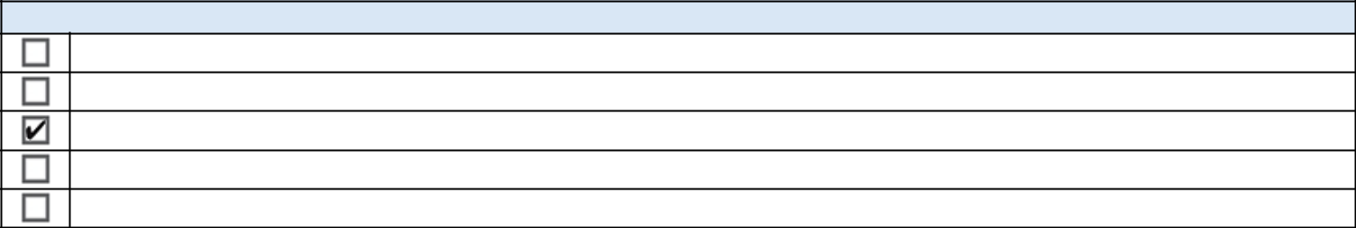

Preliminary Proxy Statement

CONFIDENTIAL, FOR USE OF THE COMMISSION ONLY (AS PERMITTED BY RULE 14a-6(e)(2))

Definitive Proxy Statement

Definitive Additional Materials

Soliciting Material Pursuant to ss.240.14a-12

GENERAL MOTORS COMPANY

(Name of Registrant as Specified In Its Charter)

(Name of Person(s) Filing Proxy Statement, if other than the Registrant)

Payment of Filing Fee (Check the appropriate box):
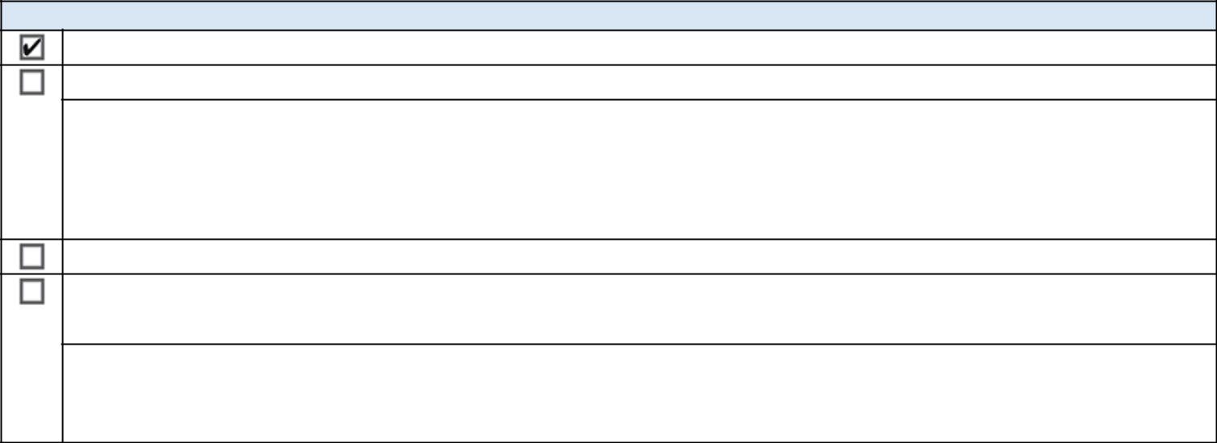

No fee required.

Fee computed on table below per Exchange Act Rules 14a-6(i)(4) and 0-11.

- Title of each class of securities to which transaction applies:

- Aggregate number of securities to which transaction applies:

- Per unit price or other underlying value of transaction computed pursuant to Exchange Act Rule 0-11 (set forth the amount on which the filing fee is calculated and state how it was determined):

- Proposed maximum aggregate value of transaction:

- Total fee paid:

Fee paid previously with preliminary materials.

Check box if any part of the fee is offset as provided by Exchange Act Rule 0-11(a)(2) and identify the filing for which the offsetting fee was paid previously. Identify the previous filing by registration statement number, or the Form or Schedule and the date of its filing.

- Amount Previously Paid:

- Form, Schedule or Registration Statement No.:

- Filing Party:

- Date Filed:

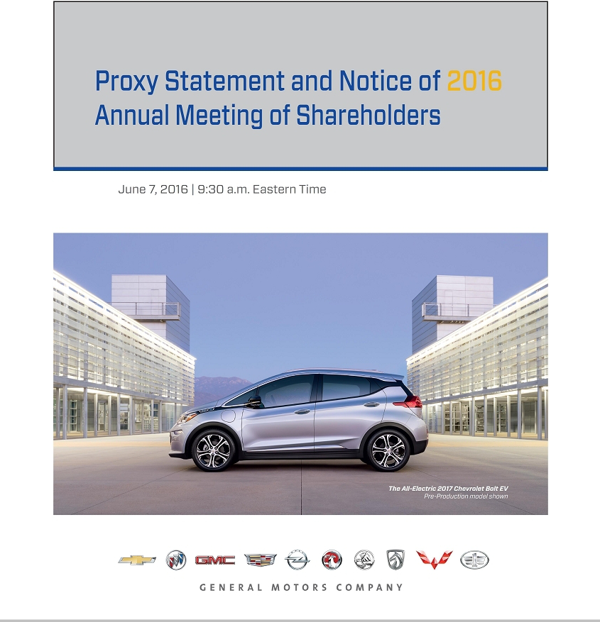

WHO WE ARE AND WHY WE ARE HERE...

We earn customers for life.

We build brands that inspire passion and loyalty.

We translate breakthrough technologies into vehicles people love.

We serve and improve the communities in which we live and work.

We are building the most valued automotive company.

Letter From the Chairman & Chief Executive Officer

Dear Fellow Shareholder:

I am pleased to invite you to attend our 2016 Annual Meeting of Shareholders.

Key to Our Success

The key to our success is placing the customer at the center of everything we do, from safety and quality to design and connectivity. We strive to earn customers for life with brands that inspire passion and loyalty and with breakthrough technologies and experiences that people love. By satisfying our current customers and winning new ones on the strength of our latest cars, trucks and crossovers, we achieved solid financial results in 2015. This strong performance enabled us to reinvest in our business, including in the technology and advanced mobility solutions our customers expect and demand. Importantly, it also enabled us to increase shareholder returns through dividends and our expanded share repurchase program.

Strategic Plan

Our strategic plan, endorsed by the Board of Directors, is to continue strengthening our core business and to take advantage of this strength to define and lead the future of personal mobility. Around the world, social and technological changes are rapidly transforming personal transportation. I believe the automotive industry will change more in the next five years than it has in the previous 50 years. We’re excited by this kind of disruption and are working to lead it. To this end, we are leveraging our 1.2 billion OnStar customer interactions, we are leading the industry in 4G LTE connectivity, we launched Maven, our unified car-sharing program, we announced a strategic alliance with Lyft Inc., the fastest-growing ridesharing company in the U.S., and we have announced our intent to acquire Cruise Automation, Inc., a leader in autonomous technology. Later this year, we will launch the groundbreaking, all-electric Chevrolet Bolt EV, featured on the front cover of this Proxy Statement, and next year we will introduce “Super Cruise” hands-free highway driving automation technology in the 2017 Cadillac CT6.

Board Alignment

Our Board and leadership team are confident that our strategic plan will enable us to lead in the transformation of personal mobility. The Board fully supports our focus on optimizing long-term financial returns for our shareholders by increasing profitability in our core business, taking advantage of growth opportunities and driving innovation through this period of disruption and change.

The Board has the right mix of relevant expertise and experience to oversee and guide the leadership team as we execute our strategic plan. The Board’s diversity and independence foster the wide range of thought and perspective that is critical to the Company’s success. Establishing a best-in-class governance and compensation environment is a priority for the Board. We’ve highlighted our key accomplishments in governance for 2015 in the pages that follow.

Shareholder Outreach

Over the past year, I have met with many of you through our expanded investor engagement program, which has enabled the GM leadership team and Board to meet and solicit feedback and share information with shareholders. Both GM and the Board benefit greatly from the insights, experiences and ideas exchanged during these engagements, and I look forward to continuing them in the year ahead.

Thank you for your support and interest in GM.

Sincerely,


Mary T. Barra

Chairman & Chief Executive Officer

Letter From the Independent Lead Director

Dear Fellow Shareholder:

General Motors Company is committed to sound corporate governance policies and practices that are designed and routinely assessed to enable the Company to operate its business responsibly, with integrity, and in the best interests of its shareholders. I want to take this opportunity to highlight the significant governance developments at GM over 2015 and early 2016. They are also described in more detail in this Proxy Statement.

Board Leadership Structure

On January 4, 2016, our Board recombined the positions of Chairman and CEO under the leadership of Mary T. Barra and designated me as the Board’s Independent Lead Director. The Board concluded that it was in the best interests of the Company and its shareholders to combine the roles of Chairman and CEO at this time to drive the most efficient execution of our strategic plan and realize our vision for the future. At the same time, our Board strengthened the responsibilities of the Lead Director role, which are described in GM’s Corporate Governance Guidelines and in this Proxy Statement, to include additional duties that further promote independent, objective oversight by the non-employee directors. With these changes, the Board has adopted the right governance structure, with the right leaders and oversight, to drive shareholder value now and in the future.

Board Refreshment

The Board continues to recruit new directors to bring fresh perspectives and new ideas into the GM Boardroom. In 2015, we added two new directors: Linda R. Gooden, retired Executive Vice President, Information Systems & Global Solutions, Lockheed Martin Corporation, and Joseph Jimenez, CEO, Novartis AG. This year, we are pleased to announce the nomination of Jane L. Mendillo for election to the Board. Jane is the retired President and CEO of Harvard Management Company and brings a seasoned finance perspective and extensive investment management experience to our Board.

Shareholder Engagement and Proxy Access

To strengthen our commitment to receiving investor feedback, the Board has adopted a Director-Shareholder Engagement Policy that promotes proactive and productive engagement between directors and shareholders. Over the course of 2015 and through 2016, members of our Board have had and will continue to have direct conversations with investors on matters that are important to them, as well as matters on which GM wishes to share information or seek input.

In mid-2015, our Board began considering whether it would be appropriate to proactively adopt proxy access to provide our shareholders greater ability to have their voices heard through nomination of director candidates. Our process included a review of best practices, trends among other large public companies adopting proxy access and an extensive engagement process with shareholders. Reflective of our commitment to an active engagement process, the Board considered feedback from our shareholders and tailored certain aspects of the Company’s proxy access bylaw, which was adopted recently, based on that feedback.

Board Oversight

Board and Committee meetings regularly devote substantial time to GM’s strategic priorities, focusing on assessing the Company’s progress to date, as well as on strategic initiatives and risks over the short and long term. The Board believes that although short-term performance is important, it should be assessed in the context of the Company’s long-term goals.

As Lead Director, it is my privilege to work alongside engaged Board members who bring exceptional knowledge, perspective and commitment into the GM Boardroom. The robust debate around strategic priorities and initiatives that takes place at every Board meeting is evidence of the Board’s proactive oversight and guidance of management through this time of rapid industry change.

On behalf of the entire Board, thank you for your continued support.

Sincerely,
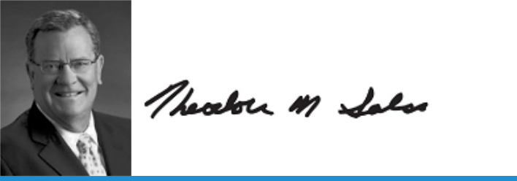

Theodore M. Solso

Independent Lead Director

Notice of 2016 Annual Meeting of Shareholders

Meeting Information:


Date: Tuesday, June 7, 2016

Time: 9:30 a.m. Eastern Time

Place: General Motors Global Headquarters
300 Renaissance Center
Detroit, Michigan 48265

April 22, 2016

Dear Fellow Shareholder:

You are cordially invited to attend the Annual Meeting of Shareholders of

General Motors Company. At the meeting you will be asked to:

- Elect the 12 director nominees named in this Proxy Statement;

- Approve, on an advisory basis, Named Executive Officer (“NEO”) compensation;

- Ratify the selection of Deloitte & Touche LLP as the Company’s independent registered public accounting firm for 2016;

- Vote on a Rule 14a-8 shareholder proposal; and

- Transact any other business that is properly brought before the meeting.

Record Date

Your vote is important. So that your shares will be represented and voted at the meeting, please submit your vote as soon as possible by one of the following methods:


Using the Internet at www.proxyvote.com


Scanning this QR code to vote with your mobile device

You are entitled to vote at the meeting if you were a holder of record of GM

common stock at the close of business on April 8, 2016.

Attending the Annual Meeting

If you plan to attend the Annual Meeting, please follow the instructions on | Calling toll-free 1-800-690-6903
page 73 of this Proxy Statement.


Webcast

Our Annual Meeting will be audio webcast on June 7, 2016 and may be accessed at www.gm.com/gmannualmeeting. Additional information regarding the audio webcast may be found on page 73.

Thank you for your interest in GM.

By Order of the Board of Directors,
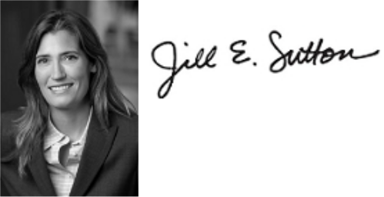

Jill E. Sutton

Corporate Secretary and

Deputy General Counsel, Corporate, Finance

and Strategic Transactions


Mark, sign, date, and return the proxy card or voting instruction form.

We are first furnishing these proxy materials to our shareholders on or about April 22, 2016.

How You Can Access the Proxy Materials Online

Important Notice Regarding the Availability of Proxy Materials for the 2016 GM Annual Meeting of Shareholders to Be Held on June 7, 2016. For additional information regarding Notice and Access, see page 72.

Our Proxy Statement and Annual Report to Shareholders are available at www.gm.com/proxymaterials. | www.gm.com/proxymaterials
You may visit this website or scan the QR code with your smartphone or other mobile device to view our
interactive Proxy Statement or to view the Annual Report.

This page intentionally left blank.

This Proxy Statement is provided in connection with the solicitation of proxies, by order of the Board of Directors of General Motors Company, to be used at the 2016 Annual Meeting of Shareholders of the Company.

In addition to this Proxy Statement and the proxy card or voting instruction form, the GM 2015 Annual Report is provided in this package or is available through the Internet.

Table of Contents

PROXY STATEMENT SUMMARY | 6
ITEM NO. 1 — ELECTION OF DIRECTORS | 9
Director Election Requirements | 9
Director Nomination Process | 9
Nominees for Director | 11
Non-Employee Director Compensation | 18
Director Stock Ownership and Holding Requirements | 20
CORPORATE GOVERNANCE | 21
Role of Board of Directors | 21
Board Size | 21
“Winning With Integrity” and Code of Ethics | 21
Corporate Governance Guidelines | 21
Director Independence | 22
Board Leadership Structure | 22
Executive Sessions | 24
Board Committees | 24
Access to Outside Advisors | 27
Board Meetings and Attendance | 27
Board and Committee Oversight of Risk | 27
Succession Planning and Leadership Development | 28
Board and Committee Evaluations | 29
Annual Evaluation of CEO | 29
Director Orientation and Continuing Education | 29
Service on Other Public Company Boards | 30
Compensation Committee Interlocks and Insider Participation | 30
Shareholder Protections | 30
Shareholder Communication With the Board | 30
Certain Relationships and Related Party Transactions | 31
Engagement Program | 31
Sustainability | 32
Public Policy Engagement | 32
SECURITY OWNERSHIP INFORMATION | 33
Security Ownership of Directors, Named Executive Officers, and Certain Other Beneficial Owners | 33
Stockholders Agreement | 34
Section 16(a) Beneficial Ownership Reporting Compliance | 34
EXECUTIVE COMPENSATION | 35
Compensation Discussion and Analysis | 35
Compensation Overview | 36
2015 Compensation Elements | 41
Performance Measures for 2015 | 42
2015 Performance Results and Compensation Decisions | 46
Compensation Policies and Governance Practices | 52
Compensation Committee Report | 53
Executive Compensation Tables | 54
Equity Compensation Plan Information | 62
ITEM NO. 2 — Approve, on an Advisory Basis, Named Executive Officer Compensation | 63
ITEM NO. 3 — Ratification of the Selection of Deloitte & Touche LLP as the Company’s Independent | 64
Registered Public Accounting Firm for 2016 | 64
Audit Committee Report | 65
Fees Paid to Independent Registered Public Accounting Firm | 66
ITEM NO. 4 — Shareholder Proposal Regarding Implementation of Holy Land Principles for Employment in | 67
Palestine-Israel | 67

Questions and Answers | 69
Proxy Materials and Voting Information | 69
Annual Meeting Information | 72
Shareholder Proposals and Company Information | 74

Back to Contents
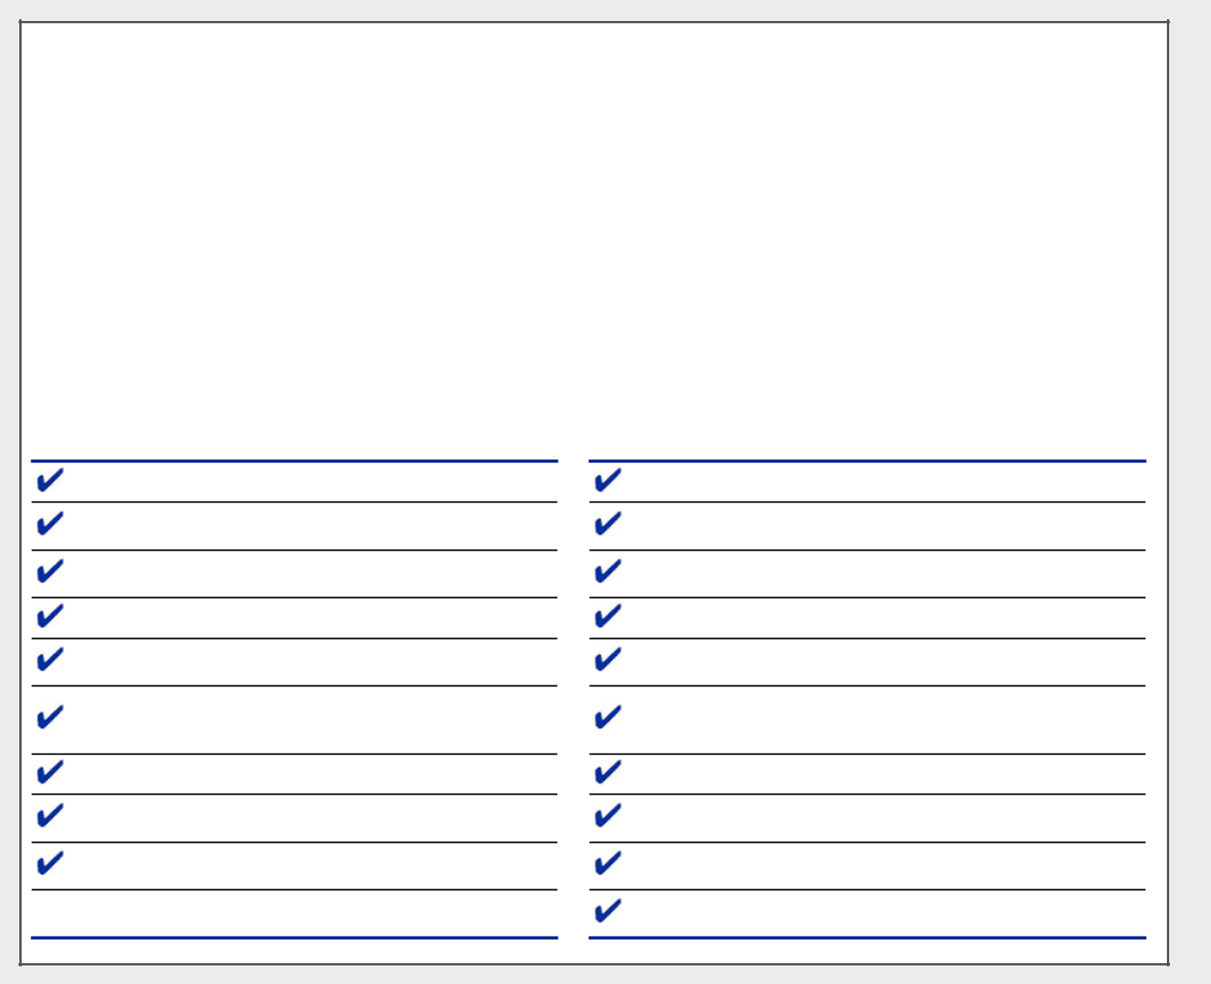

Proxy Statement Summary

This summary highlights information contained elsewhere in this Proxy Statement. It does not contain all of the information that you should consider. Please read the entire Proxy Statement carefully before voting.

Voting Recommendations

 |  | Board
Proposals: |  | Recommendation | Page
1. | Election of directors | FOR ALL | 9
2. | Approve, on an advisory basis, NEO compensation | FOR | 63
3. | Ratification of the selection of Deloitte & Touche LLP as the Company’s independent registered | FOR | 64
 | public accounting firm for 2016
4. | Shareholder proposal regarding Implementation of Holy Land Principles for Employment in | AGAINST | 67
 | Palestine-Israel

Governance Highlights

At least two-thirds of Board independent

Annual election of all directors

Majority voting with director resignation policy

Annual evaluation of CEO by Board

Annual Board and Committee self-evaluations and extensive individual Board member evaluations every five years

Audit, Governance and Corporate Responsibility, and Executive Compensation Committees composed entirely of independent directors

“Overboarding” limits

Diverse Board in terms of gender, ethnicity, and specific skills and qualifications

Director-Shareholder Engagement Policy

Regular executive session of non-management directors

Orientation program for new directors and continuing education for all directors

Robust stock ownership for executive officers and non-employee directors

Risk oversight by full Board and Committees

Shareholder right to call special meetings

Board and Committees may hire outside advisors independently of management

Proxy access

Strong Independent Lead Director with clearly delineated duties

Advisory vote on executive compensation (“Say-on-Pay”) over 97% each year since implemented

Over 70% of CEO target compensation is performance based and 90% is pay-at-risk

 | 2016 PROXY STATEMENT |  | 6

Back to Contents
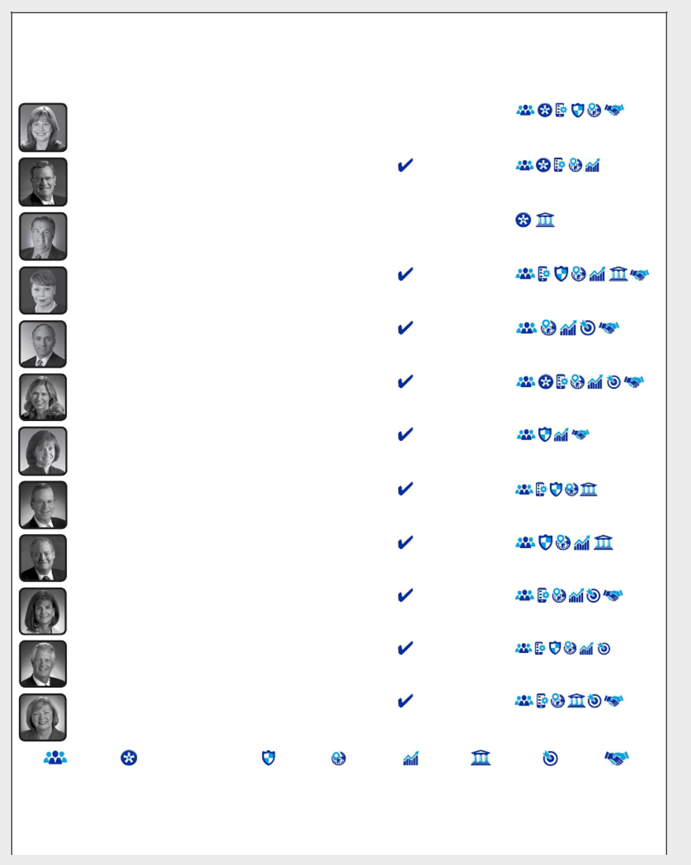

The Board’s Nominees for Director

The Board recommends a vote FOR the election of each of the following nominees for director:

 |  |  |  |  |  |  | Director |  |  | Committee |  | Skills and
 |  |  | Name |  |  | Age⁽¹⁾ | Since | Independent |  | Membership⁽²⁾ |  | Qualifications
 |  |  | Mary T. Barra |  | 54 |  | 2014 |  |  | EC (Chair)
 |  |  | Chairman & Chief Executive Officer, General
 |  |  | Motors Company
 |  |  | Theodore M. Solso |  | 69 |  | 2012 |  |  | EC
 |  |  | Independent Lead Director, General Motors
 |  |  | Company, and Retired Chairman and Chief
 |  |  | Executive Officer, Cummins, Inc.
 |  |  | Joseph J. Ashton |  | 67 |  | 2014 |  |  | FC, RC
 |  |  | Retired Vice President, United Auto Workers
 |  |  | Linda R. Gooden |  | 63 |  | 2015 |  |  | AC, RC
 |  |  | Retired Executive Vice President, Information
 |  |  | Systems & Global Solutions, Lockheed Martin
 |  |  | Corporation
 |  |  | Joseph Jimenez |  | 56 |  | 2015 |  |  | ECC, GCRC
 |  |  | Chief Executive Officer, Novartis AG
 |  |  | Kathryn V. Marinello |  | 59 |  | 2009 |  |  | AC, GCRC,
 |  |  | Senior Advisor, Ares Management LLC |  |  |  |  |  |  | FC
 |  |  | Jane L. Mendillo |  | 57 |  | — |  |  | —
 |  |  | Retired President and Chief Executive Officer,
 |  |  | Harvard Management Company
 |  |  | Admiral Michael G. Mullen |  | 69 |  | 2013 |  |  | AC, EC, RC
 |  |  | Former Chairman, Joint Chiefs of Staff |  |  |  |  |  |  | (Chair)
 |  |  | James J. Mulva |  | 69 |  | 2012 |  |  | EC, ECC, FC
 |  |  | Retired Chairman and Chief Executive Officer, |  |  |  |  |  |  | (Chair), RC
 |  |  | ConocoPhillips
 |  |  | Patricia F. Russo |  | 63 |  | 2009 |  |  | EC, ECC,
 |  |  | Chairman, Hewlett Packard Enterprise Company |  |  |  |  |  |  | FC, GCRC
 |  |  |  |  |  |  |  |  |  | (Chair)
 |  |  | Thomas M. Schoewe |  | 63 |  | 2011 |  |  | AC (Chair),
 |  |  | Retired Executive Vice President and Chief |  |  |  |  |  |  | EC, FC, RC
 |  |  | Financial Officer, Wal-Mart Stores, Inc.
 |  |  | Carol M. Stephenson |  | 65 |  | 2009 |  |  | EC, ECC
 |  |  | Retired Dean, Ivey Business School, The |  |  |  |  |  |  | (Chair),
 |  |  | University of Western Ontario |  |  |  |  |  |  | GCRC
 |  | Senior | Industry | Technology | Risk |  | Global |  | Finance | Government | Marketing |  | Diversity
 |  | Leadership |  | Management
 | (1) Age as of April 22, 2016.
 | (2) Board Committees:
 |  | AC - Audit Committee |  | ECC - Executive Compensation Committee |  |  |  | GCRC - Governance and Corporate Responsibility Committee
 |  | EC - Executive Committee |  | FC - Finance Committee |  |  |  | RC - Risk Committee
 |  |  |  |  |  | 2016 PROXY STATEMENT |  |  |  |  |  |  | 7

Back to Contents

This page intentionally left blank.

Back to Contents

ITEM NO. 1 – ELECTION OF DIRECTORS

Director Election Requirements

Our Board is elected annually by our shareholders. Upon the recommendation of the Governance and Corporate Responsibility Committee (“Governance Committee”), our Board has nominated each of the 12 persons identified below to serve as director for a one-year term or until his or her successor has been duly elected and qualified or until his or her earlier resignation or removal. Each director nominee who receives a majority of the votes cast (i.e., the number of shares voted FOR a director nominee must exceed the number of shares voted AGAINST that director nominee, excluding abstentions) will be elected as director in this uncontested election. If any nominee becomes unable to serve, proxies will be voted for the election of such other person as the Board of Directors may designate, unless the Board chooses to reduce the number of directors.

Stephen J. Girsky has elected to retire from the Board effective as of the Annual Meeting and is not standing for re-election.

Other than Jane L. Mendillo, all directors were elected at the 2015 Annual Meeting. The Board’s nomination of Ms. Mendillo followed completion of our standard candidate evaluation procedures, which include identification and evaluation of potential candidates by a search firm engaged by the Governance Committee, candidate interviews by a subcommittee of the Governance Committee, and interviews with other members of the Board.

Director Nomination Process

The Governance Committee is responsible for recommending nominees to the Board annually. In determining whether to recommend a director for re-election, the Governance Committee considers a number of factors, including the director’s history of attendance and participation in meetings, other contributions to the activities of the Board and GM, active participation in orientation and ongoing educational events, the results of Board self-evaluations and any potential or actual conflicts of interest.

The Board nominates directors upon the recommendation of the Governance Committee. The Governance Committee annually reviews with the Board the appropriate skills and characteristics needed for the Board to effectively perform its oversight function. Board nominees are then selected, whether existing or new, after considering current Board composition, Company strategy and other relevant facts and circumstances.

The selection of qualified directors is complex and crucial to our long-term success. The Governance Committee and the Board set different priorities for recruiting new Board members at different times, depending on the Company’s needs and the makeup of the Board. In every case, however, candidates for Board election must be able to contribute significantly to the Board’s discussion and decision-making on the broad array of complex issues facing the Company. The Governance Committee sometimes engages search firms to help identify and evaluate candidates. Recently, our recruiting efforts have been particularly directed toward identifying candidates who have distinguished themselves as leaders of large, complex organizations with strong expertise in technology, strategy, finance, and global investment management.

 | 2016 PROXY STATEMENT |  | 9

Back to Contents

Potential candidates meeting these priorities are further evaluated on criteria that include:

Significant leadership experience over an extended period, especially as CEO; extraordinary leadership qualities; and the ability to identify and develop those qualities in others.


Leadership experience in the automotive and related industries.

Understanding of technology and innovation.

Relevant risk management experience and oversight.

Global business and cultural experience.


Expertise in complex financial and accounting matters.

Knowledge of global government relations, public policy, and regulatory matters.

Marketing experience, including digital marketing, brand and product awareness; social media experience.

Diversity of perspective, professional experience, age, and background, such as gender, race, ethnicity, and country of origin.

In assessing potential candidates, the Governance Committee considers individuals with a broad range of business experience and varied backgrounds. Although GM does not have a formal policy governing diversity among Board members, we continually strive to add directors of diverse backgrounds. We recognize the value of overall diversity and consider members’ opinions, perspectives, personal and professional experiences, and backgrounds, including gender, race, ethnicity, and country of origin, when considering Board candidates. We believe that the judgment and perspectives offered by a diverse board of directors improves the quality of decision-making and enhances the Company’s business performance. We also believe such diversity can help the Board respond more effectively to the needs of customers, shareholders, employees, suppliers, and other stakeholders worldwide.

Pursuant to the Stockholders Agreement dated October 15, 2009 between the Company and the UAW Retiree Medical Benefits Trust (the “VEBA Trust”), the VEBA Trust has the right to designate one nominee to our Board, subject to the consent of the UAW and approval by the Board (the Board may not withhold its approval unreasonably). The VEBA Trust has designated Mr. Ashton, who has been recommended by the Governance Committee and nominated by the Board as part of the slate of candidates it recommends for election at the Annual Meeting.

The Governance Committee will consider persons recommended by shareholders for election to the Board. To recommend an individual for Board membership, write to Jill E. Sutton, Corporate Secretary and Deputy General Counsel, Corporate, Finance and Strategic Transactions (“Corporate Secretary and Deputy General Counsel”) of our Company, at the mailing address or e-mail address provided on page 74 in “How can I obtain the Company’s corporate governance information?” The Governance Committee will review the qualifications and experience of each recommended candidate using the same criteria for candidates proposed by Board members and communicate its decision to the candidate or the person who made the recommendation.

GM has received notice pursuant to our Bylaws that a shareholder owning two shares of our common stock intends to nominate candidates for election to the Board at the 2016 Annual Meeting. The Board has determined in its reasonable judgment that this is not considered a contested election, and therefore, majority voting will apply. The Governance Committee evaluated these candidates as discussed above, and the Proxy Committee appointed by the Board intends to vote against the election of these candidates.

 | 2016 PROXY STATEMENT |  | 10

Back to Contents

Nominees for Director

Your Board recommends a vote FOR all of the nominees listed below.
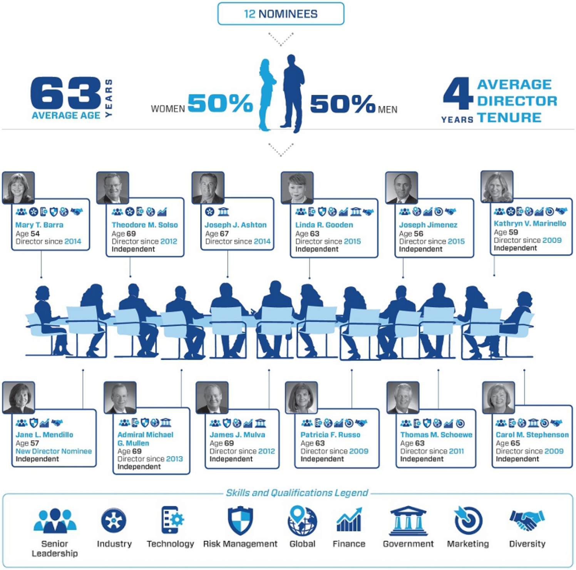

 | 2016 PROXY STATEMENT |  | 11

Back to Contents

- Information About Nominees for Director

Set forth below is information about our nominees, including their name and age, recent employment or principal occupation, their period of service as a GM director, the names of other public companies for which they currently serve as a director or have served as a director within the past five years, and a summary of their specific experience, qualifications, attributes, and skills that led to the conclusion that they are qualified to serve as a director on our Board at this time.


Mary T. Barra, Chairman & Chief Executive Officer, General Motors Company

Age: 54

Director Since: 2014

Committees: Executive (Chair)

Current Public Company Directorships: General Dynamics Corporation

Ms. Barra was elected Chairman of the GM Board of Directors on January 4, 2016. She has served as CEO of GM since January 15, 2014, when she also became a member of GM’s Board. Prior to becoming CEO, Ms. Barra served as Executive Vice President, Global Product Development, Purchasing and Supply Chain since August 2013. She served as Senior Vice President, Global Product Development, from 2011 to 2013; Vice President, Global Human Resources, from 2009 to 2011; and Vice President, Global Manufacturing Engineering, from 2008 to 2009.

Reasons for Nomination:

With more than 35 years at GM and having served in various leadership roles prior to becoming Chairman and CEO of the Company, Ms. Barra brings to our Board an in-depth knowledge of the Company and the global automotive industry. She has extensive leadership, strategic planning, operating and business experience and a deep understanding of the Company’s strengths, weaknesses, risks, and challenges. Under her leadership, GM is working to lead the transformation of personal mobility through advanced technologies such as connectivity, alternative propulsion, and autonomous driving. She has also established GM’s corporate culture and strategic direction based on putting the customer at the center of everything we do, all around the world, with quality and safety as foundational commitments.

As Chairman and CEO, Ms. Barra is able to focus the Board’s oversight and drive the most efficient execution of GM’s plan and vision for the future. In addition to her demonstrated leadership and management skills, Ms. Barra’s strong engineering background and leadership experience in global product development enables her to provide significant insight to the Board on one of the most critical and complex parts of GM’s business. Her previous leadership roles in purchasing and supply chain, human resources, and manufacturing engineering also allow her to contribute to Board deliberations on matters regarding those key areas of the Company. Ms. Barra’s service to GM and experience in serving as a director of another large public company with complex, global operations provides her with an extensive understanding of the governance and management matters that large public companies face.


Theodore M. Solso, Independent Lead Director, General Motors Company and Retired Chairman and Chief Executive Officer, Cummins, Inc.
Age: 69

Director Since: 2012

Committees: Executive

Current Public Company Directorships: Ball Corporation (Lead Director)

Prior Public Company Directorships: Ashland Inc. (1999 to 2012), where he was Lead Director from 2003 to 2010

Mr. Solso has served as the Independent Lead Director of our Board since January 4, 2016. Mr. Solso had been the Non-Executive Chairman of our Board of Directors since January 2014. He served as Chairman and Chief Executive Officer of Cummins, Inc., a global manufacturer of diesel and natural gas engines and engine-related component products, from 2000 until his retirement in 2011. Prior to becoming Chairman and CEO, Mr. Solso held various other senior management roles, including President and Chief Operating Officer from 1995 through 1999 and Vice President in charge of Cummins’ engine business from 1988 to 1995.

Reasons for Nomination:

Mr. Solso gained significant senior management experience during his 40-year career at Cummins, which culminated in his role as Chairman and CEO. He brings to our Board his experience and insight into the complexities of managing a major global organization. Mr. Solso led Cummins through strong financial performance and shareholder returns, international growth, business restructuring, and leadership in emissions reduction technology and related environmental activities, corporate responsibility, diversity, and human rights issues. His extensive experience in manufacturing and engineering of diesel engines and compliance with challenging emissions laws and regulations enables him to contribute significantly to Board deliberations regarding GM’s global product development strategies. His previous experience in serving as U.S. Chairman of the U.S.-Brazil CEO Forum provides valuable insight into advancing the business priorities of our operations in South America. In addition to his deep understanding of global markets and business operations and corporate responsibility, Mr. Solso brings to our Board his experience as a director of other large, global public companies, particularly in the areas of finance, accounting and corporate governance.

 | 2016 PROXY STATEMENT |  | 12

Back to Contents


Joseph J. Ashton, Retired Vice President, United Auto Workers

Age: 67

Director Since: 2014

Committees: Finance, Risk

Current Public Company Directorships: None

Mr. Ashton served as a Vice President of the International Union, United Automobile, Aerospace and Agricultural Workers of America (the “UAW”) from 2010 until his retirement in June 2014. Prior to that time, Mr. Ashton served as director of the UAW’s Region 9 (Central New York, New Jersey, and Pennsylvania) from 2006 to 2010 and as assistant director of Region 9 from 2003 to 2006. He had been a member of the UAW International staff since 1986. Mr. Ashton is active in labor and civic affairs, including previously serving as the Executive Vice President of the Pennsylvania AFL-CIO Executive Council and Executive Vice President of the New Jersey AFL-CIO. Under the terms of the Stockholders Agreement dated October 15, 2009, Mr. Ashton was designated for nomination to the GM Board by the VEBA Trust, of which he is a member of the Financial Committee.

Reasons for Nomination:

During his career with the UAW, Mr. Ashton played a key role in organizing campaigns and contract negotiations with major manufacturing and technology companies in a variety of industries including vehicle components, defense, aerospace, steel, and marine products. Based on these experiences, he has developed a deep understanding of how labor strategy can affect a company’s financial success, including expertise in areas such as manufacturing processes, pension and health care costs, government relations, employee engagement and training, and plant safety.


Linda R. Gooden, Retired Executive Vice President, Information Systems & Global
Solutions, Lockheed Martin Corporation
Age: 63

Director Since: 2015

Committees: Audit, Risk

Current Public Company Directorships: Automatic Data Processing, Inc., The Home Depot, Inc., WGL Holdings, Inc. (“WGL”), and Washington Gas

Light Company, a subsidiary of WGL

Ms. Gooden served as Executive Vice President, Information Systems & Global Solutions (“IS&GS”) of Lockheed Martin Corporation (“Lockheed”) from 2007 to 2013; Deputy Executive Vice President, Information and Technology Services from October to December 2006; and President, Information Technology from 1997 to December 2006.

Reasons for Nomination:

Ms. Gooden brings to our Board her strong leadership capability demonstrated through her various senior leadership positions at Lockheed. She has significant operations and strategic planning expertise and an extensive background in information technology (“IT”). Under her leadership as Executive Vice President of IS&GS, Lockheed expanded its IT capabilities beyond government customers to international and commercial markets. In her role as President of Lockheed’s IT division, Ms. Gooden grew the business to become a multibillion-dollar business. Her deep knowledge of IT adds a valuable perspective to our Board deliberations regarding GM’s IT transformation, cybersecurity matters, and various technology systems and processes. Moreover, Ms. Gooden brings to our Board her experience in business restructuring, finance, cybersecurity, and risk management. She also brings her experience as a director at other public companies, particularly in the areas of finance, audit, strategic investments, acquisitions, and divestitures.

 | 2016 PROXY STATEMENT |  | 13

Back to Contents


Joseph Jimenez, Chief Executive Officer, Novartis AG

Age: 56

Director Since: 2015

Committees: Executive Compensation, Governance and Corporate Responsibility

Current Public Company Directorships: None

Prior Public Company Directorships: Colgate-Palmolive Company (2010 to 2015)

Mr. Jimenez has been Chief Executive Officer of Novartis AG (“Novartis”) since 2010. He joined Novartis in April 2007 as Head of the Consumer Health Division, and in October 2007, he became Head of the Pharmaceuticals Division, where he served until 2010. Prior to joining Novartis, Mr. Jimenez served as an Advisor to the Blackstone Group L.P., a private equity firm, from 2006 to 2007. He was President and Chief Executive Officer of H. J. Heinz Company (“Heinz”) North America from 2002 to 2006 and Executive Vice President, President and Chief Executive Officer of Heinz Europe from 1999 to 2002. From 1993 to 1998, Mr. Jimenez held various leadership positions at ConAgra Foods Inc. (“ConAgra”), including President and Senior Vice President of two operating divisions. He began his career in 1984 at The Clorox Company, where he held a number of progressive roles in marketing and brand management.

Reasons for Nomination:

Mr. Jimenez brings to our Board significant international and operational leadership, strategic planning, and business and finance experience gained through his role as Chief Executive Officer of Novartis, a complex, global company in a highly regulated industry, and President of various operating divisions at Heinz and ConAgra. Mr. Jimenez has a long track record in consumer businesses, which enables him to bring a consumer orientation and valuable insight to Board deliberations regarding our strategy to earn customers for life. Moreover, he has business restructuring expertise, and he executed significant business transformations at both Heinz and Novartis, which will enable him to make a significant contribution to our Board as we continue to evaluate the structure of our global business. Mr. Jimenez also brings to our Board his prior experience as a director of another large, global public company.


Kathryn V. Marinello, Senior Advisor, Ares Management LLC

Age: 59

Director Since: 2009

Committees: Audit, Governance and Corporate Responsibility, Finance

Current Public Company Directorships: AB Volvo and Nielsen Holdings N.V.

Ms. Marinello has served as Senior Advisor of Ares Management LLC (“Ares”), a global asset manager, since rejoining the company in March 2014. Prior to that, she served as Chairman and Chief Executive Officer of Stream Global Services, Inc. (“Stream”), a global business process outsource service provider specializing in customer relationship management, since August 2010. Ms. Marinello served as senior advisor and consultant at Providence Equity Partners LLC, a private equity firm, and Ares from June to August 2010. She served as Chairman and Chief Executive Officer of Ceridian Corporation, a human resources outsourcing company, from December 2007 to January 2010 and President and Chief Executive Officer from 2006 to 2007. Prior to joining Ceridian, Ms. Marinello spent 10 years at General Electric Company (“GE”), serving in a variety of senior roles, including President and Chief Executive Officer of GE Fleet Services, a division of GE, from 2002 to 2006.

Reasons for Nomination:

Ms. Marinello’s experience at large, complex service companies in various industries enables her to bring a varied perspective to our Board. As Chairman and CEO of Stream, she was focused on using information technology to enhance customer service, an area that is key to GM’s long-term business strategy. At Ceridian, she led a business service company providing integrated human resource systems, that involved a wide range of issues including audit and financial reporting, compliance and controls, and mergers and acquisitions. As the former President and CEO of GE Fleet Services, Ms. Marinello has significant experience with vehicle fleet sales and financing and dealer relations, which enables her to bring the customer perspective to Board decision-making. Moreover, at GE Capital, as well as in her prior roles at Chemical Bank, Citibank, and First Bank Systems, Inc., Ms. Marinello operated large consumer financial services divisions, which included auto lending, auto warranty, telematics, and auto insurance companies, further broadening her contributions to our Board. She also brings her experience as a director of other large, global public companies.

 | 2016 PROXY STATEMENT |  | 14

Back to Contents


Jane L. Mendillo, Retired President and Chief Executive Officer, Harvard Management Company

Age: 57

New Director Nominee

Current Public Company Directorships: Lazard Ltd

Ms. Mendillo served as President and Chief Executive Officer of the Harvard Management Company (“HMC”) from 2008 to 2014, where she managed Harvard University’s approximately $37 billion global endowment and related assets. From 2002 to 2008, she served as the Chief Investment Officer of Wellesley College. Prior to that, Ms. Mendillo spent 15 years at HMC in various investment roles. She serves as chair of the investment committee of the Partners Healthcare System, is a member of the board of directors and investment committees of the Mellon Foundation and the Boston Foundation, and serves as a Senior Investment Advisor to the Old Mountain Private Trust Company.

Reasons for Nomination:

Ms. Mendillo brings to the Board valuable financial perspective and extensive investment management experience. In addition, she brings to our Board strong senior leadership and risk management experience, as well as capital markets expertise, from her over 30 years in the endowment and investment management field. As President and CEO of HMC, she successfully led the company through the financial crisis, repositioning the endowment and reestablishing a world-class investment platform to support Harvard’s future educational and research goals. As the Chief Investment Officer of Wellesley College, she built the college’s first investment office and delivered substantial growth in the college endowment through a period of rapidly changing market conditions. Ms. Mendillo’s background and extensive experience will enable her to make a significant contribution in the Board’s oversight of GM’s strategic initiatives and varied financial and risk management issues.


Admiral Michael G. Mullen, Former Chairman, Joint Chiefs of Staff

Age: 69

Director Since: 2013

Committees: Audit, Executive, Risk (Chair)

Current Public Company Directorships: Sprint Corporation

Admiral Mullen served as the 17th Chairman of the Joint Chiefs of Staff from October 2007 until his retirement in 2011. Previously, he served as the 28th Chief of Naval Operations (“CNO”) from July 2005 to 2007. CNO was one of four different four-star assignments Admiral Mullen held; the other three included Commander, U.S. Naval Forces Europe, Commander, Allied Joint Force Command, and the 32nd Vice Chief of Naval Operations. Since 2012, Admiral Mullen has served as President of MGM Consulting LLC and is the Charles and Marie Robertson Visiting Professor at the Woodrow Wilson School of Public and International Affairs at Princeton University.

Reasons for Nomination:

Admiral Mullen brings to our Board extensive senior leadership experience gained over his 43-year career in the U.S. military. As Chairman of the Joint Chiefs of Staff, the highest-ranking officer in the U.S. military, Admiral Mullen led the armed forces during a critical period of transition, overseeing two active war zones. His involvement in key aspects of U.S. diplomacy, including forging vital relationships with diverse countries around the world, brings valuable insight to our Board as we continue to evaluate the structure of our global business. In addition to having strong global relationships, Admiral Mullen has deep experience in leading change in complex organizations, risk management, crisis management, executive development and succession planning, diversity implementation, strategic planning, budget policy, cybersecurity, and technical innovation, all of which are important to the oversight of GM’s strategic initiatives. This depth of experience enables him to make a significant contribution to our Board. Admiral Mullen also brings his experience as a director of another large public company.

 | 2016 PROXY STATEMENT |  | 15

Back to Contents


James J. Mulva, Retired Chairman and Chief Executive Officer, ConocoPhillips

Age: 69

Director Since: 2012

Committees: Executive, Executive Compensation, Finance (Chair), Risk

Current Public Company Directorships: General Electric Company

Prior Public Company Directorships: Statoil ASA (2013 to 2015)

Mr. Mulva served as Chairman and Chief Executive Officer of ConocoPhillips, an international integrated oil and gas company, from 2004 until his retirement in 2012; Chairman, President and Chief Executive Officer from 2004 to 2008; and President and Chief Executive Officer from 2002 to 2004.

Reasons for Nomination:

Mr. Mulva brings to our Board 39 years of experience in the energy industry, first at Phillips Petroleum Company (“Phillips”) and then ConocoPhillips. Prior to overseeing the merger of Conoco and Phillips in 2002, Mr. Mulva served as Chairman and Chief Executive Officer of Phillips, where he also held various domestic and international senior management positions in finance, including Executive Vice President and Chief Financial Officer. As Chief Executive Officer of Phillips and later ConocoPhillips, Mr. Mulva oversaw mergers and acquisitions, business restructurings and negotiated joint ventures, positioning the company to compete in an increasingly challenging and highly competitive industry. Prior to his retirement from ConocoPhillips, Mr. Mulva oversaw the strategic repositioning of the company to split its fuel production and refining businesses. Mr. Mulva’s expertise in the energy industry provides valuable insight to our Board in developing GM’s long-term energy diversity strategy. Mr. Mulva also brings to our Board an in-depth background in finance and his experience as a director of other large, global public companies.


Patricia F. Russo, Chairman, Hewlett Packard Enterprise Company

Age: 63

Director Since: 2009

Committees: Executive, Executive Compensation, Finance, Governance and Corporate Responsibility (Chair)

Current Public Company Directorships: Alcoa Inc. (Lead Director), Hewlett Packard Enterprise Company (Chairman), KKR Management LLC (the managing partner of KKR & Co. L.P.), and Merck & Co. Inc.

Prior Public Company Directorships: Hewlett Packard Company (2011 to 2015), where she was Lead Director from 2014 to 2015

Ms. Russo has served as Chairman of Hewlett Packard Enterprise Company since November 2015, after the separation of Hewlett-Packard Company (“HP”) into two companies. She had been Lead Director of HP since 2014. She served as Chief Executive Officer of Alcatel-Lucent S.A. from 2006 to 2008. Prior to the merger of Alcatel S.A. (“Alcatel”) and Lucent Technologies, Inc. (“Lucent”) in 2006, she served as Chairman and Chief Executive Officer of Lucent from 2003 to 2006 and President and Chief Executive Officer from 2002 to 2003. Ms. Russo served as Lead Director of our Board from March 2010 to January 2014.

Reasons for Nomination:

As the chief executive officer of highly technical, global, complex companies, Ms. Russo demonstrated leadership that strongly supported her nomination to our Board. She dealt with a wide range of issues including mergers and acquisitions, technology disruptions and business restructuring as she led Lucent’s recovery through a severe industry downturn and later a merger with Alcatel, a French company. She has recently led the HP board of directors in connection with its split into two public companies, gaining valuable experience in connection with a highly complex business restructuring transaction. In addition, she brings to the Board extensive global experience in corporate strategy, finance, sales and marketing, technology, and leadership development. Ms. Russo also has extensive expertise in corporate governance and executive compensation as a member of the board and board committees of other large, global public companies.

 | 2016 PROXY STATEMENT |  | 16

Back to Contents
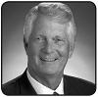

Thomas M. Schoewe, Retired Executive Vice President and Chief Financial Officer, Wal-
Mart Stores, Inc.
Age: 63

Director Since: 2011

Committees: Audit (Chair), Executive, Finance, Risk

Current Public Company Directorships: KKR Management LLC and Northrop Grumman Corporation

Prior Public Company Directorships: PulteGroup, Inc. (2009 to 2012)

Mr. Schoewe served as Executive Vice President and Chief Financial Officer of Wal-Mart Stores, Inc. (“Wal-Mart”) from 2000 to 2011. Prior to joining Wal-Mart, Mr. Schoewe worked for Black & Decker Corporation from 1986 to 1999, most recently serving as Senior Vice President and Chief Financial Officer.

Reasons for Nomination:

With extensive experience in finance, including serving as the chief financial officer of large multinational, consumer-facing companies, Mr. Schoewe brings financial expertise, corporate leadership, and operational experience to our Board. His extensive experience as a senior leader in corporate finance has provided him with key skills, including financial reporting, accounting and control, business planning and analysis, and risk management that are valuable to the oversight of our business. Mr. Schoewe also brings to our Board his experience at Wal-Mart and Black & Decker with large-scale, transformational information technology implementations, which provides valuable insight as we continue to restructure our IT operations. Further, Mr. Schoewe’s previous and current board positions at public companies involved with home building, security, and investments provides exposure to diverse industries with unique challenges enabling him to make a significant contribution to our Board.


Carol M. Stephenson, Retired Dean, Ivey Business School, The University of Western
Ontario
Age: 65

Director Since: 2009

Committees: Executive, Executive Compensation (Chair), Governance and Corporate Responsibility

Current Public Company Directorships: Ballard Power Systems, Inc., Intact Financial Corporation (formerly ING Canada), and Manitoba Telecom

Services

Ms. Stephenson served as Dean of the Ivey Business School at The University of Western Ontario (“Ivey”) from 2003 until her retirement in September 2013. Prior to joining Ivey, Ms. Stephenson served as President and Chief Executive Officer, Lucent Technologies Canada from 1999 to 2003. She was a member of the Advisory Board of General Motors of Canada, Limited (“GM Canada”), a GM subsidiary, from 2005 to 2009. Ms. Stephenson was appointed an Officer of the Order of Canada in 2009.

Reasons for Nomination:

Ms. Stephenson’s experience as Dean of Ivey and President and Chief Executive Officer of Lucent Technologies Canada provides our Board with diverse perspectives and progressive management expertise in marketing, operations, strategic planning, technology development, and financial management. Her experience on the boards of several top Canadian companies provides our Board with a broad perspective on successful management strategies and insight on matters affecting the business interests of GM and GM Canada. Ms. Stephenson also brings her experience in serving on the compensation and governance committees of other public companies.

 | 2016 PROXY STATEMENT |  | 17

Back to Contents

Non-Employee Director Compensation

We strive to provide a level of compensation we believe is necessary to attract and retain high-quality non-employee directors. Ms. Barra, our sole employee director, does not receive additional compensation for her Board service. Compensation for our non-employee directors is set by our Board at the recommendation of the Governance Committee.

The Governance Committee, which consists solely of independent directors, annually assesses the form and amount of non-employee director compensation and recommends changes, if appropriate, to the Board based upon competitive market practices. The Governance Committee reviews director compensation data for the same companies that comprise the peer group we use for benchmarking executive compensation described on page 38. The process for setting director pay is guided by the following principles:

- Fairly compensate directors for their responsibilities and time commitments;

- Attract and retain highly qualified directors by offering a compensation program consistent with those at companies having similar size, scope, and complexity;

- Align the interests of directors with our shareholders by providing a significant portion of compensation in equity and requiring directors to own our common stock (or common stock equivalents); and

- Provide compensation that is simple and transparent to shareholders.

In addition, the Governance Committee can engage the services of outside consultants, experts, and others to assist the Committee. During 2015, the Governance Committee did not engage any consultants in reviewing and setting director compensation.

- Annual Compensation

In 2015, each non-employee member of the Board received an annual retainer of $250,000 for service on the Board. The Chair of the Audit Committee received an additional annual retainer of $30,000 and the Chair of the Compensation Committee received an additional retainer of $20,000. The Chairs of all other Board Committees (excluding the Executive Committee) received an additional annual retainer of $15,000. The additional fee paid to Mr. Solso for service as non-executive Chairman of the Board was $300,000 per year. The fees for a director who joins or leaves the Board or assumes additional responsibilities during the year are prorated for his or her period of service.

Under the General Motors Company Deferred Compensation Plan for Non-Employee Directors (the “Director Compensation Plan”), non-employee directors are required to defer 50 percent of their annual Board retainer (i.e., $125,000) into Deferred Share Units (“DSUs”) of the Company’s common stock. Non-employee directors may elect to defer all or half of their remaining Board retainer or amounts payable (if any) for serving as Committee Chair, Chairman or Lead Director into additional DSUs.

Following the recommendation of the Governance Committee, our Board determined that no change would be made to director compensation for 2016. The Board also determined that for the first two months of 2016, Mr. Solso would receive an additional fee of $50,000 (i.e., the annual Chairman fee of $300,000 prorated for two months of service) for transitional services following Ms. Barra’s assumption of the Chairman role on January 4, 2016.

Effective March 4, 2016, the additional retainer paid for service as Lead Director is $100,000 per year. Mr. Solso’s pay as Lead Director reflects the additional time commitment for this role, which includes, among other responsibilities, attending all Board Committee meetings and meeting with the Company’s investors, and attending additional meetings with the Company’s senior management, including the CEO, CFO, and others.

- How Deferred Share Units Work

Each DSU is equal in value to a share of GM common stock and is fully vested upon grant, but does not have voting rights. To calculate the number of DSUs to be granted, we divide the amount of compensation required or elected to be deferred each calendar year under the Director Compensation Plan by the average daily closing market price of our common stock for that calendar year. For a director who joined or retired from the Board during the calendar year, the retainer fee is prorated and converted to DSUs based on the average daily closing market price of our common stock for the period of service. All DSUs granted are rounded up to the nearest whole share. Any portion of the retainer that is deferred into DSUs may also earn dividend equivalents, which are credited at the end of each calendar year to each director’s account in the form of additional DSUs. DSUs under this plan will not be available for disposition until after the director retires or otherwise leaves the Board. After leaving the Board, the director will receive a cash payment or payments under this plan based on the number of DSUs in the director’s account, valued at the average daily closing market price for the quarter immediately preceding payment. Directors will be paid in a lump sum or in annual installments for up to five years based on their deferral elections.

 | 2016 PROXY STATEMENT |  | 18

Back to Contents

- Other Compensation

Non-employee directors are reimbursed for reasonable travel expenses incurred in connection with their duties as directors. In addition, we pay for the cost of personal accident insurance, which provides coverage in the event of accidental death or dismemberment. Directors are responsible for associated taxes on the imputed income from the coverage.

We provide directors with the use of evaluation vehicles to provide feedback on our products as well as to enhance the public image of our vehicles. Directors are charged with imputed income based on the lease value of the vehicles provided and are responsible for associated taxes. Retired directors receive the use of an evaluation vehicle for a limited period of time.

Unless previously employed by the Company, non-employee directors are not eligible to participate in any of the savings or retirement programs for our employees. Other than as described in this section, there are no separate benefit plans for directors.

- 2015 Non-Employee Director Compensation Table

This table shows the compensation that each non-employee director received for his or her 2015 Board and Committee service. Amounts reflect partial-year Board service for Mr. Davis, Ms. Gooden, Mr. Isdell and Mr. Jimenez.

 | Fees Earned or |  | All Other
 | Paid in Cash⁽¹⁾ | Stock Awards⁽²⁾ | Compensation⁽³⁾ | Total
Director | ($) | ($) | ($) | ($)
Joseph J. Ashton | 62,500 | 185,831 | 9,868 | 258,199
Erroll B. Davis, Jr.⁽⁴⁾ | 70,000 | 58,871 | 10,843 | 139,714
Stephen J. Girsky | 125,000 | 123,898 | 9,868 | 258,766
Linda R. Gooden⁽⁵⁾ | 114,583 | 113,525 | 8,223 | 236,331
E. Neville Isdell⁽⁶⁾ | 72,500 | 58,871 | 8,143 | 139,514
Joseph Jimenez⁽⁷⁾ | – | 150,460 | 4,934 | 155,394
Kathryn V. Marinello | – | 247,763 | 9,868 | 257,631
Michael G. Mullen | 140,000 | 123,898 | 9,868 | 273,766
James J. Mulva | – | 262,625 | 9,868 | 272,493
Patricia F. Russo | 140,000 | 123,898 | 9,868 | 273,766
Thomas M. Schoewe | 155,000 | 123,898 | 9,868 | 288,766
Theodore M. Solso | – | 545,044 | 9,868 | 554,912
Carol M. Stephenson | 74,167 | 185,831 | 9,868 | 269,866

- Reflects cash compensation received in 2015 for Board and Committee service.

- Reflects aggregate grant date fair value of DSUs granted in 2015, including amounts that Ms. Marinello ($125,000) and Ms. Stephenson ($62,500) and Messrs. Ashton ($62,500), Jimenez ($72,917), Mulva ($140,000), and Solso ($425,000) elected to defer into DSUs in lieu of all or a part of their cash compensation. Grant date fair value is calculated by multiplying the number of DSUs granted by the closing price of GM common stock on the grant date (December 31, 2015), which was $34.01. The holders of DSUs also receive dividend equivalents which are reinvested in additional DSUs based on the market price of the common stock on the date the dividends are paid.

 | 2016 PROXY STATEMENT |  | 19

Back to Contents

- The following table provides more information on the type and amount of benefits included in the All Other Compensation column.

 | Aggregate
 |  | Earnings
 | on Deferred |  | Company
 | Compensation |  | Vehicles |  | Other
Director |  | (a) |  | (b) | (c) |  | Total
Mr. Ashton |  | – | $ | 9,628 | $ 240 | $ | 9,868
Mr. Davis | $ | 1,095 | $ | 9,628 | $ 120 | $ | 10,843
Mr. Girsky |  | – | $ | 9,628 | $ 240 | $ | 9,868
Ms. Gooden |  | – | $ | 8,023 | $ 200 | $ | 8,223
Mr. Isdell |  | – | $ | 8,023 | $ 120 | $ | 8,143
Mr. Jimenez |  | – | $ | 4,814 | $ 120 | $ | 4,934
Ms. Marinello |  | – | $ | 9,628 | $ 240 | $ | 9,868

 | Aggregate
 | Earnings
 | on Deferred | Company
 | Compensation | Vehicles |  | Other
Director | (a) |  | (b) | (c) | Total
Mr. Mullen | – | $ | 9,628 | $ 240 | $ 9,868
Mr. Mulva | – | $ | 9,628 | $ 240 | $ 9,868
Ms. Russo | – | $ | 9,628 | $ 240 | $ 9,868
Mr. Schoewe | – | $ | 9,628 | $ 240 | $ 9,868
Mr. Solso | – | $ | 9,628 | $ 240 | $ 9,868
Ms. Stephenson | – | $ | 9,628 | $ 240 | $ 9,868

  - We assumed the General Motors Corporation Compensation Plan for Non-Employee Directors, and it remains in place with respect to past deferrals of compensation to former directors of General Motors Corporation who are or were members of our Board. The amount reported for Mr. Davis reflects interest on fees deferred in cash-based alternatives. General Motors Corporation did not credit interest at above-market rates. In general, General Motors Corporation did not pay deferred amounts until January following the director’s retirement or separation from its board of directors. General Motors Corporation then paid those amounts, either in lump sum or in annual installments for up to ten years based on the director’s deferral election.

  - Includes incremental costs for Company vehicles, which are calculated based on the average monthly cost of providing vehicles to all directors, including lost sales opportunity and incentive costs, if any; insurance claims, if any; licensing and registration fees; and use taxes. Taxes related to imputed income are the responsibility of the director.

  - Reflects cost of premiums for providing personal accident insurance (annual premium cost of $240 is prorated, as applicable, for period of service).

- Mr. Davis resigned from the Board effective June 9, 2015.

- Ms. Gooden joined the Board on February 5, 2015.

- Mr. Isdell retired from the Board effective June 9, 2015.

- Mr. Jimenez joined the Board on June 9, 2015.

Director Stock Ownership and Holding Requirements

We believe significant stock ownership by our directors is another way to align directors’ interests with those of our shareholders. The Board’s Corporate Governance Guidelines establish a stock ownership requirement for non-employee directors intended to enhance the link between the interests of GM’s directors and shareholders. In 2015, our Board adopted a separate policy on director stock ownership and holding requirements. Under this policy, non-employee directors are prohibited from selling any GM securities or derivatives of GM securities such as DSUs while they are members of the Board. This prohibition does not apply to any GM securities or derivatives acquired by a director in compensation for previous service as an employee of the Company. Each non-employee director is required to own our common stock or DSUs with a market value of at least $400,000. Each director has up to five years from the later of the original effective date of the requirement, January 1, 2011, or the date he or she is first elected to the Board to meet this ownership requirement. As of December 31, 2015, all of our directors were in compliance with the director stock ownership requirement, except for Ms. Gooden and Messrs. Ashton and Mullen, each of whom have less than five years of service on the Board. Ownership guidelines are reviewed each year to confirm they continue to be effective in aligning the interests of the Board and our shareholders.

 | 2016 PROXY STATEMENT |  | 20

Back to Contents

CORPORATE GOVERNANCE

Role of Board of Directors

GM is governed by a Board of Directors and Committees of the Board that meet throughout the year. The Board is elected by shareholders to oversee and provide guidance on the Company’s business and affairs. The Board is the ultimate decision-making body of the Company, except for those matters reserved to shareholders. The Board oversees management’s activities in connection with proper safeguarding of the assets of the Company, maintenance of appropriate financial and other internal controls, and compliance with applicable laws and regulations and proper governance. The Board is highly engaged in the process of strategic development and oversight of ongoing execution of the Company’s strategic plan. The Board is committed to sound corporate governance policies and practices that are designed and routinely assessed to enable the Company to operate its business responsibly, with integrity, and to position GM to compete more effectively, sustain its success, and build long-term shareholder value.

Board Size

The Board of Directors sets the number of directors from time to time by resolution adopted by a majority of the Board. The Board of Directors is currently composed of 12 members. The Governance Committee reassesses the Board’s size at least annually and has concluded that the Board’s current size is appropriate. The Board has the flexibility to increase or reduce the size of the Board, based upon prevailing facts and circumstances. If any nominee is unable to serve as a director or if any director leaves the Board between annual meetings, the Board, by resolution, may reduce the number of directors or elect an individual to fill the resulting vacancy. If all of the Board’s nominees are elected, the Board will be composed of 12 members immediately following the Annual Meeting.

“Winning With Integrity” and Code of Ethics

The Board is committed to the highest legal and ethical standards in fulfilling its responsibilities. We have adopted a code of business conduct and ethics, “Winning With Integrity: Our Values and Guidelines for Employee Conduct,” that applies to our directors, officers, and employees. The code is available on our website at www.gm.com/investor, under “Corporate Governance” and is available in print upon request. We will post any updates to the code on our website.

Corporate Governance Guidelines

Our Board has adopted a governance structure that promotes the best interests of our shareholders. The Board’s Corporate Governance Guidelines form a transparent framework for the effective governance of the Company. The Governance Committee regularly considers the Board’s Corporate Governance Guidelines and periodically recommends to our Board the adoption of amendments in response to changing regulations, evolving best practices, and shareholder concerns. Our Corporate Governance Guidelines, Certificate of Incorporation, Bylaws, Board Committee Charters, and other governance materials are available on our website at www.gm.com/investor under “Corporate Governance.” To obtain a copy of these materials, see “How can I obtain the Company’s corporate governance information?” on page 74.

 | 2016 PROXY STATEMENT |  | 21

Back to Contents

Director Independence

The Board’s Corporate Governance Guidelines define our standards for director independence, based on all applicable New York Stock Exchange (“NYSE”) and U.S. Securities and Exchange Commission (“SEC”) requirements. At least two-thirds of our directors are and must continue to be independent under these standards. The Governance Committee assesses the independence of each director, applying the criteria in our Corporate Governance Guidelines, and makes recommendations to the Board. For a director or director nominee to be “independent,” the Board must affirmatively determine that the director has no material relationship with the Company other than his or her service as a director. In addition, members of the Audit and Compensation Committees must meet heightened independence standards applicable under NYSE and SEC rules, which provide that they may not be affiliates and may not accept directly or indirectly any consulting, advisory, or other compensatory fee from the Company or any of its subsidiaries other than their compensation for service as directors.

Consistent with the standards described above, the Board has reviewed all relationships between the Company and each director and director nominee, considering quantitative and qualitative criteria, and affirmatively has determined that all directors and director nominees other than Mr. Ashton, Mr. Girsky, and Ms. Barra are independent. Mr. Ashton is not independent because of his long-term affiliation with the UAW and the ties between the Company and the UAW. Mr. Girsky is not independent because of his former employment with the Company. Ms. Barra is not independent because she currently holds the position of CEO.

In recommending to the Board that each non-employee director and director nominee be found independent, the Governance Committee considered whether there were any other facts or circumstances that might impair a director’s independence. In particular, the Governance Committee evaluated charitable contributions that GM (including the GM Foundation) has made to nonprofit organizations with which our directors are or have been associated. None of these transactions was material to either GM or the director or director nominee. The Governance Committee also considered that GM, in the ordinary course of business, during the last three years, has sold fleet vehicles to and purchased products and services from companies at which some of our directors serve as non-employee directors. The Board determined that these transactions were not material to GM or the other companies involved and that none of our directors had a material interest in the transaction with these companies. In each case, these transactions were in the ordinary course of business for GM and the other companies involved and were on terms and conditions available to similarly situated customers and suppliers. Therefore, they did not impair the respective director’s independence.

Board Leadership Structure

Our Board has the flexibility to decide when the positions of Chairman and Chief Executive Officer should be combined or separate and whether an executive or independent director should be Chairman. This approach is designed to allow the Board to choose the most appropriate leadership structure for the Company to best serve the interests of our shareholders at the relevant time.

In January 2016, the Board recombined the positions of Chairman and CEO under the leadership of Ms. Barra and designated Mr. Solso as Independent Lead Director. The Board determined that this structure provides a clear and unified strategic vision for GM during a time of unprecedented industry change. As the individual with primary responsibility for managing the Company, Ms. Barra’s in-depth knowledge of our businesses and understanding of day-to-day operations brings focused leadership to our Board. The structure also reinforces accountability for the Company’s performance.

Board Oversight

The Board’s key duties include strategic, compliance, and governance oversight, as well as CEO succession. In each of these areas, the Board determined that a combined role of Chairman and CEO, with the presence of a strong Independent Lead Director, is the right Board leadership structure for GM at this time. Further, our Board’s key Committees, Audit, Executive Compensation, and Governance and Corporate Responsibility are composed of all independent directors.

Long-Term Strategic Vision

Ms. Barra and her leadership team developed a clear strategic vision to lead the Company into a new era of mobility, positioning GM to grow in this period of rapid change and disruption. As Chairman and CEO, Ms. Barra is able to focus the Board’s oversight of management’s execution of this strategy in an efficient and streamlined manner and bring pressing issues before the independent directors expeditiously.

Compliance

Ms. Barra has been a key leader as the Company has reset its culture of safety and focuses on putting the customer at the center of everything we do. As Chairman, she is able to facilitate the Board’s continued strong oversight of compliance and enterprise risk management programs.

Governance

Our independent directors demonstrate the objective thinking that is expected of boards today. And our Independent Lead Director, Mr. Solso, is a proven leader with an objective viewpoint. When the Board appointed Mr. Solso as Independent Lead Director, it also strengthened the responsibilities of Lead Director to include additional duties, to further promote independent, objective oversight. The duties of our Independent Lead Director are set forth below.

Succession Planning

CEO succession planning is conducted annually by the full Board and led by the Lead Director. This fundamental Board process will remain very robust through the change in Board leadership under Mr. Solso.

 | 2016 PROXY STATEMENT |  | 22

Back to Contents

COMBINED CHAIRMAN AND CEO ROLE


At a time of fast-paced and unprecedented change, the Board combined the roles of Chairman and CEO and appointed a strong Independent Lead Director. Under Mary Barra and her executive leadership team, the Company has:

- Consistently met business targets

- Set a clear vision for the future – to lead in the future of mobility

- Put a strong leadership team in place – from both inside and outside the Company

Key Board responsibilities best led by a combined Chairman and

CEO and a strong Independent Lead Director:

►Strategic Oversight – strategic plan announced in late 2015 and widely endorsed

►Compliance – instilled culture of safety and putting the customer at the center of everything we do

►Governance – Board open to feedback and input from investors (proxy access and Director-Shareholder Engagement Policy established)

►CEO succession planning – led by Independent Lead Director, Mr. Solso

New governance structure maintains a strong and independent Board with an Independent Lead Director:

- Mr. Solso, former Chairman, serving as Independent Lead Director

- Extremely active and engaged independent Board

- Only one GM employee on the Board

Enhanced Responsibilities of Independent Lead Director

If a GM executive holds the position of Chairman, our independent directors, by the affirmative vote of a majority of all independent directors, designate one of our independent Board members to serve as Independent Lead Director. The duties and responsibilities of our Independent Lead Director, Mr. Solso, include the following:

► Presiding over all Board meetings when the Chairman is not |  | ► Advising on the scope, quality, quantity, and timeliness of the flow of
present, including executive sessions of non-management directors, |  | information between management and the Board and approving Board
and advising the Chairman of any actions taken; |  | meeting agendas recommended by the Chairman;
► Providing Board leadership if circumstances arise in which the role |  | ► Confirming that Board meeting schedules allow enough time to discuss
of the Chairman is potentially, or perceived to be, in conflict, or if |  | all agenda items;
potential conflicts of interest arise for any director; |  | ► Interviewing, along with the Chair of the Governance Committee, all
► Calling executive sessions for non-management and independent |  | Board candidates, and making recommendations to the Governance
directors, relaying feedback from these sessions to the Chairman, |  | Committee and the Board;
and implementing decisions made by the independent directors; |  | ► Being available to advise the Chairs of the Committees of the Board in
► Leading non-management directors in the annual evaluation of the |  | fulfilling their designated roles and responsibilities to the Board; and
CEO’s performance, communicating it to the CEO, and overseeing |  | ► Being available, if requested by major shareholders, for consultation
the process for CEO succession;
 |  | and communication in accordance with the Board’s Director-
 |  | Shareholder Engagement Policy.
 | 2016 PROXY STATEMENT |  |  |  | 23

Back to Contents

Executive Sessions

Our non-management directors have an opportunity to meet in executive session without management present as part of each regularly scheduled Board meeting. Executive sessions are chaired by the Lead Director, Mr. Solso.

During executive sessions, non-management directors (or independent directors, as appropriate) review CEO performance, compensation, and succession planning; future Board agendas and flow of information to directors; the Board’s corporate governance matters; and any other matters of importance to the Company raised during a meeting or otherwise, or other issues presented by non-management directors.

The non-management directors of the Board met in executive session six times in 2015, including one time with only independent directors present.

Board Committees

Our Board of Directors has six standing Committees: Audit, Executive Compensation, Finance, Governance and Corporate Responsibility, Risk, and Executive. As a best practice and to maximize the effectiveness of the Lead Director role, Mr. Solso attends all meetings of the standing Committees of which he is not a member and serves as a resource for the Committees as needed.

GM’s Public Policy Committee was dissolved on June 9, 2015, at which time the Directors and Corporate Governance Committee was renamed the Governance and Corporate Responsibility Committee, and the charters of the Governance and Corporate Responsibility, Risk, and Executive Compensation Committees (“Compensation Committee”) were revised to incorporate responsibilities previously undertaken by the Public Policy Committee.

Each member of the Audit, Compensation, and Governance Committees has been determined by the Board to be independent according to NYSE Corporate Governance listing standards. The composition of each Committee also complies with the listing requirements and other rules of the Toronto Stock Exchange. The following outlines the key responsibilities and 2015 accomplishments of each standing Committee. Each Committee has a charter governing its activities. Further details are available on our website at www.gm.com/investor, under “Corporate Governance.”


AUDIT
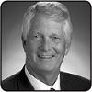

Members: Thomas M. Schoewe (Chair), Linda R. Gooden, Kathryn V. Marinello, and Michael G. Mullen

Meetings held in 2015: 9

Key Responsibilities | 2015 Key Accomplishments

Thomas M. Schoewe, Chair

“Sharpening Committee oversight and processes, enhancing the quality of financial statements and related disclosures and improving internal audit effectiveness, were key priorities in 2015.”

Oversees the quality and integrity of our financial statements, related disclosures, and internal controls;

Reviews and discusses with management the Company’s earnings releases and quarterly and annual financial statements on Forms 10-Q and 10-K prior to filing with the SEC;

Reviews significant accounting policies and practices applied by the Company in its financial statements;

Oversees the qualifications, performance, and independence of the independent auditor;

Pre-approves all audit and permitted non-audit services provided by the independent auditor;

Reviews the objectivity and performance of the Company’s internal audit function; and

Oversees the Company’s compliance with legal, ethical, and regulatory requirements.

Approved internal audit plan with greater alignment to identified risk areas;

Commenced review and approval of Global Ethics and Compliance Center resources and budget;

Instituted executive sessions with the Executive Vice President & General Counsel (“General Counsel”) at all regularly scheduled meetings;

Undertook consistent reviews of emerging accounting and internal control matters;

Monitored the disclosure of significant accounting matters and business developments and the overall effectiveness of the Company’s disclosures; and

Adopted enhancements to the Committee’s Charter to align with best practices.

Our Board has determined that each member of the Audit Committee is independent under the NYSE listing standards and the heightened independence requirements applicable to audit committee members under SEC rules. The Board has also determined that all members of the Audit Committee are financially literate in accordance with the NYSE listing standards and that Ms. Gooden, Ms. Marinello, and Mr. Schoewe are each qualified as an “audit committee financial expert” as defined by the SEC.

 | 2016 PROXY STATEMENT |  | 24

Back to Contents

EXECUTIVE

COMPENSATION


Members: Carol M. Stephenson (Chair), Joseph Jimenez, James J. Mulva, and Patricia F. Russo

Meetings held in 2015: 5

Key Responsibilities | 2015 Key Accomplishments

Carol M. Stephenson, Chair

“Our executive pay for 2015 demonstrated strong alignment with the achievement of key financial and operating objectives.”

Oversees the Company’s executive compensation policies and practices;

Reviews and approves corporate goals and objectives, evaluates CEO performance, and determines CEO compensation levels;

Reviews and approves compensation of NEOs, executive officers, and other senior leaders under its purview;

Oversees compensation policies and practices to assure the plans do not encourage unnecessary or excessive risks; and

Oversees the Company’s policies and practices that promote diversity and inclusion within the Company.

Second full year of demonstrated pay for performance under new incentive plans introduced in 2014;

Introduced non-compete and non-solicitation restrictive covenants for our most senior executives as part of Driving Stockholder Value Option Grant;

Reviewed and discussed the impact of upcoming SEC regulations; and

Adopted enhancements to the Committee’s Charter to align with best practices.

Our Board has determined that each member of our Executive Compensation Committee is independent in accordance with NYSE listing standards and our corporate governance guidelines, as well as additional independence standards applicable to Compensation Committee members.

GOVERNANCE AND

CORPORATE

RESPONSIBILITY


Members: Patricia F. Russo (Chair), Joseph Jimenez, Kathryn V. Marinello, and Carol M. Stephenson

Meetings held in 2015: 7

Key Responsibilities | 2015 Key Accomplishments

Patricia F. Russo, Chair

“Investor engagement, the addition of new Board members and our new leadership structure, as well as governance enhancements, were key priorities for 2015.”

Reviews the appropriate composition of the Board and recommends Board nominees;

Establishes the Company’s corporate governance framework, including all significant governance policies and procedures;

Oversees the self-evaluation process of the Board and Committees;

Recommends compensation of non-employee directors to the Board;

Reviews and approves related party transactions, as applicable; and

Oversees Company policies and strategies related to corporate responsibility, sustainability, and political contributions.


Realigned Board leadership structure to combine the Chairman and CEO roles and appointed an independent Lead Director;

Appointed two highly regarded directors, Linda R.

Gooden and Joseph Jimenez;

Undertook a comprehensive review of proxy access that led to the recent adoption of a proxy access bylaw;

Adopted Director-Shareholder Engagement Policy and have had and will continue to have direct conversations with investors; and

Amended the Board’s Governance Guidelines, Committee Charter and other related policies based upon a comprehensive governance review.

Our Board has determined that each member of our Governance and Corporate Responsibility Committee is independent in accordance with the NYSE listing standards and our corporate governance guidelines.

 | 2016 PROXY STATEMENT |  | 25

Back to Contents


FINANCE


Members: James J. Mulva (Chair), Joseph J. Ashton, Stephen J. Girsky, Kathryn V. Marinello, Patricia F. Russo, and Thomas M. Schoewe

Meetings held in 2015: 6

Key Responsibilities | 2015 Key Accomplishments

James J. Mulva, Chair

“Oversight of the execution of the Company’s disciplined capital allocation strategy was a key priority in 2015.”

Assists the Board in its oversight of our financial policies, strategies, and capital structure;

Reviews proposed dividend actions, stock splits and repurchases, and issuances of debt or equity securities;

Reviews any significant financial exposures and contingent liabilities of the Company, including foreign exchange, interest rate, and commodities exposures and the use of derivatives to hedge those exposures; and

Reviews the administration, investment performance, risk profile, and funding of U.S. employee benefit plans.


Adopted a new capital allocation framework to drive long-term value creation;

Increased the dividend and instituted an initial $5 billion share repurchase program, with a subsequent increase to $9 billion prior to the end of 2017;

Approved, along with the full Board, 2016 Automotive Capital Plan and GM Financial Funding Plan;

Reviewed pension funding strategy, resulting in approval of $2 billion debt issuance and discretionary pension funding; and

Adopted enhancements to the Committee’s Charter to align with best practices.

All members of the Finance Committee are non-employee directors, a majority of whom have been determined by our Board to be independent in accordance with the NYSE listing standards and our corporate governance guidelines.

RISK


Members: Michael G. Mullen (Chair), Joseph J. Ashton, Stephen J. Girsky, Linda R. Gooden, James J. Mulva, and Thomas M. Schoewe

Meetings held in 2015: 5

Key Responsibilities | 2015 Key Accomplishments

Michael G. Mullen, Chair

“In 2015, our priority was the strategic risk management transformation and oversight for significant risk areas, including customer and vehicle safety and cybersecurity.”

Reviews the Company’s strategic risk management program, risk governance structure, and risk framework;

Establishes top-down tone and culture within the Company regarding risk, including open risk discussions and integration of risk management in the Company’s behaviors, decision-making, and processes; and

Reviews the impact of the Company’s processes and procedures on customer and employee safety.


Reviewed the results of the annual risk assessment and risk framework covering top risks and mitigation plans, as appropriate;

Continued to closely monitor implementation of the Valukas Report recommendations;

Reviewed management updates on recommended future program processes for identification of GM’s key risks and plans for addressing these risks;

Continued evolution of the Company’s risk management program to an integrated level of maturity where risks are treated as a portfolio at the enterprise level as well as embedded into business decision-making; and

Adopted enhancements to the Committee’s Charter to align with best practices.

All members of the Risk Committee are non-employee directors, a majority of whom have been determined by our Board to be independent in accordance with the NYSE listing standards and our corporate governance guidelines.


In addition to the above standing Committees, our Board has an Executive Committee composed of the Chairman and CEO, the Independent Lead Director, and the Chairs of our other standing Committees. The Executive Committee is chaired by

EXECUTIVE Mary T. Barra and empowered to act for the full Board in intervals between Board meetings, with the exception of certain matters that the Board has not delegated. The Executive Committee meets as necessary, and all actions by the Executive Committee are reported at the next succeeding Board meeting. In 2015, the Executive Committee met one time.

 | 2016 PROXY STATEMENT |  | 26

Back to Contents

Access to Outside Advisors

The Board and each Board Committee can select and retain the services of outside advisors at our expense.

Board Meetings and Attendance

In 2015, our Board held a total of 12 meetings, and average director attendance at Board and Committee meetings was 95 percent. Each director standing for re-election attended at least 80 percent of the total meetings of the Board and Committees on which he or she served during the periods that he or she served in 2015. Directors are expected to attend our annual meeting of shareholders, which is held in conjunction with a regularly scheduled Board meeting. All of GM’s directors standing for re-election attended the 2015 Annual Meeting.

Board and Committee Oversight of Risk

One of the essential functions of our Board is oversight of management, directly and through its various Committees. Identifying and managing the risks we face is an important component of management’s responsibilities. Risks are considered in virtually every business decision and as part of the Company’s business strategy. We recognize that it is neither possible nor prudent to eliminate all risk. Indeed, purposeful and appropriate risk-taking is essential for the Company to be competitive on a global basis and to achieve our strategic objectives.

Our Board has overall responsibility for risk oversight, with a focus on the most significant risks facing the Company. Effective risk management is the responsibility of the CEO and other members of the Company’s management, specifically the Executive Leadership Team. As part of the risk management process, each of the Company’s business units and functions is responsible for identifying risks that could affect achievement of business goals and strategies, assessing the likelihood and potential impact of significant risks, and prioritizing the risks and actions to be taken to mitigate such risks, as appropriate.

Our Board implements its risk oversight function both as a whole and through delegation to Board Committees, particularly the Risk Committee. The Board receives regular reports from our management on particular risks within the Company, through review of the Company’s strategic plan, and through regular communication with its Committees. At least annually, management provides a comprehensive report to the Board on the key strategic, operating, financial, and compliance risks facing the Company, including management’s response to managing and mitigating such risks, as appropriate.

The Chair of the Risk Committee coordinates with the Chairs of other Board Committees in their review of the Company risks that have been delegated to these Committees to support them in coordinating the relationship between risk management policies and practices and their respective oversight accountabilities. Each of the other Board Committees, which meet regularly and report back to the Board, is responsible for oversight of risk management practices for categories of risks relevant to its functions. In general, the Board Committees oversee the following risks:

 | 2016 PROXY STATEMENT |  | 27

Back to Contents
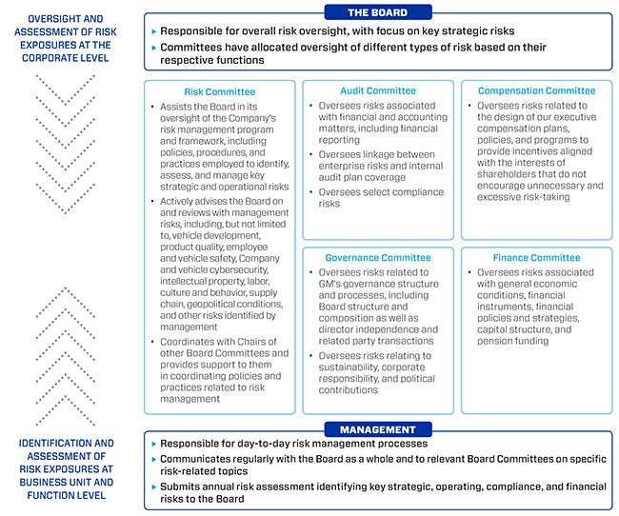

Our Board believes that its structure for risk oversight provides for open communication between management and the Board and its various committees, which effectively supports management’s enterprise risk management programs. In addition, strong independent directors chair the various committees involved in risk oversight, and all directors are involved in the risk assessment and ongoing risk reviews.

Succession Planning and Leadership Development

One of our Board’s primary responsibilities is to confirm that we have the appropriate management talent to successfully pursue our strategies. Management succession is regularly discussed by the directors with the CEO and during the Board’s executive sessions. The Board reviews candidates for all senior management positions to confirm that qualified candidates are available for all positions and that development plans are being utilized to strengthen the skills and qualifications of candidates. Our Independent Lead Director oversees the process for CEO succession and leads, at least annually, the Board’s discussion of CEO succession planning. Our CEO provides the Board with recommendations for and evaluations of potential CEO successors and reviews with the Board development plans for these successors. Directors engage with potential CEO and senior management talent at Board and Committee meetings and in less formal settings to enable directors to personally assess candidates. The Board reviews succession in the ordinary course of business as well as to conduct contingency planning in the event of an emergency or unanticipated event.

 | 2016 PROXY STATEMENT |  | 28

Back to Contents

Board and Committee Evaluations

The Board and each Committee conduct an annual self-evaluation to assess their effectiveness and consider opportunities for improvement. This process, overseen by the Governance Committee, also assesses the qualifications, skills, and experience of each director. As part of the evaluation process, each director completes a written questionnaire and is also interviewed by the Chairman and, if requested or needed, the Independent Lead Director, to provide feedback on the effectiveness of the Board, our Committees, and the contributions of individual directors. The results of the written questionnaires are compiled anonymously by the Corporate Secretary in the form of summaries for the full Board and each Committee. The feedback received from the questionnaires and interviews is reviewed and discussed by the Governance Committee (as it relates to both the Board and all Committees) and each other Committee (as it relates to such Committee). Following review and discussion by the Committees, the Chairman and Chair of the Governance Committee summarize the results of the evaluations and report to the full Board for discussion and action. In addition, the Chairman and, if applicable, the Independent Lead Director provides feedback from the individual director interviews to the full Board. Matters considered in evaluations include the following:

- The effectiveness of the Board’s leadership structure and the Board Committee structure;

- Board and Committee skills, composition, diversity, and succession planning;

- Board culture and dynamics, including the effectiveness of discussion and debate at Board and Committee meetings;

- The quality of Board and Committee agendas and the relevance of Board and Committee priorities;

- Dynamics between the Board and management, including the quality of management presentations and information provided to the Board and Committees; and

- The contribution of individual directors, including the Chairman, Lead Director, and Committee Chairs.

Annual Evaluation of CEO

The CEO reports annually to the Board regarding achievement of previously established goals and objectives. The non-management directors, meeting separately in executive session, annually conduct a formal evaluation of the CEO, which is communicated to the CEO by the Lead Director. The evaluation is based on both objective and subjective criteria, including, but not limited to: the Company’s financial performance, accomplishment of the Company’s long-term strategic objectives, and development of the Company’s top management team. The results of the evaluation are considered by the Compensation Committee in its deliberations when determining the compensation of the CEO, as further described in the “Compensation Discussion and Analysis” section in this Proxy Statement.

Director Orientation and Continuing Education

All new directors participate in the Company’s director orientation program, which generally commences promptly after the meeting at which a new director is elected. The Governance Committee oversees an orientation process developed by management to familiarize new directors, through a review of background material and meetings with senior management, with the Company’s business and strategic plans, significant financial matters; core values, including ethics, compliance programs, corporate governance practices; and other key policies and practices. Board members are encouraged to visit GM facilities, dealers, and auto shows to enhance their understanding of the Company and its competitors in the auto industry. All directors are encouraged to attend, at our expense, director continuing education programs sponsored by governance organizations and other institutions.

In 2015, as part of the Company’s comprehensive review of its governance practices and policies, the Board adopted a written policy recommended by the Governance Committee to build upon current practices and expectations set forth in the Board’s Corporate Governance Guidelines regarding the orientation process for newly appointed directors and ongoing director education. The objective of the policy is to keep directors updated with information about the Company and its operations, corporate governance, and other matters relevant to board service. Consistent with prior practices, the Governance Committee annually reviews each director’s orientation and external education activities.

 | 2016 PROXY STATEMENT |  | 29

Back to Contents

Service on Other Public Company Boards

The Board recognizes that service on other public company boards provides valuable governance and leadership experience that benefits the Company. The Board also believes, however, that it is critical that directors dedicate sufficient time to their service on the Company’s Board. Directors should advise the Chairman of the Board, Lead Director, or Chair of the Governance Committee in advance of accepting an invitation to serve on another public company board. This provides an opportunity to assess the impact of joining another board, based on various factors relevant to the specific situation, including the nature and extent of a director’s other professional obligations and the time commitment attendant to the new position. Directors who are engaged in active, full-time employment, for example, would have less time to devote to Board service than a director who exclusively serves on boards. Our Corporate Governance Guidelines provide that, without obtaining the approval of the Board:

- A director may not serve on the boards of more than four other public companies (excluding nonprofits and subsidiaries); and

- No member of the Audit Committee may serve on more than two other public company audit committees.

All directors are in compliance with this policy. In general, management may not serve on the board of more than one other public company or for-profit entity and must obtain the approval of the Governance Committee prior to accepting an invitation to serve on an outside board.

Compensation Committee Interlocks and Insider Participation

During 2015, and as of the date of this Proxy Statement, none of the members of the Compensation Committee was or is an officer or employee of the Company, and no executive officer of the Company served or serves on the compensation committee or board of any company that employed or employs any member of the Company’s Compensation Committee or Board of Directors.

Shareholder Protections

Our Board is committed to governance policies and practices that increase shareholder value and protect important shareholder rights. Our Governance Committee regularly reviews these policies and practices. Among the policies and practices the Board believes demonstrate the Company’s commitment to protecting shareholder rights are:

- Supermajority of independent directors serving on the Board, with key committees (including Audit, Compensation, and Governance) composed entirely of independent directors;

- Annual election of all directors;

- Majority voting standard for the election of directors in uncontested elections, coupled with a director resignation policy;

- Shareholder right to call for a special meeting;

- Proxy access permitting a shareholder, or a group of up to 20 shareholders, owning at least 3 percent of the Company’s outstanding voting shares continuously for at least three years, to nominate and include in the Company’s proxy materials director nominees (two individuals or 20 percent of the Board, whichever is greater); and

- Director-Shareholder Engagement Policy that contemplates proactive and productive engagement with shareholders.

Shareholder Communication With the Board

Shareholders and other interested parties may contact our Board as a whole, the non-management directors as a group, any Board Committee, the Chairman of the Board, the Lead Director, or any director by using contact information provided on our website at www.gm.com/investor, under “Corporate Governance.”

 | 2016 PROXY STATEMENT |  | 30

Back to Contents

Certain Relationships and Related Party Transactions

Our policy is that all our employees and directors must avoid any activity that is in conflict with our business interests. Our Board of Directors has adopted the Related Party Transactions Policy, a written policy regarding the review and approval or ratification of “related party transactions.” For purposes of our Policy, related party transactions are transactions in which our Company is a participant, the amount involved exceeds $120,000, and a “related party” has or will have a direct or an indirect material interest. Related parties of our Company consist of directors (including nominees for election as directors), executive officers, shareholders beneficially owning more than 5 percent of the Company’s voting securities (“Significant Shareholders”), and the immediate family members of these individuals.

During 2015, the Governance Committee reviewed and revised the Related Party Transactions Policy to provide that all related party transactions be referred to the Governance Committee for review and approval or ratification. Previously, related party transactions involving executive officers other than the CEO or the General Counsel and their immediate family members were referred to the General Counsel for review and approval or ratification.

Each director and executive officer is responsible for providing written notice to the General Counsel of any potential related party transaction involving him or her or his or her immediate family member, including any additional information about the transaction that the General Counsel or Corporate Secretary may reasonably request for review by the Governance Committee. The Governance Committee will determine whether the transaction does, in fact, constitute a related party transaction requiring compliance with this policy, in consultation with the General Counsel or Corporate Secretary and outside counsel, as appropriate.

In addition, each director and executive officer is required to complete an annual questionnaire that requests information about their immediate family members and any current, past, and proposed related party transactions. This questionnaire also includes a reminder of each directors’ obligations under the Related Party Transactions Policy.

To review a related party transaction, the Governance Committee will be provided with all relevant material information of the related party transaction, including the terms of the transaction, the business purpose of the transaction, the benefits to the Company and to the related party, and any other relevant matters. In determining whether to approve or ratify a related party transaction, the Governance Committee will consider the following factors, among others, to the extent they are relevant to the related party transaction:

- Whether the terms of the related party transaction are fair to the Company and would apply on the same basis if the transaction did not involve a related party;

- Whether there are any compelling business reasons for the Company to enter into the related party transaction and the nature of alternative transactions, if any;

- Whether the related party transaction would impair the independence of an otherwise independent director;

- Whether the Company was notified about the related party transaction before its commencement, and if not, why preapproval was not sought and whether subsequent ratification would be detrimental to the Company; and

- Whether the related party transaction would present an improper conflict of interest for any director or executive officer of the Company, taking into account the size of the transaction, the overall financial position of the director, executive officer, or other related party, the direct or indirect nature of the director’s, executive officer’s, or other related party’s interest in the transaction, and the ongoing nature of any proposed relationship and any other factors the Governance Committee deems relevant.

The Governance Committee in its discretion may refer any transaction to the Board for review and approval or ratification. Any member of the Governance Committee who has a potential interest in any related party transaction will recuse himself or herself and abstain from voting on the approval or ratification of the related party transaction, but may participate in all or a portion of the Governance Committee’s discussions of the related party transaction, if requested by the Chair of the Governance Committee.

In any case where the Governance Committee determines not to ratify a related party transaction that has been commenced without approval, the Governance Committee may direct additional actions, including, but not limited to, immediate discontinuation or rescission of the transaction or modification of the transaction to make it acceptable for ratification. The Governance Committee has authority to oversee our Related Party Transactions Policy and to amend it from time to time. In addition, the Governance Committee is responsible for annually reviewing the independence of each director and the appropriateness of any potential related party transaction and related issues. Our Related Party Transactions Policy is available on our website at www.gm.com/investor, under “Corporate Governance.”

As required under SEC rules, we will disclose all related party transactions in our Proxy Statement. No reportable transactions have occurred since January 1, 2015, or are currently proposed.

Engagement Program

Our Board believes that fostering long-term and enterprise-wide relationships with our shareholders and maintaining their trust and goodwill is a core GM objective. And to demonstrate its openness to investor feedback and input, our Board recently adopted a Director-Shareholder Engagement Policy, which contemplates both proactive engagement, in

 | 2016 PROXY STATEMENT |  | 31

Back to Contents

which shareholders are identified by the Board for selective engagement, and reactive engagement, with shareholders that seek to provide input to the Board and executive management on various matters. Through this process, GM conducts engagements with key shareholders. These engagements routinely cover governance, compensation, environmental, social, and other current and emerging issues so that the Board and management understand and address the issues that are important to our shareholders.

Since GM’s last Annual Meeting, members of the Board and management have conducted engagements with shareholders representing more than 45 percent of the Company’s outstanding shares. In addition, our management team engaged with shareholders who submitted proposals for inclusion in this Proxy Statement to discuss their concerns and areas of agreement and disagreement. The Company gained valuable feedback during these engagements, and this feedback was shared with the Board and its relevant Committees.

Sustainability

We have a long-standing commitment to our shareholders and communities to operate in an environmentally and socially responsible manner. We continue to take action to reduce our global carbon footprint, optimize the efficiency and safety of our workplace, support our customers in reducing their own environmental footprints, and encourage our suppliers to act in more sustainable ways. To do this, we provide solutions all over the world in the form of improved and new types of products, innovation for existing products and services, and advanced technologies.

Placing the customer at the center of all we do extends to both how we build our products and how we serve and improve our communities. When it comes to sustainability, we pursue outcomes that create value for all of our stakeholders.

Our sustainability strategy is aligned to our business practices and emphasizes:

- Surpassing customer expectations for quality and safety;

- Offering sustainable vehicle choices that meet the diverse needs of customers;

- Leveraging advanced technologies to enhance fuel economy, safety, and customer connectivity;

- Minimizing the impact of our operations and supply chain; and

- Building a culture that promotes our values of customers, relationships, and excellence.

Some of our 2015 accomplishments include:

- Debuting the Chevy Bolt, an all-electric vehicle offering an estimated range in excess of 200 miles;

- Ending our use of coal as an energy source in our North American plants;

- Engaging in recycling and reuse efforts that avoided approximately 9 million metric tons of CO²-equivalent emissions, more than offsetting our worldwide manufacturing emissions; and

- Increasing our use of renewable energy by more than 60 percent, with plans for aggressive expansion of this initiative.

To learn more about sustainability at GM and how we, together with our customers and shareholders, are making a difference, please access our Sustainability Report at http://www.gmsustainability.com.

Public Policy Engagement

Our Board has adopted a U.S. Corporate Political Contributions and Expenditures Policy (“Political Contributions Policy”). The Political Contributions Policy, together with other policies and procedures of the Company, guides GM’s approach to political contributions. We participate in the political process to help shape public policy and address legislation that impacts GM, our industry, and our shareholders. GM has a history of supporting and will continue to support public policies that work to drive or are necessary to furthering the achievement of our long-term, sustainable growth. As specified in its Charter, the Governance Committee oversees this policy and annually reviews the Company’s engagement in the public policy process. The Committee also annually reviews all corporate political contributions as well as GM Political Action Committee (“GM PAC”) contributions and expenditures (which are funded entirely by voluntary employee contributions). In keeping with our goal of transparency, our U.S. Corporate Political Contributions and Expenditures Policy and our annual voluntary report of U.S. political contributions are available on our website at www.gm.com/investor, under “Corporate Governance.” The report includes information about contributions to political organizations known as “section 527 organizations;” corporate contributions to individual candidates for state and local office; and portions of dues or similar payments to trade associations and social welfare organizations, to the extent the dues or other payments equal or exceed $50,000 and are attributable to political purposes. In addition, a link to the Federal Election Commission website is provided, which details employee contributions to the federal GM PAC and the GM PAC’s contributions to candidates, party committees, and other PACs.

 | 2016 PROXY STATEMENT |  | 32

Back to Contents

SECURITY OWNERSHIP INFORMATION

Security Ownership of Directors, Named Executive Officers, and Certain Other Beneficial Owners

The beneficial ownership as of April 1, 2016, of our common stock by each director, each nominee for election to the Board, each NEO, and all directors and executive officers as a group is shown in the following tables, as well as ownership of Deferred Share Units and Deferred Salary Stock Units. Each of the individuals listed in the following tables owns less than 1 percent of the outstanding shares of our common stock; all directors and officers as a group own less than 1 percent of the outstanding shares. The persons named have provided this information to us, and we have no reason to believe it is not accurate. None of the shares shown in the following tables as beneficially owned by directors and executive officers is hedged or pledged as security for any obligation.

Non-Employee Directors

 | Shares of Common
 | Stock Beneficially | Deferred Share
Director | Owned | Units⁽¹⁾
Joseph J. Ashton | 500 | 8,307
Stephen J. Girsky⁽²⁾ | 10,300 | 5,326
Linda R. Gooden | 1,000 | 3,426
Joseph Jimenez | 32,330 | 4,510
Kathryn V. Marinello | 800 | 36,891
Jane L. Mendillo | — | —
Michael G. Mullen | 750 | 9,741
James J. Mulva | 28,343 | 26,006
Patricia F. Russo | 2,300 | 18,449
Thomas M. Schoewe | 7,645 | 15,495
Theodore M. Solso | 5,000 | 34,534
Carol M. Stephenson | 800 | 35,021

- Represents the unit equivalents of our common stock under the Director Compensation Plan described on page 18.

- In addition, Mr. Girsky owns 29,172 vested and undelivered salary stock units acquired as part of his compensation during the period he was an employee of the Company. Salary stock units are denominated in stock units and will be delivered in cash or stock at his election pursuant to his delivery schedule.

Named Executive Officers and All Directors and Executive Officers as a Group

 | Shares of Common Stock | Deferred Salary
Name | Beneficially Owned⁽¹⁾ | Stock Units⁽²⁾
Mary T. Barra | 117,478 | 19,493
Charles K. Stevens, III | 46,942 | 343
Daniel Ammann | 173,850 | 19,391
Mark L. Reuss | 67,630 | 16,542
Craig B. Glidden | 21,217 | —
All Directors and Executive Officers as a Group | 651,544 | 313,443
(26 persons, including the foregoing) | 651,544 | 313,443

- Includes shares held directly by the executive officer as well as vested restricted stock and excludes shares shown in the “Deferred Salary Stock Units” column.

- Includes vested and undelivered salary stock units, which are denominated in stock units and will be delivered in cash or stock at the executive’s election pursuant to their respective delivery schedules. The total includes Mr. Girsky’s deferred salary stock units as described in footnote (2) to the above “Non-Employee Directors” table.

 | 2016 PROXY STATEMENT |  | 33

Back to Contents

Certain Beneficial Owners

The beneficial ownership, as of April 1, 2016, of our common stock by each person or group of persons who is known to be the beneficial owner of more than 5 percent of our outstanding shares of common stock on a fully-diluted basis is shown in the following table.

 |  | Percent of
 | Number of | Outstanding
Name and Address of Beneficial Owner of Common Stock | Shares⁽¹⁾ | Shares⁽¹⁾
UAW Retiree Medical Benefits Trust, as advised by its fiduciary and investment advisor Brock | 140,150,000 | 9.1%
Fiduciary Services LLC
200 Walker Street
Detroit, MI 48207
The Vanguard Group | 82,980,517 | 5.4%
100 Vanguard Blvd.
Malvern, PA 19355
Harris Associates L.P. | 81,083,512 | 5.3%
111 S. Wacker Drive, Suite 4600
Chicago, IL 60606

- Number of shares and percentage of outstanding shares reported by each beneficial owner in filings with the SEC. The Company is permitted to rely on the information set forth in these filings and has no reason to believe that the information is incomplete or inaccurate or that the beneficial owner should have filed an amended report and did not. Each beneficial owner reported as follows:

 |  |  | Sole Dispositive | Shared Dispositive
Entity/ Filing | Sole Voting Power | Shared Voting Power | Power | Power
UAW Retiree Medical Benefits Trust | — | 140,150,000 | — | 140,150,000
(Sch. 13G, filed Feb. 11, 2014)
The Vanguard Group (Sch. 13G, filed | 2,652,087 | 143,100 | 80,200,015 | 2,780,502
Feb. 10, 2016)
Harris Associates L.P. (Sch. 13G, | 70,226,598 | — | 70,226,598 | —
filed Feb. 10, 2016)

Stockholders Agreement

Pursuant to the Stockholders Agreement dated October 15, 2009, between the Company and the UAW Retiree Medical Benefits Trust (the “VEBA Trust”), the VEBA Trust will vote its shares of our common stock on each matter presented to the shareholders at the Annual Meeting in the same proportionate manner as the holders of our common stock other than our directors and executive officers. The VEBA Trust will be subject to the terms of the Stockholders Agreement until it beneficially owns less than 2 percent of the shares of our common stock then issued and outstanding.

Section 16(a) Beneficial Ownership Reporting Compliance

Federal securities laws require that our directors and executive officers and shareholders that own more than 10 percent of our common stock report to the SEC and the Company certain changes in ownership and ownership information within specified periods. As a matter of practice, the Company’s administrative staff assists our directors and executive officers in preparing initial reports of ownership and reports of changes in ownership and files those reports on their behalf. Based solely on the reports received by us or filed with the SEC and upon information furnished by these people, we believe that all such persons complied with all applicable filing requirements during 2015 with one exception. In May 2015, Mr. Mulva made a filing on Form 4 to report an open market acquisition of shares of common stock. Mr. Mulva timely reported the acquisition to the Company; however, due to an administrative error by the Company, the filing was late.

 | 2016 PROXY STATEMENT |  | 34

Back to Contents

EXECUTIVE COMPENSATION

Compensation Discussion and Analysis (CD&A)


Table of contents

Compensation Discussion and Analysis

Compensation Overview |  |  | 36
2015 Compensation Elements |  |  | 41
Performance Measures for 2015 |  |  | 42
2015 Performance Results and Compensation Decisions |  |  | 46
Compensation Policies and Governance Practices |  |  | 52
Compensation Committee Report |  |  | 53
Executive Compensation Tables
2015 Summary Compensation Table |  |  | 54
Grants of Plan-Based Awards |  |  | 56
Outstanding Equity Awards at Fiscal Year-End |  |  | 57
Option Exercises and Stock Vested |  |  | 58
Pension Benefits |  |  | 58
Nonqualified Deferred Compensation Plans |  |  | 59
Potential Payments Upon Termination |  |  | 60
Equity Compensation Plan Information |  |  | 62
Defined terms:
• AFCF – Automotive Free Cash Flow
• DB – Defined Benefit
• DC – Defined Contribution
• DSV – Driving Stockholder Value
• EBIT – Earnings Before Interest and Taxes
• EPS – Earnings Per Share
• LTIP – Long-Term Incentive Plan
• NEO – Named Executive Officer
• NHTSA – National Highway Traffic Safety Administration
• OEM – Original Equipment Manufacturer
• PSU – Performance Stock Unit
• ROIC – Return on Invested Capital
• RSU – Restricted Stock Unit
• STIP – Short-Term Incentive Plan
• TSR – Total Shareholder Return
 |  | 2016 PROXY STATEMENT |  | 35

Back to Contents


Compensation Overview

- Our Company Performance

In 2015, we continued progress toward our goal of making GM the most valued automotive company for our shareholders:

Achieved record sales, earnings, and margins;

Continued strong vehicle sales with deliveries of more than 9.9 million units globally;

Increased EPS-Diluted to $5.91 and EPS-Diluted-Adjusted by 65 percent year-over-year to $5.02;⁽¹⁾

Returned $5.7 billion to shareholders through share repurchases and dividend payments;

Generated greater than 10 percent EBIT-Adjusted margins for North America, one year ahead of plan;

Increased average transaction prices in the U.S. by nearly $800 per vehicle;

Announced plans for Autonomous Vehicle Development with real-world testing at the General Motors Technical Center Campus in 2016; Increased focus on urban mobility efforts;

Expanded connectivity available in North America, South America, China, and Europe; GM has more connected vehicles than all other OEMs combined;

Developed mixed-metal manufacturing techniques to allow for the use of more lightweight metals on future vehicles; Realized savings in material costs and logistics in excess of $2 billion;

Continued to transition GM Financial into a full captive finance company for all GM brands; and

Strengthened global Chevrolet and Cadillac brands; in the U.S., grew Chevrolet retail market share faster than any other full-line automotive brand and delivered 8 percent year-over-year increase in global Cadillac sales.

- Refer to Item 7, Management’s Discussion and Analysis of Financial Condition and Results of Operations in our Annual Report on Form 10-K for a reconciliation of this non-GAAP measure to its closest comparable GAAP measure.

  - Our Vehicle Launches

We launched 25 vehicles across the globe in 2015, including some of the key vehicles below:

- Buick Excelle (GM China)

- Chevrolet Malibu (GM China, GM International, GM North America, GM South America)

- Chevrolet Volt (GM China, GM North America)

- Opel / Vauxhall Astra (GM Europe, GM South America)

- Chevrolet Camaro (GM Europe, GM International, GM North America, GM South America)

- Chevrolet Spark (GM International, GM North America, GM South America)

- Opel Karl (GM Europe, GM North America, GM South America)

- Vauxhall Viva (GM Europe)

- Our 2015 Named Executive Officers

Mary T. Barra | Chief Executive Officer⁽¹⁾
Charles K. Stevens, III | Executive Vice President & Chief Financial Officer
Daniel Ammann | President
Mark L. Reuss | Executive Vice President, Global Product Development, Purchasing and Supply Chain
Craig B. Glidden | Executive Vice President & General Counsel⁽²⁾

- Ms. Barra was elected Chairman of the Board of Directors on January 4, 2016.

- Mr. Glidden joined GM on March 1, 2015.

 | 2016 PROXY STATEMENT |  | 36

Back to Contents
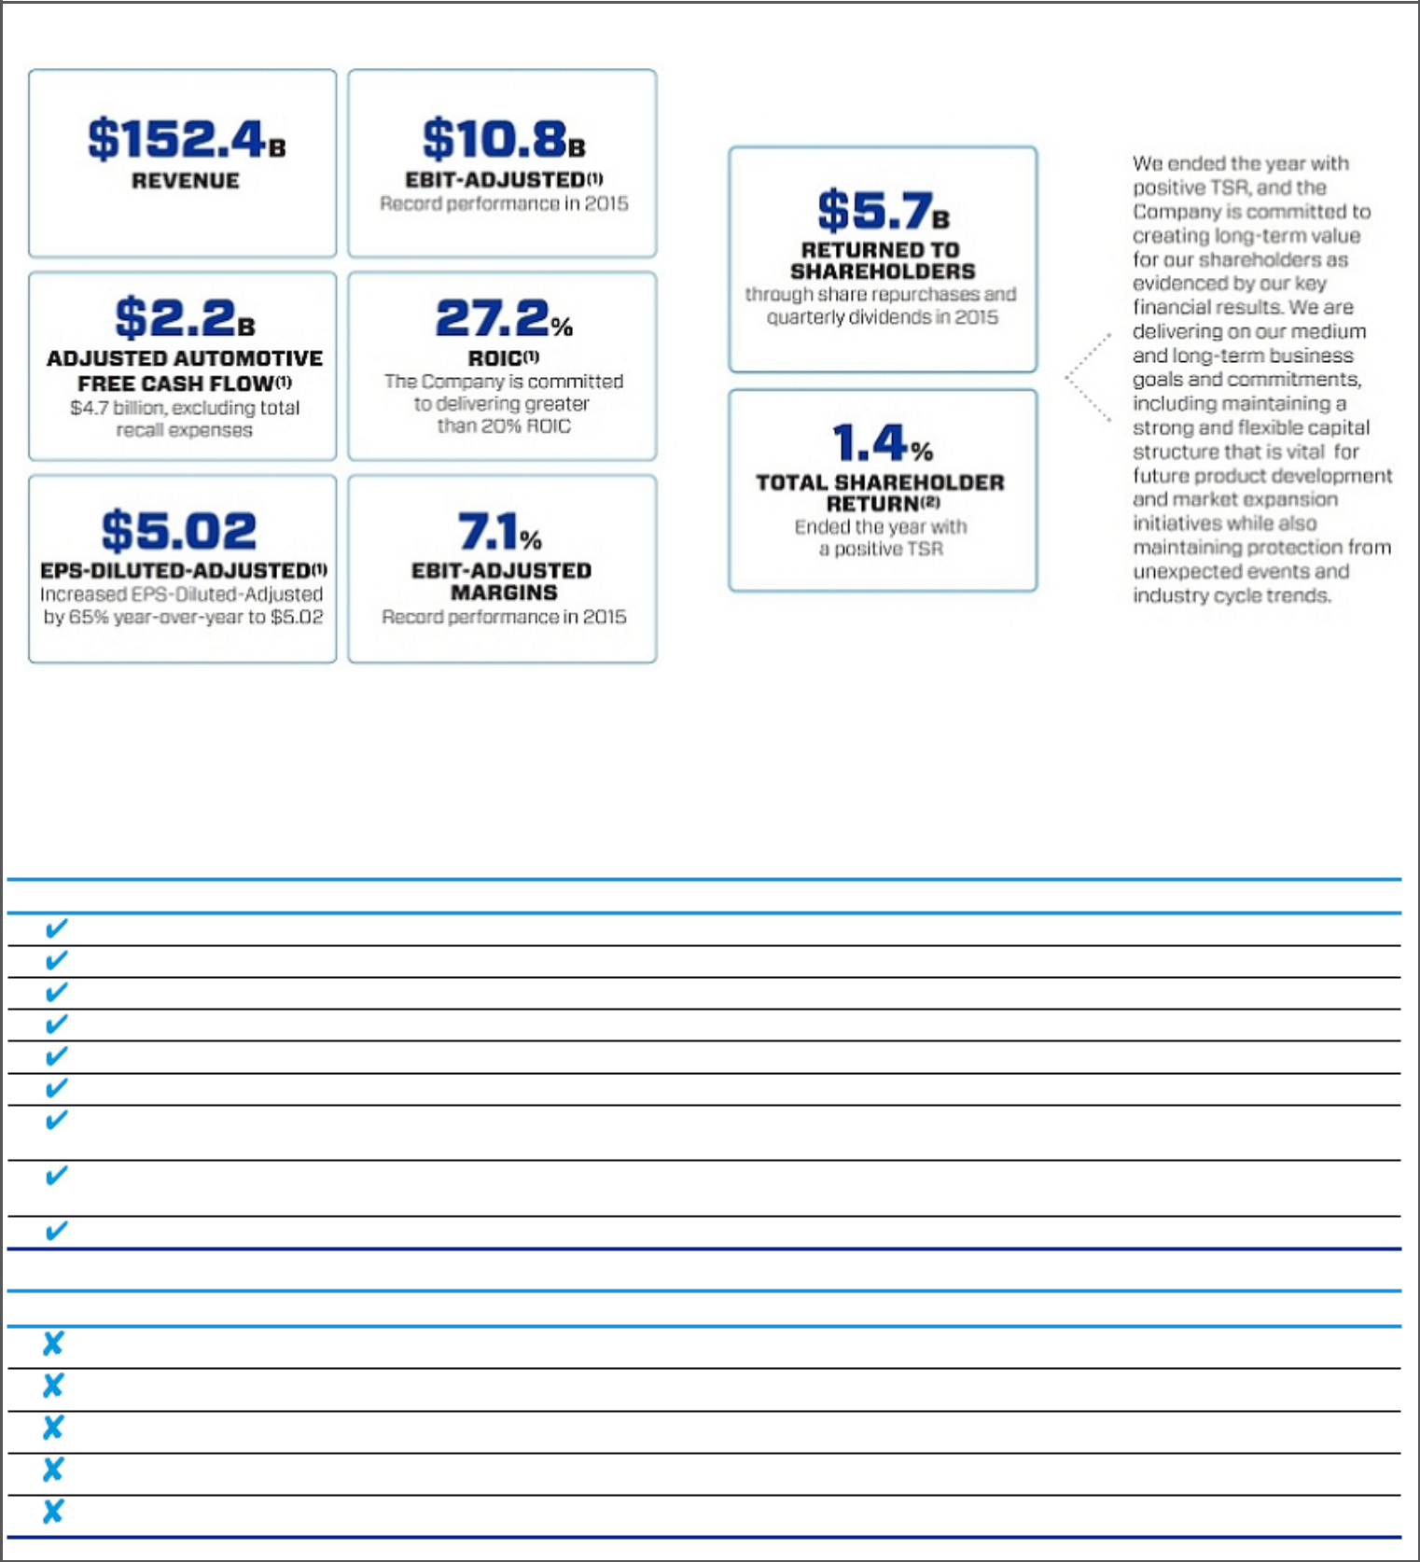

We ended the year with the following key financial results:

- Refer to Item 7, Management’s Discussion and Analysis of Financial Condition and Results of Operations in our Annual Report on Form 10-K for a reconciliation of this non-GAAP measure to its closest comparable GAAP measure.

- Assumes dividends are reinvested in common stock.

- Compensation Governance and Best Practices

WHAT WE DO

Provide short and long-term incentive plans with performance targets aligned to business goals

Conduct annual advisory vote for shareholders to approve executive compensation

Maintain a Compensation Committee composed entirely of independent directors

Establish stock ownership requirements for approximately 300 senior leaders

Enter into non-compete and non-solicitation terms with approximately 300 senior leaders

Retain independent executive compensation consultants to the Compensation Committee

Maintain a Securities Trading Policy requiring directors and executive officers to trade only during established window periods after contacting the GM Legal Staff prior to any sales or purchases of common stock

Require equity awards to have a double-trigger (termination of employment and change-in-control) to initiate protection provisions of outstanding awards

Complete annual incentive compensation risk reviews

WHAT WE DON’T DO

Grant awards to executive officers that are not subject to clawback

Provide gross-up payments to cover personal income taxes or excise taxes pertaining to executive or severance benefits

Allow directors or executives to engage in hedging or pledging of GM securities

Reward executives for excessive, inappropriate, or unnecessary risk-taking

Allow the repricing or backdating of equity awards

 | 2016 PROXY STATEMENT |  | 37

Back to Contents
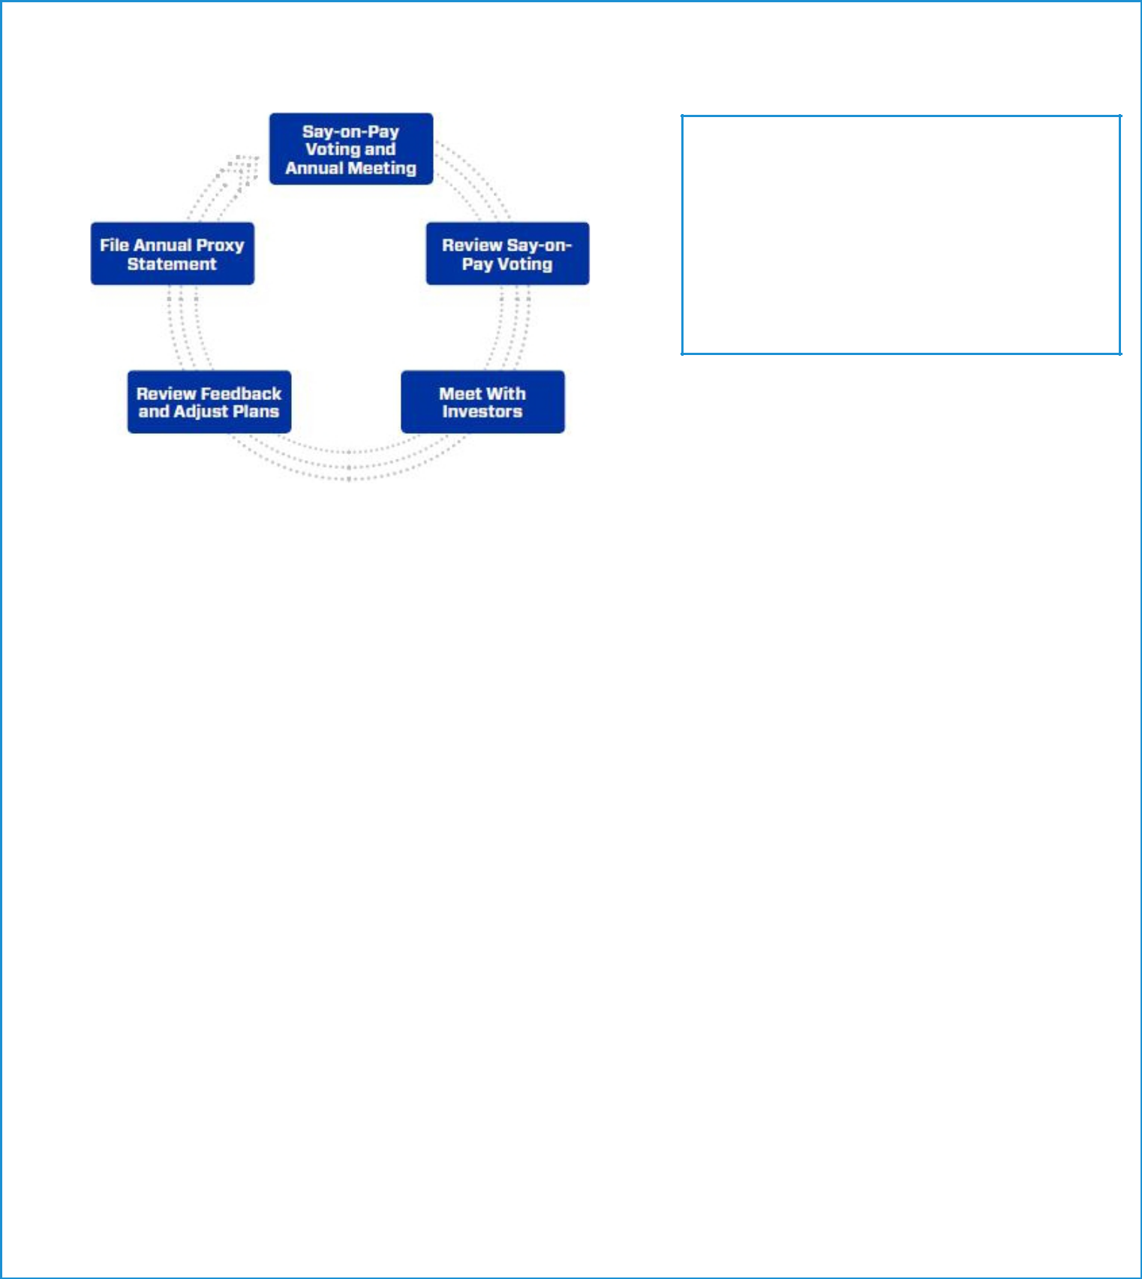

- Investor Outreach Initiatives

We view investor outreach as an ongoing cycle and in 2015 both members of the Board and select members of management continued to hold discussions with some of our largest investors. Through these discussions, we regularly receive feedback on Company performance and compensation programs.

SHAREHOLDER SAY-ON-PAY

The Compensation Committee seeks to align the Company’s executive compensation program with the interests of the Company’s shareholders. The Compensation Committee considers the results of the annual Say-On-Pay vote, input from management, input from its independent compensation consultant, and investor outreach initiatives when setting compensation for our executives. In 2015, our shareholders continued to demonstrate support of the compensation programs, with over 97 percent voting in favor.

Some of the feedback we heard from investors and how it impacted compensation design included the following:

What We Heard | How We Responded
Pay for performance | 72% of the CEO’s compensation is tied to the performance of Company goals, and 67% for other
 | NEOs.
Align compensation to the interests of | Executives at GM have the majority of their total compensation in the form of equity. Our annual STIP
shareholders | and PSUs both have metrics that will create long-term shareholder value.
Consider stock options | In 2015, we made a one-time stock option grant, which included non-compete and non-solicitation
 | terms; 60% of the options feature performance-based vesting, and 40% feature time-based vesting.
 | The award is described in full on page 45.
Simplify compensation plans | We continue to evaluate both short and long-term compensation plans to ensure executive line of
 | sight with alignment to creating shareholder value.

The Company values investor feedback and will continue our investor outreach initiatives to ensure our executive compensation programs remain aligned to shareholder expectations.

- 2015 Peer Group for Compensation Comparisons

In 2015, we made changes to our peer group by removing ConocoPhillips, Chevron Corporation, and Lockheed Martin Corporation and adding Intel Corporation, based on the guidelines established by the Compensation Committee for our peer group selection. Companies must satisfy each of the following criteria to be considered for the peer group:

- Revenue greater than $25 billion

- Significant international revenue

- Capital intensive operations

Additionally, the Compensation Committee considers the following factors when selecting our peer group:

- Companies with comparable R&D expenditures as a percent of revenue

- Durable goods manufacturer

- Business/production complexity

- Consumer end-user

- Strong brand reputation

We do not limit our peer group to our industry alone, because we believe compensation practices for NEOs at other large U.S.-based multinationals affect our ability to attract and retain diverse talent around the globe.

 | 2016 PROXY STATEMENT |  | 38

Back to Contents
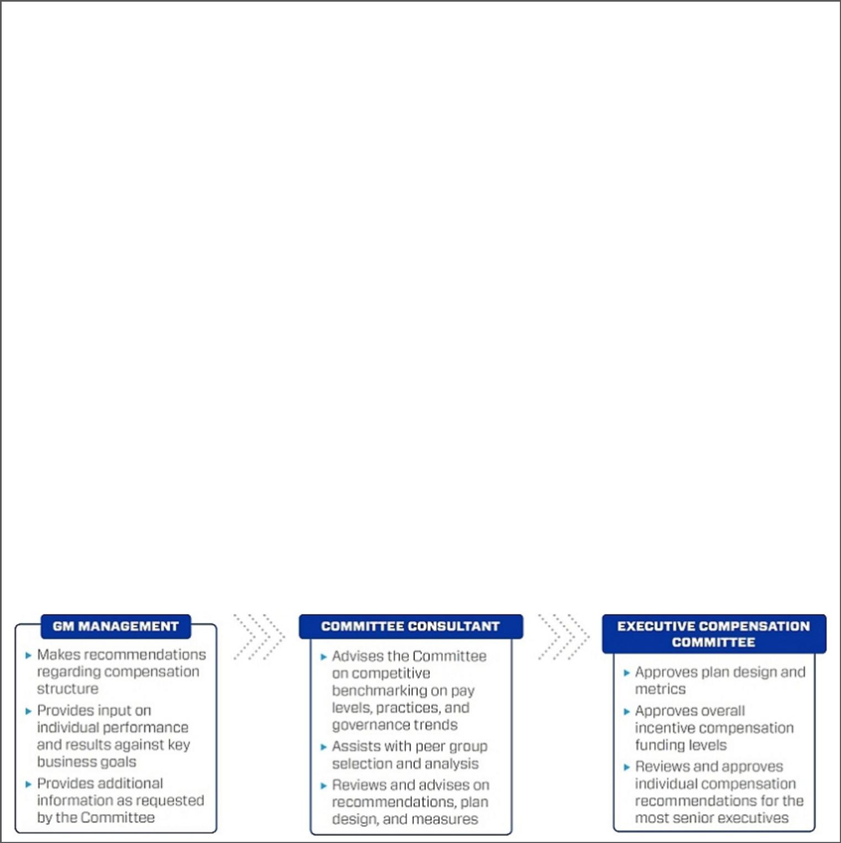

 |  |  | Significant
 |  |  | International | Capital Intensive
Company | Industry | Revenue > $25B | Revenue | Operations
3M Company | Industrial Conglomerates | X | X | X
The Boeing Company | Aerospace and Defense | X | X | X
Caterpillar Inc. | Construction Machinery and Heavy Trucks | X | X | X
Deere & Company | Agricultural and Farm Machinery | X | X | X
The Dow Chemical Company | Diversified Chemicals | X | X | X
Du Pont | Diversified Chemicals | X | X | X
Ford Motor Company | Automobile Manufacturers | X | X | X
General Electric Company | Industrial Conglomerates | X | X | X
Hewlett-Packard Company | Technology Hardware, Storage, and Peripherals | X | X | X
Honeywell International Inc. | Aerospace and Defense | X | X | X
IBM Corporation | IT Consulting and Other Services | X | X | X
Intel Corporation | Semiconductors | X | X | X
Johnson & Johnson | Pharmaceuticals | X | X | X
Johnson Controls Inc. | Auto Parts and Equipment | X | X | X
PepsiCo. Inc. | Soft Drinks and Food | X | X | X
Pfizer Inc. | Pharmaceuticals | X | X | X
The Procter & Gamble Company | Household Products | X | X | X
United Technologies Corp. | Aerospace and Defense | X | X | X

- How We Use Comparator Data to Assess Compensation

We use executive compensation surveys to benchmark relevant market data for executive positions. In addition, we benchmark proxy statement disclosures of our peer group and adjust this data to reflect expected compensation growth. Further, we review the competitive market position of each of our executives compared with the peer group and benchmarked positions from executive compensation surveys.

We generally target our total direct compensation levels for the executive group on average to be at or near the market median. However, an individual’s total direct compensation may be positioned above or below the market median because of his or her specific responsibilities, experience, and performance.

- How We Plan Compensation

 | 2016 PROXY STATEMENT |  | 39

Back to Contents
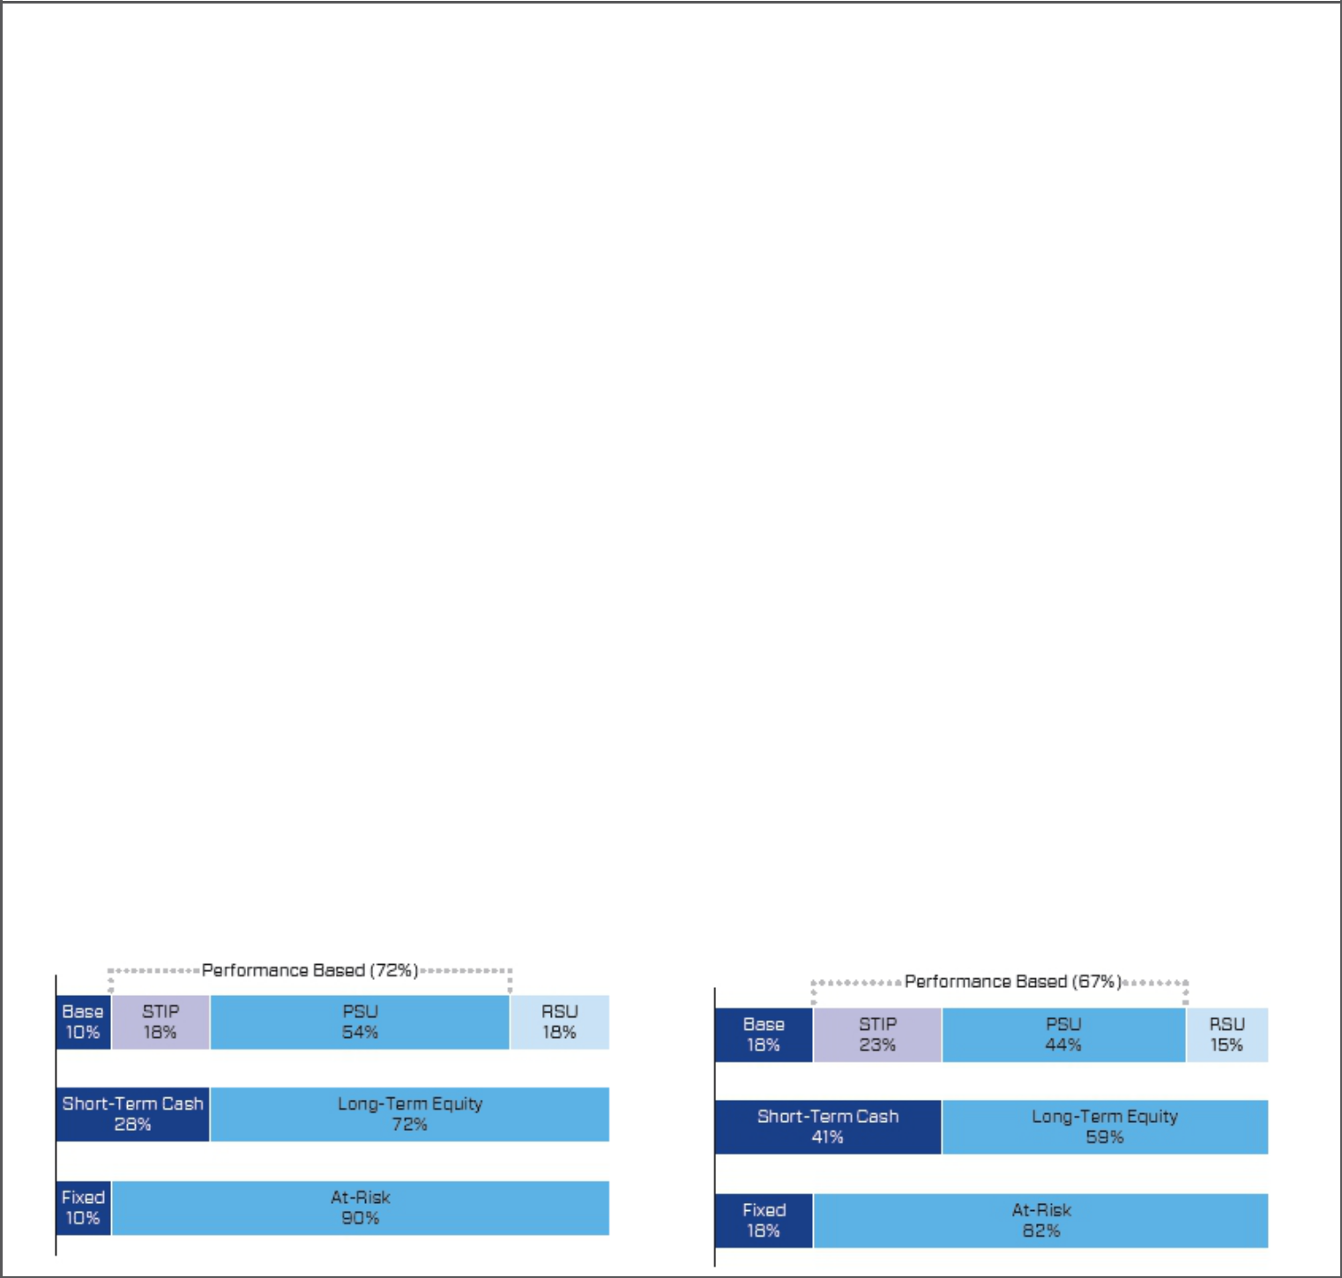

- 2015 Compensation Programs

We believe aligning pay to the achievement of both short-term and long-term goals is a cornerstone of executive engagement and have set up a pay program seeking to:

- Align individual and business performance with the interests of our shareholders;

- Tie individual rewards to Company performance;

- Support sound compensation policies and governance practices;

- Avoid unnecessary risk-taking; and

- Enhance our ability to attract, retain, and reward critical talent.

During 2015, the compensation structure for our NEOs included the following core elements:

- Base salary;

- STIP;

- Long-term PSUs; and

- Long-term RSUs.

Additionally, in 2015, we granted our senior leaders a one-time DSV Option Grant that included non-compete and non-solicitation terms for each senior leader. DSV awards vest over a period of 4.6 years with 60 percent of the options vesting only if performance goals are met as described on page 45, and 40 percent time-based vesting.

- Performance-Based Compensation Structure

Our NEOs are focused on optimizing long-term financial returns for our shareholders through increasing profitability, increasing margins, putting the customer at the center of everything we do, growing the business, and driving innovation.

The performance-based structure incorporates both short-term and long-term incentives established from financial and operational metrics for fiscal year 2015 and beyond. In addition to base salary, this structure, shown graphically below, includes an annual STIP award and an LTIP award made up of both PSUs and RSUs to focus our executives on long-term Company performance. The Compensation Committee believes a majority of compensation should be in the form of equity to align the interests of executives with those of shareholders.

For our CEO, 90 percent of target compensation is pay-at-risk, 72 percent is linked to performance against goals, and 72 percent is linked to the performance of common stock. For other NEOs, on average 82 percent of target compensation is pay-at-risk, 67 percent is linked to performance against goals, and 59 percent is linked to the performance of common stock.

CEO – 2015 Compensation Structure Average NEO – 2015 Compensation Structure

 | 2016 PROXY STATEMENT |  | 40

Back to Contents

2015 Compensation Elements

In 2015, the compensation provided to our senior leaders was guided by six general principles:

- Investor Return – Compensation should be directly linked to the long-term interests of our shareholders, and our executives should be exposed to the market performance of common stock as are our investors;

- Performance-Based Compensation – A substantial portion of total compensation should be performance-based over a relevant performance period;

- No Incentives to Take Excessive Risk – The compensation structure should avoid incentives to take unnecessary and excessive risk (e.g., should be paid over a period of time that takes into account the potential risk over the same time period);

- Appropriate Allocation of Compensation Components – The structure should allocate fixed and variable pay elements to form an appropriate mix of short and long-term pay elements;

- Comparable Structures and Payments – Compensation structures and amounts should be competitive with those paid to persons in comparable positions at other, similar companies; and

- Employee Contribution – Compensation should reflect the individual’s performance and contributions.

Each NEO’s 2015 compensation structure included the following pay elements:

- Base Salary – NEOs are paid a market-competitive base salary that reflects each NEO’s contribution, background, tenure, as well as the knowledge and skills he or she brings to the role;

- STIP – The STIP is an annual cash incentive plan. The STIP rewards each NEO based on the achievement of annual Company financial and operational performance goals and individual performance. The potential Company payout ranges from 0 to 200 percent of target, based on actual Company performance;

- PSUs – PSUs are equity awards designed to align each NEO’s interests with the long-term interests of the Company and its shareholders. PSUs can be earned at a level from 0 to 200 percent of target, based on the achievement of Company performance against ROIC and Global Market Share targets over the three-year performance period beginning January 1, 2015; and

- RSUs – RSUs are time-based awards vesting ratably over a three-year period. RSUs align the interests of NEOs with shareholders and help to retain top talent.

- Perquisites, Benefits, and Other Compensation

We provide perquisites, benefits, and other compensation to our NEOs consistent with market practices. The following perquisites, benefits, and other compensation were provided to NEOs in 2015:

- Personal Air Travel – Ms. Barra is prohibited by Company policy from commercial air travel due to security-related reasons identified by an independent third-party security consultant. As a result, the Company pays the costs associated with the use of chartered or Company-owned aircraft for both business and personal use. Ms. Barra is permitted guests for personal travel and incurs imputed income for all passengers, including, herself at the U.S. Internal Revenue Service (the “IRS”) Standard Industry Fair Level rates. Other NEOs may travel on chartered or Company-owned aircraft in limited circumstances with prior approval from the CEO or the Senior Vice President Global Human Resources, and also incur imputed income for any personal travel.

- Company Vehicle Programs – NEOs are eligible to participate in the Executive Company Vehicle Program and are allowed to use evaluation vehicles on which they give feedback. Additionally, NEOs are eligible to use driver services provided by the Company and in accordance with Company policies.

- Security – NEOs may receive security services, including home security systems and monitoring, for specific security-related reasons identified by independent third-party security consultants.

- Financial Counseling – NEOs are eligible to receive financial counseling, estate planning, and tax preparation services through approved providers.

- Executive Physicals – NEOs are eligible to receive executive physicals with approved providers.

- Driving Stockholder Value Option Grant (One-Time Award)

On July 28, 2015, the Compensation Committee authorized the DSV Option Grant providing a one-time stock option award to senior leaders in exchange for agreeing to non-compete and non-solicitation terms with the Company. The award is described in full on page 45 and vests over a period of 4.6 years, with 40 percent featuring time-based vesting and 60 percent featuring performance-based vesting.

 | 2016 PROXY STATEMENT |  | 41

Back to Contents

- 2015 Target Compensation

Our target total direct compensation for each NEO in 2015 was as follows:

 | Annual Base |  | Target Total Cash | LTIP |  |  | Target Total Direct
 | Salary | STIP | Compensation | PSUs | RSUs |  | Compensation
Name | ($) | ($) | ($) | ($) | ($) |  | ($)
Mary T. Barra | 1,750,000 | 3,062,500 | 4,812,500 | 9,000,000 | 3,000,000 |  | 16,812,500
Charles K. Stevens, III | 1,000,000 | 1,250,000 | 2,250,000 | 2,156,250 | 718,750 |  | 5,125,000
Daniel Ammann | 1,200,000 | 1,500,000 | 2,700,000 | 3, 375,000 | 1,125,000 |  | 7,200,000
Mark L. Reuss | 1,100,000 | 1,375,000 | 2,475,000 | 2,868,750 | 956,250 |  | 6,300,000
Craig B. Glidden | 700,000 | 875,000 | 1,575,000 | 1,443,750 | 481,250 |  | 3,500,000

- CEO Realized Compensation

Realized compensation provides a more accurate view of the compensation Ms. Barra actually received. The table to the right shows realized compensation for fiscal years 2013, 2014, and 2015. Realized compensation includes actual salary earned, actual STIP payments, and equity awards that vested during each year.

In 2015, Ms. Barra’s realized compensation was $7.3 million. For year-end 2013, Ms. Barra was Executive Vice President, Global Product Development, Purchasing and Supply Chain. On January 15, 2014, the Board of Directors elected Ms. Barra to the position of CEO. On January 4, 2016, Ms. Barra was elected to the additional role of Chairman of the Board of Directors.

REALIZED COMPENSATION (in millions)
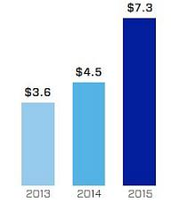

Performance Measures for 2015

- How We Set Performance Targets

Annually, the Compensation Committee approves the performance measures for the STIP and LTIP. The Compensation Committee reviews recommendations from management, receives input from the Compensation Committee consultant, evaluates the annual budget and mid-term business plan, and reviews prior-year performance to set value-creating goals tied to long-term shareholder value.

- 2015 STIP Performance Measures for NEOs

The STIP aligns with our plans to create the world’s most valued automotive company and increasing shareholder value. The STIP rewards NEOs for performance linked to the Company’s achievement of annual financial goals, operational performance goals, and individual performance. The STIP is an annual cash incentive award intended to be deductible under U.S. Internal Revenue Code (“IRC”) Section 162(m) and is funded for each covered NEO once the Company achieves the threshold of positive EBIT-Adjusted.

The Compensation Committee annually reviews and approves the goals to assess the difficulty in level of achievement and overall linkage to shareholders through the achievement of the business plan and strategic objectives.

Actual STIP awards, if any, are determined following the completion of the plan year by adjusting each NEO’s target incentive award opportunity to reflect the achievement against the performance measures displayed below. Awards can be further adjusted following a final assessment of individual performance. The table below describes each STIP performance measure, its weighting, its target, and the behaviors each measure drives to make GM the world’s most valued automotive company:

 | 2016 PROXY STATEMENT |  | 42

Back to Contents

STIP Measure | Weight |  | Target | Leadership Behaviors
EBIT-Adjusted | 25% | $ | 10.3B | Focus on operating profit and driving strong profitability
Adjusted AFCF⁽¹⁾ | 25% | $ | 3.8B | Focus on driving strong cash flow in the business
Global Market Share | 25% |  | 11.7% | Focus on continuing to grow in the global marketplace
Global Quality | 25% |  | (2) | Focus on developing and marketing the highest-quality products

- Adjusted AFCF for incentive purposes excludes payments related to certain recall-related expenses attributable to 2014.

- Global Quality is based on performance against the following measures: Loyalty (10% Weight), 12 Months-In-Service Warranty Frequency (10% Weight), and Policy & Warranty Expense (5% Weight).

The potential payouts for each performance measure range from 0 to 200 percent of target, based on actual Company performance with the threshold performance level being 50 percent of each STIP measure. The STIP calculation and the STIP targets for the 2015 performance period for each NEO are as follows:
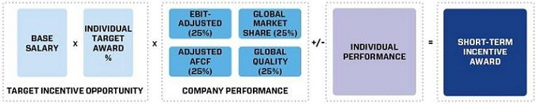

 |  |  | Target as % of
Name |  | Base Salary | Salary |  | Target STIP
Mary T. Barra | $ | 1,750,000 | 175% | $ | 3,062,500
Charles K. Stevens, III | $ | 1,000,000 | 125% | $ | 1,250,000
Daniel Ammann | $ | 1,200,000 | 125% | $ | 1,500,000
Mark L. Reuss | $ | 1,100,000 | 125% | $ | 1,375,000
Craig B. Glidden | $ | 700,000 | 125% | $ | 875,000

- 2015–2017 LTIP Performance Measures for NEOs

Grants under the LTIP are intended to link the financial interests of NEOs with the long-term interests of shareholders. The structure for NEOs included 75 percent PSUs and 25 percent RSUs. PSUs cliff-vest following the three-year performance period, and RSUs vest ratably over three years.
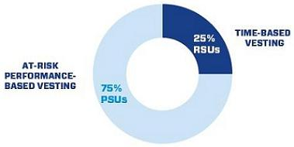

The 2015–2017 PSUs are awarded based on performance against the following Company measures: ROIC and Global Market Share over the three-year performance period. The PSU performance measures were chosen to promote both efficient use of capital and long-term growth to create value for the shareholders. The following table shows the PSU performance measures and the leadership behaviors that each drives to make GM the world’s most valued automotive company:

 | 2016 PROXY STATEMENT |  | 43

Back to Contents

LTIP Measure | Weight | Target | Leadership Behaviors
ROIC⁽¹⁾ |  |  | Focus on making sound investments that follow the disciplined capital approach of driving
ROIC⁽¹⁾ | 100% | 20% | 20% or higher returns in world-class vehicles and leading technology
Global Market
Share⁽²⁾ | Modifier | (3) | Focus on continuing to grow in the global marketplace

- The three-year average ROIC target is 20% and performance shall be calculated using the GM average annual ROIC for calendar years 2015, 2016, and 2017, where ROIC is calculated as Total Company EBIT-Adjusted divided by Average Total Company Net Assets. EBIT-Adjusted is defined as earnings excluding interest income, interest expense, and income taxes as well as certain additional adjustments. A discussion of EBIT-Adjusted, supplemental detail of all adjustments, and a reconciliation of GM’s automotive segments’ EBIT-Adjusted and GM Financial earnings before taxes-adjusted to net income attributable to shareholders is disclosed in Item 7, Management’s Discussion and Analysis of Financial Condition and Results of Operations, in our Annual Report on Form 10-K. Net Assets will be the four-quarter average for the year, adding back average automotive debt and interest liabilities (except capital leases) and automotive net Pension and OPEB liabilities and excluding average automotive net income tax assets.

- The three-year average Global Market Share target range performance shall be calculated using the GM average annual global market share for calendar years 2015, 2016, and 2017 as reported by GM Global Sales Reporting and reflected in the Annual Reports on Form 10-K.

- The Performance Target for Global Market Share will be disclosed at the end of the three-year performance period, as future Global Market Share measures are not disclosed.

PSUs, if any, vest and are awarded and delivered following the completion of the three-year performance period, January 1, 2015 –December 31, 2017, and may be awarded at a level between 0 and 200 percent of target based on actual Company results. Final PSU awards are calculated as follows:
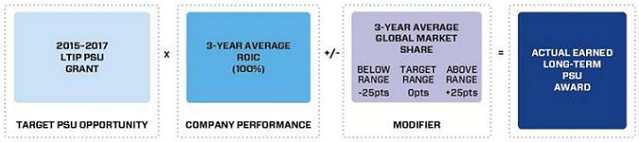

When determining grant amounts, the Compensation Committee considers the individual responsibilities, experience, performance, and market data. The following NEOs received equity grants as part of their 2015 structure:

 | PSUs⁽¹⁾ |  |  | RSUs⁽²⁾
 | Units | % of |  | Units | % of |  | Total Units
Name | Granted | Total Units |  | Granted | Total Units |  | Granted
Mary T. Barra | 238, 917 | 75% |  | 79,639 | 25% |  | 318,556
Charles K. Stevens, III | 57,241 | 75% |  | 19,081 | 25% |  | 76,322
Daniel Ammann | 89,594 | 75% |  | 29,865 | 25% |  | 119,459
Mark L. Reuss | 76,155 | 75% |  | 25,385 | 25% |  | 101,540
Craig B. Glidden | 39,297 | 75% |  | 13,099 | 25% |  | 52,396

- PSUs cliff-vest based on performance following the three-year performance period January 1, 2015 – December 31, 2017.

- RSUs vest ratably over the three-year period.

 | 2016 PROXY STATEMENT |  | 44

Back to Contents

- 2015–2020 Driving Stockholder Value Option Grant

On July 28, 2015, the Compensation Committee authorized a one-time DSV Option Grant for senior leaders under the 2014 LTIP. The purpose of the grant was to maintain the consistency in leadership needed for achieving the Company’s near-term and long-term goals as new competitors enter the automotive manufacturer market and actively seek to recruit our talent. The grant included both non-compete and non-solicitation terms and was intended to drive momentum as we make GM the world’s most valued automotive company.

Benefit to Shareholders Benefit to the Company Benefit to Senior Leaders

- Senior leaders aligned to the interests of shareholders
- Increased focus on GM stock price

- Stable leadership

- Non-compete and non-solicitation terms with senior leaders

- Upside potential on stock price appreciation due to business performance

The Compensation Committee established 40 percent of the award with time-based vesting to provide incentive for senior leaders to enter into non-compete and non-solicitation terms. The Compensation Committee chose to use TSR compared to the OEM Peer Group (displayed below) for the remaining 60 percent of the award to focus the senior leaders on our stock price performance against other OEMs. We understand investors can choose the automotive company in which to invest, and we must perform better than our competition.

VESTING SCHEDULE AND PERFORMANCE PERIODS
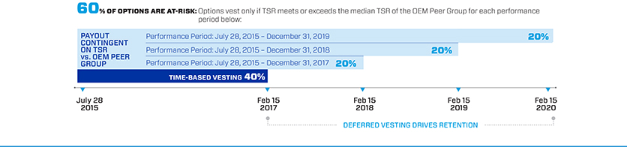

Dow Jones Automobiles & Parts Titans 30 Index – OEM Peer Group

Toyota Motor Company | Volkswagen AG | Suzuki Motor Corp.
Daimler AG | Bayerische Motoren Werke AG | Fiat Chrysler Automobiles NV
Ford Motor Company | Nissan Motor Co. Ltd. | Porsche Automobile Holding SE
Honda Motor Co. Ltd. | Renault SA | Mazda Motor Corp.
General Motors Co.⁽¹⁾ | Hyundai Motor Co. | Kia Motors Corp.

- General Motors Company is not factored in the TSR performance of the OEM Peer Group. For purposes of calculating the starting and ending stock prices for the OEM Peer Group and GM, the 30-trading day trailing average stock price converted to U.S. dollars prior to and including the grant date through each performance-period end date as described above.

Each of the NEOs received the following stock option award as part of the Driving Stockholder Value Option Grant:

 |  |  |  |  | 2018: 20% | 2019: 20% | 2020: 20%
 |  | Exercise | Total | 2017: 40% | TSR vs. OEM | TSR vs. OEM | TSR vs. OEM
Name |  | Price | Grant | Time-Based | Peer Group⁽¹⁾ | Peer Group⁽¹⁾ | Peer Group⁽¹⁾
Mary T. Barra | $ | 31.32 | 2,603,037 | 1,041, 215 | 520,608 | 520,607 | 520,607
Charles K. Stevens, III | $ | 31.32 | 623,645 | 249,458 | 124,729 | 124,729 | 124,729
Daniel Ammann | $ | 31.32 | 976,139 | 390,456 | 195,228 | 195,228 | 195,227
Mark L. Reuss | $ | 31.32 | 829,719 | 331,888 | 165,944 | 165,944 | 165,943
Craig B. Glidden | $ | 31.32 | 417, 571 | 167,029 | 83,514 | 83,514 | 83,514

- This portion of the award will be forfeited if TSR does not meet or exceed the median TSR of the OEM Peer Group for the measurement period.

 | 2016 PROXY STATEMENT |  | 45

Back to Contents

- Summary of Outstanding Performance Awards Granted in Prior Years

 |  |  | Performance
Award | Performance Period |  | Metrics | Vest Date |  | Potential Payouts | Performance Results
2014-2016 PSUs | 3 Years |  | ROIC (100%) | 2/11/2017 |  | Minimum - 0%
 | 1/1/2014 – 12/31/2016 |  | Global Market |  |  | Target – 100%
 |  |  | Share (Modifier) |  |  | Maximum – 200%
2015-2017 PSUs | 3 Years |  | ROIC (100%) | 2/11/2018 |  | Minimum - 0%
 | 1/1/2015 – 12/31/2017 |  | Global Market |  |  | Target – 100% | Performance
 |  |  | Share (Modifier) |  |  | Maximum – 200% | determined at the end
DSV Option Grant | 2.5 Years |  |  | 2/15/2018 |  | Minimum - 0% | of the performance
 | 7/28/2015 – 12/31/2017 |  |  |  |  | Minimum - 0% | period
 |  |  | TSR vs. OEM Peer |  |  | Target – 100%
 | 3.5 Years |  | TSR vs. OEM Peer | 2/15/2019 |  | Target – 100%
 | 7/28/2015 – 12/31/2018 |  | Group |  |  | Maximum – 100%
 | 4.5 Years |  |  | 2/15/2020
 | 7/28/2015 – 12/31/2019

2015 Performance Results and Compensation Decisions

- 2015 Short-Term Incentive Plan

The Company portion of the 2015 STIP award was calculated based on Company achievement of the following equally-weighted performance measures: EBIT–Adjusted, Adjusted AFCF, Global Market Share, and Quality. Actual 2015 Company performance in the combined measures produced an overall payout of 100 percent based on the achievement of the following levels for each measure as approved by the Compensation Committee:

 |  |  |  |  |  |  |  |  | Performance | Performance
STIP Measure | Weight |  | Threshold |  | Target |  | Maximum |  | Results | Payout
EBIT – Adjusted ($B) | 25% | $ | 6.6 | $ | 10.3 | $ | 13.2 | $ | 10.8 | 29%
Adjusted AFCF ($B)⁽¹⁾ | 25% | $ | 0.0 | $ | 3.8 | $ | 6.7 | $ | 4.5 | 31%
Global Market Share | 25% |  | 11.2% |  | 11.7% |  | 12.0% |  | 11.3%⁽²⁾ | 15%
Global Quality⁽³⁾ | 25% |  |  | Various Metrics |  |  |  |  | (4) | 25%
Result |  |  |  |  |  |  |  |  |  | 100%

- Adjusted AFCF for incentive purposes excludes payments related to certain recall-related expenses attributable to 2014.

- Global Market Share of 11.2% was achieved. When excluding the impact of the Company’s decision to exit unprofitable markets during 2015, the Global Market Share increases to 11.3%. The Compensation Committee determined the adjustment was warranted, which increased the payout from 13% to 15%.

- Global Quality Measures for 2015 included: Loyalty (10% Weight – Payout 14%), 12 Months-in-Service Warranty Frequency (10% Weight – Payout 7%), and Policy & Warranty Expense (5% Weight – Payout 4%; see footnote 4 below).

- Policy & Warranty Expense excludes certain recall campaign actions that resulted in true-ups to an initial reserve established in 2014 as a special charge. The Compensation Committee approved the adjustment to be consistent with how the target was set. This increased the Global Quality payout from 21% to 25%.

Individual performance may also influence final STIP awards. The compensation decision made for each individual executive is discussed beginning on the next page.

 | 2016 PROXY STATEMENT |  | 46

Back to Contents

- Compensation Decisions for Mary T. Barra

Mary T. Barra, Chief Executive Officer


Ms. Barra’s performance for 2015 was directly aligned with the Company’s 2015 strategic objectives:

Earn Customers for Life

- Continued relentless focus on safety, quality, innovation, customer preferences, and the overall ownership experience that puts the customer at the center of everything we do.

Grow Our Brands

- Launched 25 vehicles and strengthened all brands.

- Redefined the Cadillac brand image, focused on vehicle design and engineering, and premiered the “Dare Greatly” marketing and advertising campaign.

Lead in Technology and Innovation

- Focused on technology and innovation with several key programs, including our car-sharing programs, which we combined under our Maven brand in January 2016; next generation Volt and all-new Bolt concept; OnStar in vehicles on four continents; and introduced 4G LTE with Android Auto and Apple CarPlay.

Drive Core Efficiencies

- Expanded Operational Excellence training in 2015 and executed projects that resulted in savings exceeding $475 million.

Culture to Win

- Delivered on business plan and commitments two years in a row.

- Continued to attract top talent to the leadership team.

Effective January 1, 2015, the Compensation Committee increased Ms. Barra’s base salary from $1,600,000 to $1,750,000 based on her individual performance and the competitive market analysis provided by the Compensation Committee’s independent compensation consultant. The Compensation Committee awarded Ms. Barra an annual equity grant of $12 million consisting of 75 percent PSUs and 25 percent RSUs as discussed above. Ms. Barra participated in the one-time DSV Option Grant during 2015.

The total compensation for Ms. Barra in 2015, including salary, bonus, STIP and LTIP awards, and options is displayed below.

Pay Element | Majority of Pay Is At-Risk |  | Awarded Value
Base Salary | Fixed – Only Guaranteed Pay Element | $ | 1,750,000
STIP | Performance to Company Metrics | $ | 3,062,500
PSUs⁽¹⁾ | Performance to Company Metrics and Stock Price | $ | 9,000,003
RSUs⁽²⁾ | Performance to Stock Price | $ | 3,000,001
TOTAL |  | $ | 16,812,504
DSV Options⁽¹⁾ | Performance to Stock Price and TSR Against OEM Peer Group | $ | 11,167,029
TOTAL WITH ONE-TIME AWARDS |  | $ | 27,979,533

- PSUs and DSV Options are subject to performance vesting, and not all awards may vest as displayed.

- RSUs are subject to time-based vesting.

 | 2016 PROXY STATEMENT |  | 47

Back to Contents

- Compensation Decisions for Charles K. Stevens, III

Charles K. Stevens, III, Executive Vice President & Chief Financial Officer


Mr. Stevens met several objectives for 2015 performance against his goals including:

- Executed a comprehensive, aggressive, and proactive investor outreach program.

- Maintained strong external reporting, accounting, and control environment.

- Improved long-term cost benchmarks and action items.

- Executed on several key Finance priority initiatives and further improved the overall efficiencies of the Global Business Services organization, driving organizational savings.

Effective January 1, 2015, the Compensation Committee increased Mr. Stevens’ base salary from $700,000 to $1,000,000 based on his individual performance and the competitive market analysis provided by the Compensation Committee’s independent compensation consultant. The Compensation Committee awarded Mr. Stevens an annual equity grant of $2.875 million, consisting of 75 percent PSUs and 25 percent RSUs. Mr. Stevens participated in the one-time DSV Option Grant during 2015.

The Compensation Committee elected to provide an individual STIP adjustment for the 2015 performance year in the amount of $125,000 for Mr. Stevens as a result of his performance. The total compensation for Mr. Stevens in 2015, including salary, bonus, STIP and LTIP awards, and options is displayed below.

Pay Element | Majority of Pay Is At-Risk |  | Awarded Value
Base Salary | Fixed – Only Guaranteed Pay Element | $ | 1,000,000
STIP | Performance to Metrics | $ | 1,250,000
STIP Individual Adjustment | Performance – Based on Individual Results | $ | 125,000
PSUs⁽¹⁾ | Performance to Metrics and Stock Price | $ | 2,156,268
RSUs⁽²⁾ | Performance to Stock Price | $ | 718,781
TOTAL |  | $ | 5,250,049
DSV Options⁽¹⁾ | Performance to Stock Price and TSR Against OEM Peer Group | $ | 2,675,437
TOTAL WITH ONE-TIME AWARDS |  | $ | 7,925,486

- PSUs and DSV Options are subject to performance vesting, and not all awards may vest as displayed.

- RSUs are subject to time-based vesting.

 | 2016 PROXY STATEMENT |  | 48

Back to Contents

- Compensation Decisions for Daniel Ammann

Daniel Ammann, President

Mr. Ammann met several objectives for 2015 performance against his goals including:

- Launched GM Financial as a full automotive captive in the United States for all GM brands.

- Improved the Chevrolet brand opinion, resulting in record high momentum in the U.S. and significantly improved the brand opinion in other key countries, including Argentina, South Korea, and India.
- Redefined the Cadillac brand positioning, brand values, and brand campaign with the successful “Dare Greatly” advertising campaign.

- Improved the financial position of General Motors Europe and made significant progress toward profitability in the region.

Effective January 1, 2015, the Compensation Committee increased Mr. Ammann’s base salary from $1,000,000 to $1,200,000 based on his individual performance and the competitive market analysis provided by the Compensation Committee’s independent compensation consultant. The Compensation Committee awarded Mr. Ammann an annual equity grant of $4.5 million, consisting of 75 percent PSUs and 25 percent RSUs. Mr. Ammann participated in the one-time DSV Option Grant during 2015.

The Compensation Committee elected to provide an individual performance adjustment to Mr. Ammann’s 2015 STIP award for $150,000 due to the key business results achieved. The total compensation for Mr. Ammann in 2015, including salary, bonus, STIP and LTIP awards, and options is displayed below.

 | Pay Element | Majority of Pay Is At-Risk |  | Awarded Value
 | Base Salary | Fixed – Only Guaranteed Pay Element | $ | 1,200,000
 | STIP | Performance to Metrics | $ | 1,500,000
 | STIP Individual Adjustment | Performance – Based on Individual Results | $ | 150,000
 | PSUs⁽¹⁾ | Performance to Metrics and Stock Price | $ | 3,375,006
 | RSUs⁽²⁾ | Performance to Stock Price | $ | 1,125,015
 | TOTAL |  | $ | 7,350,021
 | DSV Options⁽¹⁾ | Performance to Stock Price and TSR Against OEM Peer Group | $ | 4,187,636
 | TOTAL WITH ONE-TIME AWARDS |  | $ | 11,537,657

- PSUs and DSV Options are subject to performance vesting, and not all awards may vest as displayed.

- RSUs are subject to time-based vesting.

 | 2016 PROXY STATEMENT |  | 49

Back to Contents

- Compensation Decisions for Mark L. Reuss

Mark L. Reuss, Executive Vice President, Global Product Development, Purchasing and Supply Chain


Mr. Reuss met several objectives for 2015 performance against his goals including:

- Delivered an increased focus on customer safety, resulting in GM being publically recognized by NHTSA as the model company for others to follow.

- Awarded numerous product awards, including Motor Trend Car of the Year for the 2016 Chevrolet Malibu and Motor Trend Truck of the Year for the 2016 Chevrolet Colorado.
- Increased the use of technology across GM’s product portfolio.

- Focused on new vehicle launches in partnership with manufacturing.

- Achieved realized savings in material costs and logistics in excess of $2 billion.

Effective January 1, 2015, the Compensation Committee increased Mr. Reuss’ base salary from $850,000 to $1,100,000 based on his individual performance and the competitive market analysis provided by the Compensation Committee’s independent compensation consultant. The Compensation Committee awarded Mr. Reuss an annual equity grant of $3.825 million, consisting of 75 percent PSUs and 25 percent RSUs. Mr. Reuss participated in the one-time DSV Option Grant in 2015.

The Compensation Committee awarded an individual performance adjustment to the STIP payout of $140,000 for Mr. Reuss as a result of performance against goals. The total compensation for Mr. Reuss in 2015, including salary, bonus, STIP and LTIP awards, and options is displayed below.

Pay Element | Majority of Pay Is At-Risk |  | Awarded Value
Base Salary | Fixed – Only Guaranteed Pay Element | $ | 1,100,000
STIP | Performance to Metrics | $ | 1,375,000
STIP Individual Adjustment | Performance – Based on Individual Results | $ | 140,000
PSUs⁽¹⁾ | Performance to Metrics and Stock Price | $ | 2,868,759
RSUs⁽²⁾ | Performance to Stock Price | $ | 956,253
TOTAL |  | $ | 6,440,012
DSV Options⁽¹⁾ | Performance to Stock Price and TSR Against OEM Peer Group | $ | 3,559,495
TOTAL WITH ONE-TIME AWARDS |  | $ | 9,999,507

- PSUs and DSV Options are subject to performance vesting, and not all awards may vest as displayed.

- RSUs are subject to time-based vesting.

 | 2016 PROXY STATEMENT |  | 50

Back to Contents

- Compensation Decisions for Craig B. Glidden

Craig B. Glidden, Executive Vice President & General Counsel

Mr. Glidden met several objectives for 2015 performance against his goals including:

- Resolved complex legal matters.

- Assumed responsibility of the Public Policy function in addition to his duties as General Counsel.

- Restructured the Legal Staff to align with the business and filled several key roles with proven and accomplished legal professionals.

Mr. Glidden joined General Motors as Executive Vice President & General Counsel on March 1, 2015, with an annual base salary of $700,000. Effective April 1, 2015, with Compensation Committee approval, Mr. Glidden received a one-time cash sign-on bonus in the amount of $500,000 and an equity sign-on RSU grant of 69,407 shares with a grant date value of $2.55 million to replace awards being forfeited at his previous employer. Additionally, the Compensation Committee authorized an annual equity grant of $1.925 million, consisting of 75 percent PSUs and 25 percent RSUs. Mr. Glidden also participated in the one-time DSV Option Grant in 2015.

The Compensation Committee awarded an individual performance adjustment to the STIP payout of $70,000 for Mr. Glidden as a result of performance against goals. The total compensation for Mr. Glidden in 2015, including salary, bonus, STIP and LTIP awards, options, and sign-on awards is displayed below.

Pay Element | Majority of Pay Is At-Risk |  | Awarded Value
Base Salary | Fixed – Only Guaranteed Pay Element | $ | 583,333
STIP | Performance to Metrics | $ | 875,000
STIP Individual Adjustment | Performance – Based on Individual Results | $ | 70,000
PSUs⁽¹⁾ | Performance to Metrics and Stock Price | $ | 1,443,772
RSUs⁽²⁾ | Performance to Stock Price | $ | 481,257

TOTAL |  | $ | 3,453,362
DSV Options⁽¹⁾ | Performance to Stock Price and TSR Against OEM Peer Group | $ | 1,791,380
Sign-On Cash | One-Time Sign-On Cash Award | $ | 500,000
Sign-On RSUs⁽²⁾ | Performance to Stock Price | $ | 2,550,013
TOTAL WITH ONE-TIME AWARDS |  | $ | 8,294,755

- PSUs and DSV Options are subject to performance vesting, and not all awards may vest as displayed.

- RSUs are subject to time-based vesting.

 | 2016 PROXY STATEMENT |  | 51

Back to Contents

Compensation Policies and Governance Practices

- Stock Ownership Requirements

In June 2014, in conjunction with shareholder approval of the STIP and LTIP, the Compensation Committee implemented stock ownership requirements to more closely align the interests of executives with those of our shareholders. The requirements:

  - cover approximately 300 senior leaders;

- set five years as the time frame for ownership requirements;

- establish a multiple of each executive’s base salary on the date they are first covered; and

- make it possible to meet ownership requirements by owning a multiple of base or required shares.

The table to the right shows the stock ownership requirement by level in the Company as well as ownership requirements for each of our NEOs.

 | Ownership Requirement
Position | as a Multiple of Salary
• CEO | 6x
• President | 4x
• Executive Vice President | 4x
• Senior Vice President | 3x
• Senior Executive | 1x

The share requirement to meet ownership guidelines is based on the 12-month trailing stock price from June 30 in the year the senior leader is first covered by stock ownership requirements. As of December 31, 2015, all NEOs are on track to meet stock ownership requirements by their respective dates.

- Policy on Recoupment of Incentive Compensation

We have adopted a corporate policy to recover incentive compensation paid to executive officers in cases where financial statements are restated because of employee fraud, negligence, or intentional misconduct. Under this clawback policy, which is posted on our website, www.gm.com/investor, under “Corporate Governance,” if our Board or an appropriate Board Committee determines any bonus, retention award, or short or long-term incentive compensation has been paid to any executive officer based on materially inaccurate misstatement of earnings, revenues, gains, or other criteria, the Board or Compensation Committee will take the action it deems necessary to recover the compensation paid, remedy the misconduct, and prevent its recurrence. For this purpose, a financial statement or performance metric will be treated as materially inaccurate when an employee knowingly engaged in providing inaccurate information or knowingly failed to timely correct information relating to those financial statements or performance metrics. We will continue to review our policy to ensure it is consistent with all legal requirements and in the best interests of the Company and its shareholders.

- Securities Trading Policy

Our securities trading policy prohibits our employees from buying or selling GM securities when in possession of material nonpublic information. Any sale or purchase of common stock by directors and executive officers must be made according to a Rule 10b5-1 plan or during pre-established periods after receiving preclearance by a member of the GM Legal Staff.

Trading in GM derivatives (i.e., puts or calls), engaging in short sales, and pledging of GM securities is also prohibited. All GM executive officers are in compliance with the policy of not pledging any shares of common stock. This policy is posted on our website, www.gm.com/investor, under “Corporate Governance.”

- Tax Considerations

IRC Section 162(m) generally disallows federal tax deductions for compensation in excess of $1 million paid to the CEO and the next three of our highest-paid officers (other than the CFO) whose compensation is required to be reported in the Summary Compensation Table of this Proxy Statement (“Covered Executives”). Certain performance-based compensation is not subject to this deduction limitation. Generally, we strive to maximize the tax deductibility of compensation arrangements. The Compensation Committee, however, may award compensation that is not fully tax deductible if it deems it appropriate as compensation designed to attract and retain talented executives in the highly competitive market for talent.

STIP awards are paid based on the achievement of performance measures approved by shareholders in 2014 as part of the 2014 STIP. Because the STIP awards are intended to be deductible as performance-based compensation under 162(m), the Compensation Committee set the maximum award for each NEO (except the CFO) at $7.5 million. Incentive amounts equal to the maximum will be funded for each covered executive officer once a threshold level of positive EBIT-Adjusted has been achieved. The Compensation Committee then exercises negative discretion, as needed, to determine actual incentive awards based on other business and individual performance, as described in the “Short-Term Incentive Plan” section of the CD&A.

 | 2016 PROXY STATEMENT |  | 52

Back to Contents

- Compensation Committee and Consultant Independence

Our Compensation Committee is composed entirely of independent directors as determined by the Board under NYSE standards and as defined for various regulatory purposes. Farient Advisors assisted the Compensation Committee in 2015. Farient Advisors is an independent compensation consulting firm that takes direction from and is solely responsible to the Compensation Committee. The Compensation Committee is also aided in its deliberations by in-house legal counsel.

Under its charter, the Compensation Committee has the authority to hire outside consultants and advisors at the Company’s expense. The Compensation Committee retains the services of Farient Advisors for advice on issues related to the compensation of NEOs and other executive compensation-related matters. A representative of Farient Advisors attended all Compensation Committee meetings, either in person or via telephone, consulted with and advised the Compensation Committee members on executive compensation, including the structure and amounts of various pay elements, and developed executive benchmarking data for the Compensation Committee. Farient Advisors provided no services to the Company’s management.

The Compensation Committee annually reviews the performance of the compensation consultant and considers the following factors when assessing consultant independence in accordance with NYSE standards:

  - Services provided to GM management outside of the services provided to the Compensation Committee;

- Fees paid as a percentage of Farient Advisors’ total revenue;

- Policies and procedures of Farient Advisors designed to prevent conflicts of interest;

- Any business or personal relationships with members of the Compensation Committee;

- Stock ownership by employees of Farient Advisors; and

  - Any business or personal relationships between GM and Farient Advisors

The Compensation Committee reviewed the performance and independence of Farient Advisors and no performance or independence issues were identified.

- Compensation Risk Assessment

During 2015, the Compensation Committee reviewed and discussed the impact of executive compensation programs on organizational risk. The Compensation Committee discussed plans and reviewed risk mitigation features in each of the plans to evaluate, with the assistance of our risk management organization, the overall impact compensation programs have on organizational risk. The Compensation Committee determined compensation programs have sufficient risk mitigation features and do not encourage or reward employees for taking excessive or unnecessary risk. The mix of our short and long-term compensation programs appropriately reward employees while balancing risk through the delayed payment of long-term awards.

As a result of the compensation risk review completed on December 8, 2015, the Compensation Committee determined the overall risk of compensation programs exposing the organization to unnecessary or excessive risks is low.

- Employment and Termination Agreements

The Company has no employment or termination agreements with any of our 2015 NEOs. All NEOs are eligible to receive the same severance treatment available to other executive employees.

Compensation Committee Report

The Compensation Committee has reviewed and discussed with management the CD&A and, based on that review and discussion, has recommended to the Board of Directors that the CD&A be included in this Proxy Statement and incorporated by reference in the GM 2015 Annual Report on Form 10-K.

Compensation Committee

Carol M. Stephenson (Chair)

Joseph Jimenez

James J. Mulva

Patricia F. Russo

 | 2016 PROXY STATEMENT |  | 53

Back to Contents

Executive Compensation Tables

- 2015 Summary Compensation Table

 |  |  |  |  |  |  | Change in
 |  |  |  |  |  |  | Pension
 |  |  |  |  |  |  | Value and
 |  |  |  |  |  | Nonequity | NQ Deferred
Name and |  |  |  | Stock | Option | Incentive Plan | Compensation | All Other
Principal |  | Salary | Bonus⁽³⁾ | Awards⁽⁴⁾ | Awards⁽⁵⁾ | Compensation⁽⁶⁾ | Earnings⁽⁷⁾ | Compensation⁽⁸⁾ | Total
Position⁽¹⁾⁽²⁾ | Year | ($) | ($) | ($) | ($) | ($) | ($) | ($) | ($)
Mary T. Barra⁽¹⁾ | 2015 | 1,750,000 | – | 12,000,004 | 11,167,029 | 3,062,500 | 12,012 | 597,118 | 28,588,663
Chief Executive | 2014 | 1,567,803 | – | 11,760,567 | – | 2,072,000 | 349,926 | 412,532 | 16,162,828
Officer | 2013 | 750,000 | – | 4,446,504 | – | – | – | 36,636 | 5,233,140
Charles K. Stevens, III | 2015 | 1,000,000 | – | 2,875,049 | 2,675,437 | 1,375,000 | – | 176,738 | 8,102,224
Executive Vice President | 2014 | 691,667 | – | 3,177,354 | – | 647,500 | 265,201 | 113,110 | 4,894,832
& Chief Financial Officer
Daniel Ammann | 2015 | 1,200,000 | – | 4,500,021 | 4,187,636 | 1,650,000 | – | 262,420 | 11,800,077
President | 2014 | 990,530 | – | 6,310,564 | – | 925,000 | – | 263,252 | 8,489,346
 | 2013 | 750,000 | – | 4,481,562 | – | – | – | 28,475 | 5,260,037
Mark L. Reuss | 2015 | 1,100,000 | – | 3,825,012 | 3,559,495 | 1,515,000 | – | 199,629 | 10,199,136
Executive Vice | 2014 | 846,212 | – | 7,458,881 | – | 786,300 | 275,588 | 110,796 | 9,477,777
President, Global
Product Development,
Purchasing and Supply
Chain
Craig B. Glidden | 2015 | 583,333 | 500,000 | 4,475,042 | 1,791,380 | 945,000 | – | 145,064 | 8,439,819
Executive Vice President
& General Counsel

- Titles in the table reflect the NEOs’ positions as of December 31, 2015; Mary Barra was elected Chairman of the Board of Directors on January 4, 2016.

- Messrs. Stevens and Reuss were not NEOs in 2013, and Mr. Glidden was not employed by the Company prior to 2015.

- For Mr. Glidden, the amount includes a cash sign-on bonus of $500,000.

- Stock Awards displays the grant date fair value computed in accordance with Financial Accounting Standards Board (“FASB”) Accounting Standards Codification (“ASC”) Topic 718 and include RSUs and PSUs at target. The maximum award for PSUs for the 2015–2017 performance period is 200% of grant, the value at the time of grant was $37.67 per share. The table below shows the maximum PSU grant and value based on the grant date value of $37.67 per share. The value at the time of grant for Mr. Glidden was $36.74 for both PSUs and RSUs.

 | Maximum PSU Grant | Maximum PSU Grant Value
 | (#) | ($)
Mary T. Barra | 477,834 | 18,000,007
Charles K. Stevens, III | 114,482 | 4,312,537
Daniel Ammann | 179,188 | 6,750,012
Mark L. Reuss | 152,310 | 5,737,518
Craig B. Glidden | 78,594 | 2,887,544

- Option Awards displays the grant date fair value, computed in accordance with FASB ASC Topic 718, for the DSV Option Grant. All options use the grant date closing price of $31.32 as the exercise price for each option granted.

- Each NEO was eligible for a payment under the STIP for 2015 performance based on the Company’s achievement of annual financial goals, operational and performance goals, and individual performance. The amounts displayed represent the Company performance portion of the annual STIP at 100% with adjustments for individual performance as follows: Mr. Stevens received an additional $125,000, Mr. Ammann received an additional $150,000, Mr. Reuss received an additional $140,000, and Mr. Glidden received an additional $70,000. Individual performance adjustments are based on performance against individual goals for each NEO determined by the Compensation Committee at the beginning of each year.

- These amounts represent the actuarial change in the present value of the executive’s accrued benefit for 2015 attributed to year-over-year variances in applicable discount rates, lump sum interest rate, mortality rates, and employer contributions to tax-qualified and non-tax qualified plans as described in the section titled “Pension Benefits” on page 58. The Company does not credit interest at above-market rates to any deferred accounts, and no interest amounts are included in these totals. Mr. Stevens had a decrease in the present value of his pension in the amount of $6,968, and Mr. Reuss had a decrease in the amount of $9,106. Mr. Ammann and Mr. Glidden are not eligible for defined benefit pension plans.

- Totals for amounts included as “All Other Compensation” are described in the table below

 | 2016 PROXY STATEMENT |  | 54

Back to Contents

All Other Compensation

 | M.T. Barra | C.K. Stevens | D. Ammann | M.L. Reuss | C.B. Glidden
 | ($) | ($) | ($) | ($) | ($)
Perquisites and Other Personal | 286,848 | 32,216 | 127,150 | 37,440 | 31,058
Benefits⁽¹⁾
Employer Contributions to Savings | 299,320 | 138,850 | 133,000 | 157,178 | 45,500
Plans⁽²⁾
Life and Other Insurance Benefits⁽³⁾ | 8,511 | 5,672 | 2,270 | 5,011 | 2,862
Other⁽⁴⁾ | 2,439 | – | – | – | 65,644
TOTAL | 597,118 | 176,738 | 262,420 | 199,629 | 145,064

- See Perquisites and Other Personal Benefits table below for additional information.

- Includes employer contributions to tax-qualified and non-tax qualified savings and retirement plans during 2015.

- Includes premiums paid by the Company for Group Variable Universal Life insurance for executives. Executives are responsible for any ordinary income taxes resulting from the cost of the GM-paid premiums. For Ms. Barra, amounts also include the Company’s cost of premiums for providing personal accident insurance for members of the Board.

- Amounts for Ms. Barra are related to tickets to various GM-sponsored events. Amounts for Mr. Glidden include $65,644 for costs associated with his relocation to Detroit, Michigan.

Perquisites and Other Personal Benefits

 | M.T. Barra | C.K. Stevens | D. Ammann | M.L. Reuss | C.B. Glidden
 | ($) | ($) | ($) | ($) | ($)
Personal Travel⁽¹⁾ | 187,906 | – | – | – | –
Security⁽²⁾ | 47,280 | – | 87,750 | – | –
Company Vehicle Programs⁽³⁾ | 35,802 | 21,856 | 28,543 | 22,080 | 16,938
Executive Physical⁽⁴⁾ | 5,500 | – | – | 5,000 | 5,250
Financial Counseling⁽⁵⁾ | 10,360 | 10,360 | 10,857 | 10,360 | 8,870
TOTAL | 286,848 | 32,216 | 127,150 | 37,440 | 31,058

- Personal travel pursuant to Company policy as discussed on page 41. Includes both the full cost of chartered aircraft and the incremental cost when using Company-owned aircraft. Incremental costs include fuel, flight crew expenses, landing fees, ground transportation fees, and other miscellaneous variable expenses.

- Amounts include the actual costs of residential security system upgrades for Ms. Barra as recommended by independent security consultants. Mr. Ammann relocated to Detroit, Michigan in 2014 and purchased a home in 2015. Amounts for Mr. Ammann include the costs of residential security system upgrades and installations as recommended by independent security consultants.

- Company vehicle programs include the incremental cost of cars and drivers provided by the Company for various events and incremental costs to maintain the Executive Company Vehicle Program fleet. Participants in the program evaluate the vehicles they drive and provide feedback. Participants are charged imputed income based on the value of the vehicles they choose to drive. Taxes assessed on imputed income are the responsibility of the participant.

- Costs associated with executive physicals for each executive with approved providers.

- Costs associated with financial counseling and estate planning services with approved providers.

 | 2016 PROXY STATEMENT |  | 55

Back to Contents

- Grants of Plan–Based Awards

Grants were made to each NEO under the 2014 LTIP. Each grant consisted of PSUs and RSUs for each NEO. PSUs, which vest and deliver at the end of the performance period, will be earned at a level between 0 and 200 percent of target. PSUs are based on the achievement of performance conditions relating to ROIC and Global Market Share over a three-year performance period from January 1, 2015 to December 31, 2017. The RSUs will vest ratably over the three-year period.

On July 28, 2015, the Compensation Committee granted stock options in exchange for executives agreeing to non-compete and non-solicitation terms. On February 15, 2017, 40 percent of the option grant will vest, and the remaining 60 percent will vest on each February 15 in 2018, 2019, and 2020 only if the Company meets the TSR performance conditions as described above on page 45.

 |  |  |  |  |  |  |  |  |  |  |  |  | All Other | All Other
 |  |  |  | Estimated Future Payouts |  |  |  | Estimated Future Payouts |  |  |  |  | Stock | Option | Exercise
 |  |  |  |  |  |  |  |  |  |  |  |  | Awards: | Awards: | or Base | Grant Date
 |  |  |  | Under Non-Equity Incentive |  |  |  | Under Equity Incentive |  |  |  |  | Number of | Number of | Price of | Fair Value
 |  |  |  | Plan Awards |  |  |  | Plan Awards |  |  |  |  | Shares of | Securities | Option | of Stock
 | Award |  | Approval | Threshold | Target | Maximum |  | Threshold | Target |  | Maximum |  | Stock or | Underlying | Awards | and Options
Name | Type | Grant Date | Date | ($) | ($) | ($) |  | (#) | (#) |  | (#) |  | Units (#) | Options (#) | ($/share) | Awards($)⁽¹⁾
Mary T. Barra | STIP | 1/20/2015 | 1/20/2015 | 382,813 3,062,500 6,125,000
 | RSU | 2/11/2015 | 1/20/2015 |  |  |  |  |  |  |  |  |  | 79,639 |  |  | 3,000,001
 | PSU | 2/11/2015 | 1/20/2015 |  |  |  |  | 59,730 | 238,917 |  | 477,834 |  |  |  |  | 9,000,003
 | DSV | 7/28/2015 | 7/28/2015 |  |  |  |  | 1,561,822 | 1,561,822 | 1,561,822 |  |  |  | 1,041,215 | 31.32 | 11,167,029
 | Options⁽²⁾
Charles K. | STIP | 1/20/2015 | 1/20/2015 | 156,250 1,250,000 2,500,000
Stevens, III | RSU | 2/11/2015 | 1/20/2015 |  |  |  |  |  |  |  |  |  | 19,081 |  |  | 718, 781
 | PSU | 2/11/2015 | 1/20/2015 |  |  |  |  | 14,311 | 57,241 |  | 114,482 |  |  |  |  | 2,156,268
 | DSV | 7/28/2015 | 7/28/2015 |  |  |  |  | 374,187 | 374,187 |  | 374,187 |  |  | 249,458 | 31.32 | 2,675,437
 | Options⁽²⁾
Daniel
Ammann | STIP | 1/20/2015 | 1/20/2015 | 187,500 1,500,000 3,000,000
 | RSU | 2/11/2015 | 1/20/2015 |  |  |  |  |  |  |  |  |  | 29,865 |  |  | 1,125,015
 | PSU | 2/11/2015 | 1/20/2015 |  |  |  |  | 22,399 | 89,594 |  | 179,188 |  |  |  |  | 3,375,006
 | DSV | 7/28/2015 | 7/28/2015 |  |  |  |  | 585,683 | 585,683 |  | 585,683 |  |  | 390,456 | 31.32 | 4,187,636
 | Options⁽²⁾
Mark L. Reuss STIP |  | 1/20/2015 | 1/20/2015 | 171,875 1,375,000 2,750,000
 | RSU | 2/11/2015 | 1/20/2015 |  |  |  |  |  |  |  |  |  | 25,385 |  |  | 956,253
 | PSU | 2/11/2015 | 1/20/2015 |  |  |  |  | 19,039 | 76,155 |  | 152,310 |  |  |  |  | 2,868,759
 | DSV | 7/28/2015 | 7/28/2015 |  |  |  |  | 497,831 | 497,831 |  | 497,831 |  |  | 331,888 | 31.32 | 3,559,495
 | Options⁽²⁾
Craig B. | STIP | 1/20/2015 | 1/20/2015 | 109,375 | 875,000 1,750,000
Glidden
 | RSU | 4/1/2015 | 1/20/2015 |  |  |  |  |  |  |  |  |  | 13,099 |  |  | 481,257
 | RSU | 4/1/2015 | 1/20/2015 |  |  |  |  |  |  |  |  |  | 69,407⁽³⁾ |  |  | 2,550,013
 | PSU | 4/1/2015 | 1/20/2015 |  |  |  |  | 9,825 | 39,297 |  | 78,594 |  |  |  |  | 1,443,772
 | DSV | 7/28/2015 | 7/28/2015 |  |  |  |  | 250,542 | 250,542 |  | 250,542 |  |  | 167,029 | 31.32 | 1,791,380
 | Options⁽²⁾

- This column shows the aggregate grant date fair value of PSUs, RSUs, and stock options granted to the NEOs in 2015. The aggregate grant date fair value is the amount that the Company expects to expense in its financial statements over the award’s vesting schedule. All grant date fair values have been computed in accordance with FASB ASC Topic 718.

  - For RSUs, grant date fair value is calculated based on the closing price of the common stock on the grant date.

  - For PSUs, grant date fair value is calculated based on the closing price of the common stock on the grant date at target.

  - For DSV Options, grant date fair value is calculated using option valuation methodologies to value each option on the grant date, resulting in a $4.29 per unit value.

- DSV Options displayed under “Estimated Future Payouts Under Equity Incentive Plan Awards” represent 60% of the overall grant featuring performance-based vesting as described on page 45. Amounts displayed under All Other Option Awards represent 40% of the overall grant featuring time-based vesting. The DSV Options are valued in accordance with FASB ASC Topic 718. All options use the grant date closing price of $31.32 as the exercise price for each option granted.

- The 69,407 RSUs granted to Mr. Glidden was a one-time award to replace equity forfeited at a prior employer.

 | 2016 PROXY STATEMENT |  | 56

Back to Contents

- Outstanding Equity Awards at Fiscal Year-End

 |  |  | Option Awards |  |  |  |  |  | Stock Awards⁽¹⁾
 |  |  |  |  |  |  |  |  |  |  | Equity
 |  |  |  |  |  |  |  |  |  | Equity | Incentive
 |  |  |  | Equity |  |  |  |  |  | Incentive | Plan Awards:
 |  |  |  | Incentive |  |  |  |  |  | Plan Awards: | Market or
 |  | Number of | Number of | Plan Awards: |  |  |  |  | Market | Number of | Payout Value
 |  | Securities | Securities | Number of |  |  |  | Number | Value of | Unearned | of Unearned
 |  | Underlying | Underlying | Securities |  |  |  | of Shares | Shares or | Shares, Units, | Shares, Units,
 |  | Unexercised | Unexercised | Underlying |  |  |  | of Units or | Units of | or Other | or Other
 |  | Options | Options | Unexercised | Option |  | Option | Stock That | Stock That | Rights That | Rights That
 | Grant | Exercisable | Unexercisable | Unearned | Exercise |  | Expiration | Have Not | Have Not | Have Not | Have Not
Name | Date | (#) | (#) | Options (#) | Price ($) |  | Date | Vested (#) | Vested ($) | Vested (#) | Vested ($)
Mary T. Barra | 7/28/2015 | – | 1,041, 215⁽²⁾ | 1,561,822⁽³⁾ | 31.32 |  | 7/28/2025
 | 2/11/2015 |  |  |  |  |  |  | 79,639⁽⁴⁾ | 2,708,522 | 238,917⁽⁵⁾ | 8,125,567
 | 6/11/2014 |  |  |  |  |  |  | 46,143⁽⁴⁾ | 1,569,323 | 207,642⁽⁵⁾ | 7,061,904
 | 2/13/2014 |  |  |  |  |  |  |  |  | 37, 511⁽⁶⁾ | 1,275,749
 | 3/1/2013 |  |  |  |  |  |  |  |  | 14,749⁽⁶⁾ | 501,613
Charles K. Stevens,III | 7/28/2015 | – | 249,458⁽²⁾ | 374,187⁽³⁾ | 31.32 |  | 7/28/2025
 | 2/11/2015 |  |  |  |  |  |  | 19,081⁽⁴⁾ | 648,945 | 57,241⁽⁵⁾ | 1,946,766
 | 6/11/2014 |  |  |  |  |  |  | 11,190⁽⁴⁾ | 380,572 | 50,353⁽⁵⁾ | 1,712,506
 | 2/13/2014 |  |  |  |  |  |  | 17,148⁽⁴⁾ | 583,203
 | 3/1/2013 |  |  |  |  |  |  | 7,374⁽⁴⁾ | 250,790
Daniel Ammann | 7/28/2015 | – | 390,456⁽²⁾ | 585,683⁽³⁾ | 31.32 |  | 7/28/2025
 | 2/11/2015 |  |  |  |  |  |  | 29,865⁽⁴⁾ | 1,015,709 | 89,594⁽⁵⁾ | 3,047,092
 | 6/11/2014 |  |  |  |  |  |  | 20,995⁽⁴⁾ | 714,040 | 94,477⁽⁵⁾ | 3,213,163
 | 2/13/2014 |  |  |  |  |  |  |  |  | 37,511⁽⁶⁾ | 1,275,749
 | 3/1/2013 |  |  |  |  |  |  |  |  | 15,210⁽⁶⁾ | 517,292
Mark L. Reuss | 7/28/2015 | – | 331,888⁽²⁾ | 497,831⁽³⁾ | 31.32 |  | 7/28/2025
 | 2/11/2015 |  |  |  |  |  |  | 25,385⁽⁴⁾ | 863,344 | 76,155⁽⁵⁾ | 2,590,032
 | 6/11/2014 |  |  |  |  |  |  | 17,938⁽⁴⁾ | 610,071 | 80,721⁽⁵⁾ | 2,745,321
 | 2/13/2014 |  |  |  |  |  |  | 57,160⁽⁷⁾ | 1,944,012 | 33,224⁽⁶⁾ | 1,129,948
 | 3/1/2013 |  |  |  |  |  |  |  |  | 12,905⁽⁶⁾ | 438,899
Craig B. Glidden | 7/28/2015 | – | 167,029⁽²⁾ | 250,542⁽³⁾ | 31.32 |  | 7/28/2025
 | 4/1/2015 |  |  |  |  |  |  | 13,099⁽⁴⁾ | 445,497 | 39,297⁽⁵⁾ | 1,336,491
 | 4/1/2015 |  |  |  |  |  |  | 69,407⁽⁸⁾ | 2,360,532

- The awards are valued based on the closing price of common stock on the NYSE on December 31, 2015, which was $34.01.

- Option awards granted under the DSV Option Grant on July 28, 2015 to Ms. Barra and Messrs. Stevens, Ammann, Reuss, and Glidden. This portion represents the 40% of the award that features time-based vesting and vests on February 15, 2017.

- Option awards granted under the DSV Option Grant on July 28, 2015 to Ms. Barra and Messrs. Stevens, Ammann, Reuss, and Glidden. This portion represents the 60% of the award that features performance-based vesting and vests ratably each February 15 of 2018, 2019, and 2020.

- RSU awards were granted to Ms. Barra and Messrs. Stevens, Ammann, and Reuss on February 11, 2015, and Mr. Glidden on April 1, 2015. RSUs granted in 2015 vest ratably each February 11 of 2016, 2017, and 2018. RSU awards were granted to Ms. Barra and Messrs. Stevens, Ammann, and Reuss on June 11, 2014, and vest ratably each February 13 of 2015, 2016, and 2017. RSUs granted to Mr. Stevens on February 13, 2014, and March 1, 2013, vest ratably over three years on each anniversary of the grant date.

- PSU awards were granted to Ms. Barra and Messrs. Stevens, Ammann, and Reuss on February 11, 2015, and Mr. Glidden on April 1, 2015. PSUs granted in 2015 cliff-vest on February 11, 2018, upon completion of results for the performance period January 1, 2015 – December 31, 2017. PSUs were granted to Ms. Barra and Messrs. Stevens, Ammann, and Reuss on June 11, 2014. PSUs granted in 2014 cliff-vest on February 13, 2017, upon completion of results for the performance period January 1, 2014 – December 31, 2016.

- Troubled Asset Relief Program (the “TARP”) RSU awards were granted to Ms. Barra and Messrs. Amman and Reuss on February 13, 2014, and March 1, 2013. TARP RSUs vest two-thirds on the second anniversary of the grant date and one-third on the third anniversary of the grant date.

- RSUs granted to Mr. Reuss for retention purposes on February 13, 2014 cliff-vest on February 13, 2017.

- Sign-on RSUs granted to Mr. Glidden on April 1, 2015 vest, 50% on April 1, 2016, and 50% on April 1, 2017.

 | 2016 PROXY STATEMENT |  | 57

Back to Contents

- Option Exercises and Stock Vested

 | Option Awards⁽¹⁾ |  |  | Stock Awards⁽²⁾
 | Number of Shares | Value Realized on |  | Number of Shares | Value Realized on
 | Acquired on | Exercise |  | Acquired on Vesting | Vesting
Name | Exercise (#) | ($) |  | (#) | ($)
Mary T. Barra | – | – |  | 65,913 | 2,476,240
Charles K. Stevens, III | – | – |  | 30,288 | 1,137,321
Daniel Ammann | – | – |  | 54,262 | 2,037,643
Mark L. Reuss | – | – |  | 45,885 | 1,722,967
Craig B. Glidden | – | – |  | – | –

- No stock options were exercised in 2015.

- We computed the aggregate dollar value realized on vesting by multiplying the number of shares of stock vested by the closing price of common stock on the NYSE on the vesting date.

- Pension Benefits

GM Salaried Retirement Plan

Eligibility and Vesting: The GM Salaried Retirement Plan (SRP) is a funded, tax-qualified retirement program that covers eligible employees hired prior to January 1, 2007. Employees who commenced service on or after January 1, 2007 are eligible to participate only in defined contribution plans. Employees are vested in the SRP after five years of qualifying service. The plan permitted employee contributions, which vested immediately, until December 31, 2006. All Defined Benefit accruals were frozen on September 30, 2012, with service continuing toward eligibility to retire.

Benefit Formula:

Service prior to January 1, 2001 – The plan provided benefits on both a contributory and noncontributory formula. The contributory formula factors the contributions of the executive and earnings for each fiscal year. The formulas were frozen effective December 31, 2006, and effective January 1, 2007, employees continued to participate in the SRP under a new formula that provided a pension accrual equal to 1.25 percent of the employee’s eligible earnings up to the IRS-prescribed limits for tax-qualified plans. The 1.25 percent accruals were frozen September 30, 2012.

Service from January 1, 2001 to December 31, 2006 – The plan provided benefits under a cash balance formula with pay credits based on age through December 31, 2006, when the formula was frozen, with balances continuing to earn interest credits thereafter.

Time and Form of Payment: The accumulated benefit an employee earns over his or her career with the Company is payable starting after retirement. Normal retirement age is defined as age 65. Employees who commenced service prior to 1988 may elect early retirement after 30 years of credited service or 85 points, based on combined age and service, or age 60 and 10 or more years of service, with certain age-reduction factors applied. The plan also provides Social Security supplements for those hired prior to 1988. For employees hired on and after January 1, 1988, and prior to December 31, 2000, Social Security supplements are not payable, and age-reduction factors are greater for retirements prior to age 60. The plan provides both a spousal joint and survivor annuity and contingent annuitant optional form of payment. The employee may elect either a monthly annuity for life or a 100 percent lump sum of all benefits payable.

Tax Code Limitations on Benefits: Section 415 of the IRC limits the benefits payable under the GM SRP. For 2015, the maximum single life annuity a named executive could have received under these limits was $210,000 per year. This ceiling is actuarially adjusted in accordance with IRS rules to reflect employee contributions, actual forms of distribution, and actual retirement dates.

GM Executive Retirement Plan

Eligibility and Vesting: The GM Executive Retirement Plan (DB ERP) is an unfunded and non-tax-qualified retirement program that covers eligible executives, including named executives, to provide retirement benefits above amounts available under our other pension programs.

Benefit Formula:

Service Prior to January 1, 2007 – The supplemental pension will equal the greater of (a) 2 percent of the average monthly base salary multiplied by all years of contributory service less the sum of all benefits payable under the GM Salaried

 | 2016 PROXY STATEMENT |  | 58

Back to Contents

Retirement plus the maximum Social Security Benefit as of January 2007 multiplied by all years of noncontributory service or (b) 1.5 percent of the average monthly base salary plus annual incentive plan compensation multiplied by all years of contributory service, up to a maximum of 35 years less the sum of all benefits payable under the GM SRP plus 100 percent of the maximum Social Security benefit as of January 2007. In both cases, the base salary and annual incentive plan payments are determined using the highest 60 months out of the last 120 months prior to retirement.

Service from January 1, 2007 to December 31, 2007 – The supplemental pension will equal 1.25 percent multiplied by their annual base salary and is applicable to amounts in excess of the IRS-prescribed limit applicable to tax-qualified plans.

Service from January 1, 2008 to September 30, 2012 – The supplemental pension will equal 1.25 percent multiplied by their annual base salary plus short-term incentive payments and is applicable to amounts in excess of the IRS-prescribed limit applicable to tax-qualified plans.

Time and form of payment: Normal retirement age under the plan is age 65; however, employees who commenced service prior to January 1, 2007, including NEOs, may retire at age 60 with 10 or more years of service without any reduction in benefits. Employees may also retire at age 55 with 10 or more years of service with benefits reduced using the same factors as are utilized for early retirement under the GM SRP. The GM DB ERP is payable as a five-year certain annuity, with payments starting upon the retirement of the executive and continuing for 60 months.

 |  | Number of Years
 |  | of Eligible Credited | Present Value
 |  | Service as of | of Accumulated | Payments During
 |  | December 31, | Benefits⁽²⁾ | Last Fiscal Year
Name | Plan Name | 2015⁽¹⁾ | ($) | ($)
Mary T. Barra | SRP | 33.3 | 931,535 | –
 | DB ERP | 33.3 | 893,140 | –
Charles K. Stevens, III | SRP | 36.5 | 1,019,533 | –
 | DB ERP | 36.5 | 406,945 | –
Daniel Ammann⁽³⁾ |  | – | – | –
Mark L. Reuss | SRP | 28.8 | 743,701 | –
 | DB ERP | 28.8 | 554,546 | –
Craig B. Glidden⁽³⁾ |  | – | – | –

- Eligible service recognizes credited service under the frozen qualified SRP in addition to future service to determine retirement eligibility.

- The present value of the SRP benefit amount shown takes into consideration the ability to elect a joint and survivor annuity form of payment. For SRP and DB ERP benefits, the present value represents the value of the benefit payable at age 60 (or immediately if over age 60). Benefits and present values reflect the provisions of the SRP and DB ERP as of December 31, 2015. Present values shown here are based on the mortality and discount rate assumptions used in the December 31, 2015, FASB ASC Section 718, “Compensation-Retirement Benefits” except where needed to meet proxy statement requirements. The discount rates used for the SRP are 4.43% for calculations as of December 31, 2015. The discount rates used for the ERP are 3.71% for calculations as of December 31, 2015.

- Mr. Ammann and Mr. Glidden are eligible to participate only in defined contribution plans offered by the Company.

- Nonqualified Deferred Compensation

We maintain certain deferred compensation programs and arrangements for executives, including the NEOs.

DC ERP – Allows for the equalization of benefits for highly compensated salaried employees under the RSP when such employees’ contribution and benefit levels exceed the maximum limitations on contributions and benefits imposed by Section 2004 of ERISA, as amended, and Section 401(a)(17) and 415 of the IRC, as amended. The DC ERP is maintained as an unfunded plan and we bear all expenses for administration of the plan and payment of amounts to participants.

Aggregate account balances disclosed below include both vested and unvested contributions by GM. Contributions made prior to 2007 were vested immediately. Contributions made between January 1, 2007, and September 30, 2012, vest when the participant attains age 55 with 10 years of service. Contributions made on October 1, 2012, and later vest when the participant attains three years of service, regardless of age.

Salary Stock Units (SSUs) – NEOs received a portion of their total annual compensation in the form of SSUs, which were granted each quarter while the Company was under TARP. SSUs are nonforfeitable and become deliverable quarterly in three equal installments at each of the first, second, and third anniversaries of the grant date. No SSUs have been granted since the Company exited TARP in 2013.

The table below reflects December 31, 2015, balances for the various nonqualified deferred compensation plans, including vested but unpaid SSUs, based on the closing price of common stock ($34.01), and any contributions, earnings, and withdrawals during the year.

 | 2016 PROXY STATEMENT |  | 59

Back to Contents

 |  |  | Registrant | Aggregate | Aggregate
 |  | Executive | Contributions | Earnings | Withdrawals | Aggregate
 |  | Contributions | in the Last | in the Last | and | Balance at 2015
 |  | in the Last | Fiscal Year⁽¹⁾ | Fiscal Year⁽²⁾ | Distributions⁽³⁾ | Fiscal Year End
Name | Plan | Fiscal Year | ($) | ($) | ($) | ($)
Mary T. Barra | SSU | – | – | (96,225) | (2,146,575) | 946,158
 | DC ERP | – | 285,216 | (8,050) | – | 473,042
Charles K. Stevens, III | SSU | – | – | (1,732) | (41,315) | 15,917
 | DC ERP | – | 127,767 | (6,180) | – | 211,923
Daniel Ammann | SSU | – | – | (97,423) | (2,194,762) | 943,029
 | DC ERP | – | 114,400 | 4,516 | – | 183,565
Mark L. Reuss | SSU | – | – | (81,647) | (1,842,417) | 803,350
 | DC ERP | – | 133,945 | (6,075) | – | 198,797
Craig B. Glidden | DC ERP | – | 25,467 | (210) | – | 25,257

- No SSUs were granted in 2015, as the Company was no longer under TARP. The full amount shown under Registrant Contributions is included in the Employer Contributions to Savings Plans for each NEO, shown above in the All Other Compensation table.

- Earnings that may be included in the Aggregate Earnings in the Last Fiscal Year column are not reported in the Change in Pension Value and Non-qualified Deferred Compensation totals in the Summary Compensation Table, because we do not pay above-market earnings on deferred compensation.

- Payments of SSUs granted on various dates and at various share prices were made to each of the NEOs pursuant to TARP restrictions.

- Potential Payments Upon Termination

The Company does not maintain individual employment agreements with any NEO that provides guaranteed payments in the event of a termination of employment or change in control. In the event that an NEO’s position with the Company is eliminated, including the elimination of the NEO’s position as a result of a change in control, the NEO would be eligible for severance pay under the GM Executive Severance Program.

The table below shows the potential payments to each NEO assuming a termination of employment on December 31, 2015, due to each of the following: voluntary separation or termination for cause; Executive Severance Program (as amended on February 1, 2016); full career status retirement; disability; death; and change in control with termination of employment. Each of the separation events is described in more detail below. These provisions are generally applicable to participants in each of the applicable plans, and they are not reserved only for NEOs. The payments below are in addition to the present value of the accumulated benefits from each NEOs qualified and nonqualified pension plans shown in the Pension Benefits table on page 59, and the aggregate balance due to each NEO that is shown in the Nonqualified Deferred Compensation table above.

For purposes of the following table, the Company describes these terminations and potential payments:

- Voluntary Separation or Termination for Cause – A voluntary separation occurs when an executive voluntarily terminates employment with the Company. A termination for cause occurs when an executive is dismissed from employment by the Company for cause, which is considered to include, but is not limited to, the executive’s gross negligence, willful misconduct, or violation of state or federal securities laws. Under each of these scenarios, executives generally forfeit all outstanding equity awards and are not eligible for any award or payment under the STIP. Full career status retirements receive different treatment, as discussed below.

- Executive Severance Program – A separation occurs when an executive’s position is eliminated or the Company and an executive agree to mutually end the employment relationship. An executive will be eligible to receive severance pay from the Company calculated based on their position and reflected as a multiple of base salary, STIP, and COBRA. An executive will receive cash payments of the value of the equity awards that vest within the next year after separation at the time of vesting if the executive enters into a mutual separation agreement. All unvested stock options are usually forfeited. An executive is also eligible for outplacement assistance based on their position.

- Full Career Status Retirement – A full career status retirement occurs when an executive reaches the age of 55 with 10 or more years of continuous service or age 62 or older and the executive voluntarily separates from the Company. If an executive enters into a separation or severance agreement, they cannot also elect full career status retirement. In the event of full career status retirement, the executive is generally eligible for a prorated STIP award based on months of active service in the performance year as of their termination date and once final performance has been determined. RSUs granted within one year prior to the date of retirement are prorated based on months of active service prior to the date of retirement. RSUs granted more than one year prior to the date of retirement continue to vest in accordance with their vesting schedule. PSUs granted within one year prior to the date of retirement are prorated based on months of active service prior to the date of retirement and will be adjusted for final corporate performance against the performance measures contained in the awards; such awards will be payable following approval of such performance. PSUs granted more than one year prior to the date of retirement will remain outstanding until the end of the performance period, at which time they will be adjusted for final corporate performance and be settled following approval of such performance. Stock options granted within one year prior to the date of retirement are prorated based on months of active service prior to the date of retirement. Stock options granted more than one year prior to the date of retirement will continue to vest in accordance with their vesting schedule. As of December 31, 2015, only Mr. Stevens was eligible for full career status retirement.

 | 2016 PROXY STATEMENT |  | 60

Back to Contents

- Disability – Disability occurs when an executive terminates employment by reason of their inability to engage in any gainful activity due to a medically determinable physical or mental impairment that can be expected to result in death or can be expected to last for a continuous period of not less than 12 months. Executives are eligible for a full-year STIP award related to the year in which termination occurs once final performance has been determined. Unvested RSUs and TARP RSUs continue to vest according to their vesting schedule. Unvested PSUs vest immediately upon such termination and will remain outstanding until the end of the performance period, at which time they will be adjusted for final corporate performance and be settled following approval of such performance. Stock options will continue to vest in accordance with their vesting schedule.

- Death – Following the death of an executive, the beneficiary of the executive will be eligible to receive the target STIP award subject to adjustment for final corporate and individual performance following determination of the final award. RSUs immediately vest in full and are settled within 90 days of death. PSUs vest immediately upon death and will remain outstanding until the end of the performance period, at which time they will be adjusted for final corporate performance and be settled following approval of such performance. Stock options immediately vest upon death. TARP RSUs are prorated for months of active service and settled as soon as possible.

- Change in Control – In the event of a termination of employment resulting from a change in control, an executive will be eligible for severance under the GM Executive Severance Program that provides a severance payment based on position and multiple of base salary and COBRA. Executives also receive a STIP award at target and the STIP award for the prior year, if such award has been determined, but not paid. If the STIP award for the prior year has not been determined, the award shall be determined at target and paid. All RSU awards will generally vest and become payable immediately prior to the change in control. For PSUs, the performance period will end immediately prior to the change in control and awards will be determined based on actual performance and converted to a time-based award. Stock options immediately vest and are exercisable upon termination as a result of a change in control. TARP RSU awards are not subject to change in control provisions, and unvested awards are forfeited.

 |  | Voluntary
 |  | Separation or | Executive |  |  |  | Change in
 | Compensation | Termination | Severance |  |  |  | Control with
Name | _{Element}(1)(2)(3) | for Cause | Program | Retirement⁽⁴⁾ | Disability | Death | Termination
Mary T. Barra | Cash | – | 3,553,994 | – | – | – | 3,538,994
 | STIP | – | 3,062,500 | – | 3,062,500 | 3,062,500 | 3,062,500
 | LTIP | – | 1,687,542 | – | 28,244,848 | 27,756,293 | 26,467,486
 | TOTAL | – | 8,304,036 | – | 31,307,348 | 30,818,793 | 33,068,980
Charles K. Stevens, III | Cash | – | 1,544,246 | – | – | – | 1,529,246
 | STIP | – | 1,250,000 | 1,250,000 | 1,250,000 | 1,250,000 | 1,250,000
 | LTIP | – | 1,046,216 | 3,903,216 | 7,200,387 | 6,975,853 | 7,200,387
 | TOTAL | – | 3,840,462 | 5,153,216 | 8,450,387 | 8,225,853 | 9,979,633
Daniel Ammann | Cash | – | 1,844,246 | – | – | – | 1,829,246
 | STIP | – | 1,500,000 | – | 1,500,000 | 1,500,000 | 1,500,000
 | LTIP | – | 695,573 | – | 12,408,859 | 11,919,433 | 10,615,818
 | TOTAL | – | 4,039,819 | – | 13,908,859 | 13,419,433 | 13,945,064
Mark L. Reuss | Cash | – | 1,694,246 | – | – | – | 1,679,246
 | STIP | – | 1,375,000 | – | 1,375,000 | 1,375,000 | 1,375,000
 | LTIP | – | 592,829 | – | 12,553,571 | 12,121,151 | 10,984,724
 | TOTAL | – | 3,662,075 | – | 13,928,571 | 13,496,151 | 14,038,970
Craig B. Glidden | Cash | – | 1,094,246 | – | – | – | 1,079,246
 | STIP | – | 875,000 | – | 875,000 | 875,000 | 875,000
 | LTIP | – | 148,488 | – | 5,265,786 | 5,265,786 | 5,265,786
 | TOTAL | – | 2,117,734 | – | 6,140,786 | 6,140,786 | 7,220,032

- Cash amounts shown for Executive Severance Program and Change in Control with Termination are based on the Executive Severance Program filed with the SEC on Form 8-K on February 3, 2016. Payments are 2X Base for the CEO and 1.5X Base for all other NEOs. Under an Executive Severance Program, the CEO is eligible for a cash payment equal to 24 months of COBRA premiums, and the other NEOs, 18 months of COBRA premiums. There are no cash payments due upon Full Career Status Retirement, Disability, or Death.

- STIP values shown for Full Career Status Retirement, Disability, and Death are based on the actual full-year performance at the overall corporate achievement. STIP amounts shown for Executive Severance Program and Change in Control with Termination reflect target-level performance. Executives forfeit STIP awards for Voluntary Separation or Termination for Cause.

- LTIP amounts reflect the value of unvested RSU awards, PSU awards, and stock options that may vest upon termination. The value of the awards is based on GM’s closing stock price on December 31, 2015, of $34.01. For the Executive Severance Program, RSU awards and PSU awards are delivered in cash once vested; the value displayed reflects the value of awards that would be subject to payment based on December 31, 2015.

- Only Mr. Stevens was eligible for retirement as of December 31, 2015.

 | 2016 PROXY STATEMENT |  | 61

Back to Contents

Equity Compensation Plan Information

The following table provides information as of December 31, 2015, about the Company’s common stock that may be issued upon the exercise of options, warrants, and rights under all of the Company’s existing equity compensation plans.

 |  |  | Number of Securities
 |  |  | Remaining Available for
 | Number of Securities to |  | Future Issuance Under
 | be Issued Upon Exercise | Weighted-Average Exercise | Equity Compensation Plan
 | of Outstanding Options, | Price of Outstanding Options, | (excluding securities
 | Warrants, and Rights | Warrants, and Rights | reflected in column (A))
Plan Category | (A) | (B) | (C)
Equity compensation plans approved by | 33,687,420⁽¹⁾ | 31.32⁽²⁾ | 21,097,467
security holders
Equity compensation plans not approved | – | – | –
by security holders
Total | 33,687,420 | 31.32 | 21,097,467

- The number includes the following:

  - 26,096,853 shares represent options granted as part of the DSV Option Grant

  - 7,590,567 shares represent PSU awards assuming performance is achieved at target. For performance above target, awards may be settled in common stock or cash.

- This is the weighted-average exercise price of the 26,096,853 options outstanding granted as part of the DSV grant. No other options have been granted.

 | 2016 PROXY STATEMENT |  | 62

Back to Contents

ITEM NO. 2 – APPROVE, ON AN ADVISORY BASIS, NAMED EXECUTIVE OFFICER COMPENSATION

Executive compensation is an important matter for our shareholders. The Dodd-Frank Wall Street Reform and Consumer Protection Act requires that we provide you with the opportunity to vote to approve, on a nonbinding advisory basis, the compensation of our named executive officers, as disclosed in this Proxy Statement in accordance with the compensation disclosure rules of the SEC (sometimes referred to as “Say-on-Pay”).

An advisory vote on how frequently we would hold Say-on-Pay votes was held at the 2014 Annual Meeting, and over 82 percent of shares voted were voted in favor of an annual vote. In 2015, over 97 percent of shares voted were voted “FOR” our Say on Pay proposal.

The Compensation Committee has approved the compensation arrangements for our named executive officers described in our CD&A and accompanying compensation tables beginning on page 35 of this Proxy Statement. We urge you to read the CD&A for a more complete understanding of our executive compensation plans, including our compensation philosophy and objectives and the 2015 compensation of named executive officers.

We are asking shareholders to vote in favor of the following resolution:

RESOLVED, that the compensation paid to the Company’s named executive officers, as disclosed pursuant to Item 402 of Regulation S-K, including the Compensation Discussion and Analysis, compensation tables, and the related narrative discussion, is hereby APPROVED.

As an advisory vote, this proposal is nonbinding. Although the vote is nonbinding, the Board of Directors and the Compensation Committee value the opinions of our shareholders and will consider the outcome of the vote when making future compensation decisions for named executive officers.

The next Say-on-Pay vote will occur at our 2017 Annual Meeting.

Vote Required

The affirmative vote of a majority of the shares of our Common Stock present or represented by proxy and entitled to vote at the Annual Meeting is required for approval of this proposal. If you own shares through a broker, bank, or other nominee, you must instruct your broker, bank, or other nominee on how to vote your shares to ensure that your shares will be represented and voted on this proposal.

The Board of Directors recommends a vote FOR the advisory proposal to approve executive compensation.

 | 2016 PROXY STATEMENT |  | 63

Back to Contents

ITEM NO. 3 – RATIFICATION OF THE SELECTION OF DELOITTE & TOUCHE LLP AS THE COMPANY’S INDEPENDENT REGISTERED PUBLIC ACCOUNTING FIRM FOR 2016

The Audit Committee is directly responsible for the appointment, compensation, retention, and oversight of the independent registered public accounting firm retained to audit the Company’s financial statements. To oversee continuing audit independence and objectivity, the Audit Committee periodically considers whether there should be a rotation of the independent registered public accounting firm. In accordance with the mandated rotation of the accounting firm’s lead engagement partner, the Audit Committee is also involved in the selection of the accounting firm’s lead engagement partner working with Deloitte & Touche LLP (“Deloitte”), with input from management.

The Audit Committee annually evaluates the performance of the independent auditor and reviewed the following performance factors in deciding whether to retain the independent auditor:

- The quality and candor of Deloitte’s communications with the Audit Committee and management;

- The effectiveness and efficiency of Deloitte’s audit services and the results from periodic management and Audit Committee performance assessments;

- Deloitte’s independence;

- Deloitte’s global capabilities, technical expertise, and knowledge of the Company’s global operations and industry;

- Available external data about quality and performance, including recent Public Company Accounting Oversight Board reports on Deloitte and its peer firms;

- The appropriateness of Deloitte’s fees; and

- Deloitte’s tenure as our independent auditor.

Following this evaluation, the Audit Committee has selected Deloitte as GM’s independent registered public accounting firm for 2016. The Audit Committee believes that the retention of Deloitte to serve as the Company’s independent registered public accounting firm for 2016 is in the best interest of the Company and its shareholders. Deloitte and its predecessor companies have been GM’s or General Motors Corporation’s auditors since 1918. The Audit Committee considers Deloitte well qualified, with offices or affiliates in or near most locations in the U.S. and other countries where General Motors operates.

The Board of Directors has concurred in an advisory capacity with the Audit Committee’s selection of Deloitte, and the appointment of Deloitte will be submitted to the shareholders at the Annual Meeting for ratification. If the shareholders do not ratify the selection of Deloitte as the independent registered public accounting firm for the Company for 2016, the Audit Committee will reconsider whether to engage Deloitte, but may ultimately determine to engage that firm or another audit firm without resubmitting the matter to shareholders. Among the factors the Audit Committee may consider in making this determination are the difficulty and the expense of changing independent registered public accounting firms in the middle of a fiscal year. Even if the shareholders ratify the selection of Deloitte, the Audit Committee may in its sole discretion terminate the engagement of Deloitte and direct the appointment of another independent registered public accounting firm at any time during the year, although it has no current intention to do so.

Representatives of Deloitte will attend the Annual Meeting and will have the opportunity to make any statement they wish. They will also be available to respond to appropriate questions.

The Board of Directors recommends a vote FOR the proposal to ratify the selection of Deloitte & Touche LLP as the independent registered public accounting firm for GM and its subsidiaries for 2016.

The following Audit Committee Report shall not be deemed incorporated by reference by any general statement incorporating by reference in this Proxy Statement or any portion hereof into any filing under the Securities Act of 1933, as amended, or the Securities Exchange Act of 1934, as amended, and shall not otherwise be deemed filed thereunder.

 | 2016 PROXY STATEMENT |  | 64

Back to Contents

Audit Committee Report

The Audit Committee of the General Motors Board of Directors is a standing committee composed of four directors who meet the independence, financial expertise, and other qualification requirements of the NYSE and applicable securities laws. It operates under a written charter adopted by the Committee and approved by the Board of Directors, which is posted on our website at www.gm.com/investor, under “Corporate Governance.” The members of the Committee are Thomas M. Schoewe (Chair), Linda R. Gooden, Kathryn V. Marinello, and Michael G. Mullen. The Board has determined that Mr. Schoewe, Ms. Gooden, and Ms. Marinello qualify as “audit committee financial experts” as defined by the SEC’s regulations. The Committee annually selects the Company’s independent registered public accounting firm (“auditor”).

Management is responsible for the Company’s internal controls and the financial reporting process and has delivered its opinion on the effectiveness of the Company’s controls. The auditor is responsible for performing an independent audit of the Company’s consolidated financial statements and opining on the effectiveness of those controls in accordance with the standards of the Public Company Accounting Oversight Board (United States) (the “PCAOB”) and issuing its reports thereon. As provided in its charter, the Committee’s responsibilities include monitoring and overseeing these processes.

Consistent with its charter responsibilities, the Committee has met and held discussions with management and Deloitte & Touche LLP, the Company’s auditor for 2015, regarding the Company’s audited financial statements and internal controls for the year ended December 31, 2015. In this context, management represented to the Committee that the Company’s consolidated financial statements were prepared in accordance with accounting principles generally accepted in the United States. The Committee reviewed and discussed the consolidated financial statements with management and the auditor and further discussed with the auditor the matters required to be discussed by the standards of the PCAOB.

The Company’s auditor has also provided to the Committee the written disclosures and the letter required by the applicable requirements of the PCAOB concerning independence, and the Committee has discussed with the auditor the auditor’s independence. The Committee has also considered and determined that the provision of non-audit services provided to GM is compatible with maintaining the auditor’s independence. The Committee concluded that Deloitte is independent from the Company and its management.

Based upon the Committee’s discussions with management and the auditor as described in this report and the Committee’s review of the representation of management and the reports of the auditors to the Committee, the Committee recommended to the Board of Directors and the Board of Directors approved the inclusion of the audited consolidated financial statements in the Company’s Annual Report on Form 10-K for the year ended December 31, 2015, as filed with the SEC on February 3, 2016.

Audit Committee

Thomas M. Schoewe (Chair)

Linda R. Gooden

Kathryn V. Marinello

Michael G. Mullen

 | 2016 PROXY STATEMENT |  | 65

Back to Contents

Fees Paid to Independent Registered Public Accounting Firm

The Audit Committee retained Deloitte to audit the Company’s consolidated financial statements and the effectiveness of internal controls, as of and for the year ended December 31, 2015. The Company and its subsidiaries also retained Deloitte and certain of its affiliates, as well as other accounting and consulting firms, to provide various other services in 2015. Deloitte initially presents the proposed annual audit services and their related fees to the Audit Committee for approval on an audit-year basis.

The services performed by Deloitte in 2015 were preapproved in accordance with the preapproval policy and procedures established by the Audit Committee. This policy requires that prior to the provision of services by the auditor, the Audit Committee will be presented, for consideration, a description of the types of Audit-Related, Tax, and All Other Services expected to be performed by the auditor during the fiscal year, with amounts budgeted for each category (Audit-Related, Tax, and All Other Services). Any requests for such services for $1 million or more not contemplated and approved by the Audit Committee initially must thereafter be submitted to the Audit Committee (or the Chair of the Audit Committee in an urgent case) for specific preapproval. Requests for services less than $1 million individually can be approved by management based on the amounts approved for each category. Management must report actual spending for each category to the full Audit Committee periodically during the year.

These services are actively monitored (both spending level and work content) by the Audit Committee to maintain the appropriate objectivity and independence in Deloitte’s core work, which is the audit of the Company’s consolidated financial statements and internal control. The Audit Committee determined that all services provided by Deloitte in 2015 were compatible with maintaining the independence of Deloitte.

The following table summarizes Deloitte fees billed or expected to be billed in connection with 2015 services. For comparison purposes, actual billings for 2014 services are also displayed.

 | 2015 | 2014
Type of Fees | ($ in millions) | ($ in millions)
Audit | 32 | 36
Audit-Related | 5 | 7
Tax | 5 | 7
Subtotal | 42 | 50
All Other Services | 3 | 1
TOTAL | 45 | 51

Audit Fees – Includes fees for the integrated audit of the Company’s annual consolidated financial statements and attestation of the effectiveness of the Company’s internal controls over financial reporting, including reviews of the interim financial statements contained in the Company’s Quarterly Reports on Form 10-Q and audits of statutory financial statements.

Audit-Related Fees – Includes fees for assurance and related services that are traditionally performed by the independent registered public accounting firm. More specifically, these services include employee benefit plan audits, comfort letters in connection with funding transactions, other attestation services, and consultation concerning financial accounting and reporting standards.

Tax Fees – Includes fees for tax compliance, tax planning, and tax advice. Tax compliance involves preparation of original and amended tax returns and claims for refund. Tax planning and tax advice encompass a diverse range of services, including assistance with tax audits and appeals, tax advice related to mergers and acquisitions and employee benefit plans, and requests for rulings or technical advice from taxing authorities.

All Other Fees – Includes fees for other advisory services related to risk management, contract compliance activities, and product-related data enhancement.

 | 2016 PROXY STATEMENT |  | 66

Back to Contents

ITEM NO. 4 – SHAREHOLDER PROPOSAL REGARDING IMPLEMENTATION OF HOLY LAND PRINCIPLES FOR EMPLOYMENT IN PALESTINE-ISRAEL

Holy Land Principles, Inc., Capitol Hill, P.O. Box 15128, Washington, D.C. 20003-0849, owner of approximately 134 shares of common stock, has given notice that it intends to present for action at the Annual Meeting the following shareholder proposal:

WHEREAS, General Motors Company has operations in Palestine-Israel;

WHEREAS, achieving a lasting peace in the Holy Land — with security for Israel and justice for Palestinians — encourages us to promote a means for establishing justice and equality;

WHEREAS, fair employment should be the hallmark of any American company at home or abroad and is a requisite for any just society;

WHEREAS, Holy Land Principles, Inc., a non-profit organization, has proposed a set of equal opportunity employment principles to serve as guidelines for corporations in Palestine-Israel.

These are:

- Adhere to equal and fair employment practices in hiring, compensation, training, professional education, advancement and governance without discrimination based on national, racial, ethnic or religious identity.

- Identify underrepresented employee groups and initiate active recruitment efforts to increase the number of underrepresented employees.

- Develop training programs that will prepare substantial numbers of current minority employees for skilled jobs, including the expansion of existing programs and the creation of new programs to train, upgrade, and improve the skills of minority employees.

- Maintain a work environment that is respectful of all national, racial, ethnic and religious groups.

- Ensure that layoff, recall and termination procedures do not favor a particular national, racial, ethnic or religious group.

- Not make military service a precondition or qualification for employment for any position, other than those positions that specifically require such experience, for the fulfillment of an employee’s particular responsibilities.

- Not accept subsidies, tax incentives or other benefits that lead to the direct advantage of one national, racial, ethnic or religious group over another.

- Appoint staff to monitor, oversee, set timetables, and publicly report on their progress in implementing the Holy Land Principles.

RESOLVED: Shareholders request the Board of Directors to:

Make all possible lawful efforts to implement and/or increase activity on each of the eight Holy Land Principles.

Supporting Statement

The proponent believes that GM benefits by hiring from the widest available talent pool. An employee’s ability to do the job should be the primary consideration in hiring and promotion decisions. Implementation of the Holy Land Principles — which are both pro-Jewish and pro-Palestinian — will demonstrate concern for human rights and equality of opportunity in its international operations. Please vote your proxy FOR these concerns

 | 2016 PROXY STATEMENT |  | 67

Back to Contents

The Board of Directors recommends a vote AGAINST the adoption of this shareholder proposal for the following reasons:

GM is committed to providing fair employment throughout its operations, globally. We have robust policies and procedures in place to support our long-standing commitment to equal employment opportunity, non-discrimination and diversity in each of our operations around the world, including in Israel. These policies and procedures also support our objective to provide a workplace environment that naturally encourages each employee to contribute to their highest potential and to be engaged in accomplishing GM’s vision of building the world’s most valued automotive company. They reflect our respect for employee differences as a source of innovation, which is critical to GM’s success.

Our commitment to integrity in the workplace can be found in GM’s Code of Conduct, Winning With Integrity: Our Values and Guidelines for Employee Conduct (“Winning With Integrity”), which describes the policies and expectations that guide the conduct of our employees worldwide. Winning With Integrity can be found on the Company’s website, www.gm.com/investor, by clicking on “Investors,” then “Corporate Governance.”

In relevant part, Winning With Integrity describes our guiding principles for the workplace environment and articulates our commitment to fair employment. GM will extend equal employment opportunities to qualified applicants and employees and strives to maintain a workplace environment that is free of discrimination, hostility, and physical or verbal harassment with respect to age, race, color, sex, religion, national origin, disability, sexual orientation, gender identity or expression, or military status. We will also adhere to government, state, and local guidelines that support providing a workplace which exhibits respect for employees and fair employment opportunities. As further explained below, our robust employment policies and procedures support GM’s position.

We hire, promote, train, and compensate employees based on merit, experience, or other work-related criteria. We recognize the value of incorporating diverse backgrounds in our global workforce and endeavor to drive diversity throughout the Company by creating a work environment that accepts and tolerates differences while promoting productivity and teamwork. As a result of this commitment, GM continues to earn national and global recognition, as evidenced by the many awards we have received from leading publications and organizations, such as DiversityInc, LATINA Style, Black Enterprise, American Chamber of Commerce (Middle East and North Africa), and Fortune Magazine Korea, just to name a few.

GM’s operations in Israel complies with all of GM’s global employment principles and practices, while operating according to all local and international regulatory requirements. We are actively growing our team in Israel and doing so through application of our own fair employment policies. GM Israel is a diverse organization with employees from different nationalities, such as Israeli, German, French, and Danish; various countries of origin, such as Russia, Argentina, United Kingdom, Australia, and Peru; and different religions, including Judaism, Islam, and Christianity.

As with many other local and multinational companies, GM Israel receives incentives from the local government, particularly provided to companies, similar to GM, that have a local research and development or product development site. The purpose of these incentives is to promote local technical activity and deliverables with a goal only to increase Israel’s industrial business and activity. None of these government incentives lead directly or indirectly to discrimination or a preference toward a particular nationality, race, ethnic, or religious group.

GM maintains strong policies and procedures that affirm our commitment to equal opportunity employment, non-discrimination and diversity that we apply globally. As such, the Board believes that our current employment standards fully satisfy the proposal’s objective and, therefore, the adoption of the proposal is unnecessary.

The Board of Directors recommends a vote AGAINST this shareholder proposal, Item No. 4.

 | 2016 PROXY STATEMENT |  | 68

Back to Contents

QUESTIONS AND ANSWERS

- Proxy Materials and Voting Information

- How does the Board of Directors recommend that I vote on matters to be considered at the Annual Meeting?

The Board of Directors recommends that you vote as follows:

 |  | Board Voting
Agenda Item | Description | Recommendation
1 | Election of directors | FOR ALL
2 | Approve, on an advisory basis, named executive officer compensation | FOR
 | Ratification of the selection of Deloitte & Touche LLP as the Company’s independent registered public | FOR
3 | accounting firm for 2016
 | Shareholder proposal regarding Implementation of Holy Land Principles for Employment in Palestine- | AGAINST
4 | Israel

- Who is entitled to vote?

Holders of record of our common stock as of the close of business on April 8, 2016, are entitled to vote at the Annual Meeting. On that date, the Company had 1,539,751,519 shares of common stock outstanding and entitled to vote. Each share of our common stock entitles the holder to one vote.

- How do I vote without attending the Annual Meeting?

When you timely submit your proxy or voting instructions in the proper form, your shares will be voted according to your instructions. You may give instructions to vote for or against or to abstain from voting for the election of all the Board of Directors’ nominees or any individual nominee and to vote for or against or to abstain from voting on, each of the other matters submitted for voting. If you sign, date, and return the proxy card or voting instruction form without specifying how you wish to cast your vote, your shares will be voted according to the recommendations of the Board of Directors, as indicated in this Proxy Statement. Internet and telephone voting is available 24 hours a day, through 11:59 p.m. Eastern Time on Monday, June 6, 2016.

Shareholders may vote their proxy in any one of the following ways:

- If you received a paper copy of proxy materials: To vote by Internet or telephone, you should follow the instructions provided on the proxy card or voting instruction form enclosed with the proxy materials. To vote by mail, mark, sign, date, and return the proxy card or voting instruction form. We encourage you to mark, sign, date, and mail the proxy card or voting instruction form included with the proxy materials and return it in time to be received before the date of the Annual Meeting. If you hold your shares in multiple accounts or registrations, you will receive a proxy card or voting instruction form for each account. Please mark, sign, date, and return all proxy cards or voting instruction forms you receive. If you choose to vote by phone or by the Internet, please vote once for each proxy card or voting instruction form you receive, and you do not need to mail your proxy card or voting instruction form.

- If you received a paper Notice: You may access and review the Proxy Statement and Annual Report on the Internet and submit your vote by Internet by following the instructions provided in the Notice or on the website indicated in the Notice. If you prefer to vote by mail, you must request a paper copy of the proxy materials and follow the instructions on the proxy card or voting instruction form included with the proxy materials.

- If you received the proxy materials electronically via e-mail: You may access and review the Proxy Statement and Annual Report on the Internet and submit your vote by Internet or telephone by following the instructions on the website provided in the e-mail notification.

 | 2016 PROXY STATEMENT |  | 69

Back to Contents

By submitting your vote by Internet, telephone, or mail and following the instructions on the proxy card or voting instruction form, you will authorize the Proxy Committee to vote your shares of our common stock as you direct and as they determine on all matters that we do not know about now, but that may be properly presented at the meeting. We encourage you to vote by Internet or by telephone by following the instructions on the proxy card or voting instruction form.

- How can I change or revoke my proxy or voting instruction?

After you have submitted your proxy or voting instructions by Internet, telephone, or mail, you may revoke your proxy at any time until it is voted at the Annual Meeting. If you are a shareholder of record, you may do this by voting subsequently by Internet or telephone, submitting a new proxy card with a later date, sending a written notice of revocation to the Corporate Secretary at the address provided in “How can I obtain the Company’s corporate governance information?” on page 74, or by voting in person at the Annual Meeting.

If you are a beneficial shareholder, you may subsequently vote by Internet or telephone, or you may revoke your vote through your broker, bank, or other nominee in accordance with their instructions.

- Will my vote be confidential? Who will count the vote?

As a matter of policy, GM believes your vote should be private except in contested elections. Therefore, we use an independent third party to receive, inspect, count, and tabulate proxies. Representatives of the independent third party also act as judges at the Annual Meeting.

- What is the difference between a “shareholder of record” and a “beneficial” shareholder of shares held in street name?

If your shares are owned directly in your name in an account with GM’s stock transfer agent, Computershare Trust Company, N.A. (“Computershare”), you are considered the “shareholder of record” of those shares in your account.

If your shares are held in an account with a broker, bank, or other nominee as custodian on your behalf, you are considered a “beneficial” shareholder of those shares, which are held in “street name.” The broker, bank, or other nominee is considered the shareholder of record for those shares. As the beneficial owner, you have the right to instruct the broker, bank, or other nominee on how to vote the shares in your account.

- I am a beneficial shareholder. What happens if I do not provide voting instructions to my broker?

As a beneficial shareholder, you must provide voting instructions to your broker, bank, or other nominee by the deadline provided in the proxy materials you receive from your broker, bank, or other nominee to ensure your shares are voted the way you would like. If you do not provide voting instructions to your broker, bank, or other nominee, whether your shares can be voted on your behalf depends on the type of item being considered for vote. Under NYSE rules, brokers are permitted to exercise discretionary voting authority only on “routine” matters. Therefore, your broker may vote on Item No. 2 (Ratification of the Selection of Deloitte & Touche LLP as the Company’s Independent Registered Public Accounting Firm for 2016) even if you do not provide voting instructions, because it is considered a routine matter. Your broker is not permitted to vote on the other Agenda Items if you do not provide voting instructions, because those items involve matters that are considered non-routine.

- What is a broker non-vote?

If your broker does not receive instructions from you on how to vote your shares and does not have discretion to vote on a proposal because it is a non-routine matter, the broker may return the proxy without voting on that proposal. This is known as a “broker non-vote.” A broker non-vote is deemed as not entitled to vote at the meeting with regard to a proposal so that it does not have any effect on the outcome of a vote.

 | 2016 PROXY STATEMENT |  | 70

Back to Contents

- What is the Proxy Committee and what do they do?

The Proxy Committee, which is appointed by the Board, is composed of the following executive officers of the Company: Mary T. Barra, Daniel Ammann, and Charles K. Stevens, III. If you sign and return a proxy card or voting instruction form with voting instructions, one or more members of the Proxy Committee will vote your shares as you direct on the matters described in this Proxy Statement. If you sign and return a proxy card or voting instruction form without voting instructions, one or more members of the Proxy Committee will vote your shares as recommended by the Board.

10. What are the voting requirements to elect the directors and to approve each of the proposals?

Under GM’s Bylaws, directors are elected by a majority in uncontested elections and by a plurality in contested elections. A contested election is one in which the number of nominees exceeds the number of directors to be elected, and other conditions are met. In an uncontested election, nominees will be elected directors if they receive a majority of the votes cast (i.e., the number of shares voted “for” a director must exceed the number of votes cast “against” that director, without counting abstentions or broker non-votes). In a contested election, the nominees who receive a plurality of the votes cast (i.e., more votes in favor of their election than other nominees) will be elected directors.

The following table sets forth the vote required for approval and the effect of abstentions and broker non-votes for each of the following Agenda Items for the Annual Meeting.

 |  | Effect of Abstentions
Agenda Item Description | Vote Required for Approval | and Broker Non-Votes

1 | Election of directors | This year’s election will be considered
 |  | uncontested, so majority voting will apply.
 |  | Nominees receiving a majority of votes cast for
 |  | their election will be elected as a director.

Abstentions and broker non-votes are not considered as votes cast and have no effect on the outcome of the vote.

- Approve, on an advisory basis, named executive officer compensation

The majority of votes cast of shares present in person or by proxy and entitled to vote.

Abstentions have the same effect as a vote against.

Broker non-votes have no effect on the outcome of the vote.

- Ratification of the selection of Deloitte & Touche LLP as the Company’s independent registered public accounting firm for 2016

The majority of votes cast of shares present in person or by proxy and entitled to vote.

Abstentions have the same effect as a vote against.

NYSE rules permit brokers to vote uninstructed shares at their discretion on this proposal, so broker non-votes are not expected.

- Shareholder proposal regarding Implementation of Holy Land Principles for Employment in Palestine-Israel

The majority of votes cast of shares present in person or by proxy and entitled to vote.

Abstentions have the same effect as a vote against.

Broker non-votes have no effect on the outcome of the vote.

11. Can I access proxy materials on the Internet instead of receiving paper copies?

Yes. You may consent to receive your proxy materials and Annual Report by Internet, which will reduce the amount of paper you receive, our future postage and printing expenses, and the impact on the environment. At your request, you will be notified by e-mail when these documents are available electronically through the Internet. If you are a shareholder of record, you may sign up for this service at www.computershare.com/gm. If you are a beneficial shareholder, you should refer to the instructions provided by your broker, bank, or other nominee on how to receive electronic delivery of proxy materials. You may also enroll for electronic delivery when you vote by Internet.

 | 2016 PROXY STATEMENT |  | 71

Back to Contents

12. Why did I receive a Notice of Internet Availability of Proxy Materials in the mail?

The SEC permits companies to furnish proxy materials to shareholders through the Internet, a process called “Notice and Access.” In that regard, we are mailing a Notice instead of a paper copy of the proxy materials to most of our shareholders. The Notice tells you how to access and review our Proxy Statement and Annual Report on the Internet and how to vote your shares after you have reviewed the proxy materials. If you would like to receive a paper copy of these proxy materials or electronic delivery of materials via e-mail, free of charge, you should follow the instructions for requesting such materials included in the Notice. Shareholders who have previously elected delivery of proxy materials electronically will receive an e-mail with instructions on how to access these proxy materials electronically. Shareholders who have previously elected to receive a paper copy of our proxy materials will receive a full paper set of these materials by mail.

13. What is “householding” and how does it affect me?

The SEC permits companies to send a single envelope containing all of the Notices or a single copy of their Annual Report and Proxy Statement to any household at which two or more shareholders reside if it appears they are members of the same family. Each shareholder will continue to receive a separate proxy card, voting instruction form, or Notice and it will include the unique control number, which is needed to vote those shares. This procedure, referred to as householding, is intended to reduce the volume of duplicate information shareholders receive and also to reduce expenses for companies. General Motors has instituted this procedure for its shareholders.

If one set of these documents was sent to your household for the use of all GM shareholders in your household and one or more of you would prefer to receive additional sets, or if multiple copies of these documents were sent to your household and you want to receive one set, please contact Broadridge Financial Solutions, Inc., by calling toll-free at 866-540-7095, or by writing to Broadridge Financial Solutions, Inc., Householding Department, 51 Mercedes Way, Edgewood, New York 11717.

If a broker, bank, or other nominee holds your shares, please contact your broker, bank, or other nominee directly if you have questions about delivery of materials, require additional copies of the Proxy Statement or Annual Report, or wish to receive multiple copies of proxy materials by stating that you do not consent to householding.

14. How can nominees obtain proxy materials for beneficial owners?

Brokers, banks, and other nominees who want a supply of the Company’s proxy materials to send to beneficial owners should write to Broadridge Financial Solutions, Inc., 51 Mercedes Way, Edgewood, New York 11717.

- Annual Meeting Information

15. Are there any other matters to be voted upon at the Annual Meeting?

We do not know of any matters to be voted on by shareholders at the Annual Meeting other than those included in this Proxy Statement. Your executed proxy gives the Proxy Committee authority to vote your shares in accordance with its best judgment with respect to any other matter that may properly come before the shareholders at the Annual Meeting in accordance with Rule 14a-4(c) of the SEC’s proxy rules, and the Proxy Committee intends to exercise its judgment accordingly in such circumstances.

16. How can I vote in person at the Annual Meeting?

If you are a shareholder of record, you may vote your shares at the Annual Meeting by completing a ballot at the meeting. If you are a beneficial shareholder and want to vote your shares in person at the Annual Meeting, you must bring a signed legal proxy from your broker, bank, or other nominee giving you the right to vote the shares, which must be submitted with your ballot at the meeting. You will not be able to vote your shares at the meeting without a legal proxy. Accordingly, we encourage you to vote your shares in advance by telephone, Internet, or by completing and mailing the enclosed proxy card or voting instruction form, even if you plan to attend the meeting. Your vote at the Annual Meeting will supersede any prior vote by you.

 | 2016 PROXY STATEMENT |  | 72

Back to Contents

17. What constitutes a quorum at the Annual Meeting?

The presence of the holders of a majority of the outstanding shares of our common stock, in person or by proxy, will constitute a quorum for transacting business at the Annual Meeting. Abstentions and broker non-votes are counted as present for purposes of establishing a quorum at the meeting.

18. How can I attend the Annual Meeting?

To attend the Annual Meeting, you must be a holder of our common stock as of the record date of April 8, 2016, and request an admission ticket in advance by following the instructions below.

If your shares are owned directly in your name in an account with Computershare, GM’s stock transfer agent, you must provide your name and address as shown on your account or voting materials with your admission ticket request. If you hold your shares in an account with a broker, bank, or other nominee, you must include proof of your stock ownership, such as a copy of the portion of your Notice or voting instruction form that shows your name and address or a letter from your broker, bank, or other nominee confirming your stock ownership as of April 8, 2016. The e-mail notification received with electronic delivery of proxy materials is not sufficient proof of stock ownership.

Please send your Annual Meeting admission ticket request and proof of stock ownership as described above to GM Stockholder Services by one of the following methods:

- Email: stockholder.services@gm.com;

- Fax: 313-667-1426; or

- Mail: GM Stockholder Services, Mail Code 482-C23-D24, 300 Renaissance Center
Detroit, Michigan 48265.

Because our space is limited, you may bring only one guest to the meeting. If you plan to bring a guest, you will need to provide the name of your guest when making your ticket request. Ticket requests will be processed in the order in which they are received and must be received no later than June 1, 2016. Please include your e-mail address or telephone number in your fax or mail communication in case we need to contact you regarding your ticket request. You will receive your admission ticket(s) by mail. On the day of the meeting, each shareholder must accompany their guest at the meeting entrance. Shareholders and accompanying guests must each have an admission ticket to enter the meeting. Both admission tickets will be issued in the shareholder’s name. Along with the admission ticket, each shareholder and accompanying guest will be required to present a form of government-issued photo identification, such as a driver’s license or passport. The admission ticket is not transferable.

Large bags, backpacks and packages, suitcases, briefcases, personal communication devices (e.g., cell phones, smartphones, and tablets), cameras, recording equipment, and other electronic devices will not be permitted in the meeting, and attendees will be subject to a security inspection.

19. Will there be a webcast of the Annual Meeting?

Yes. There will be an audio webcast of our Annual Meeting on Tuesday, June 7, 2016, at 9:30 a.m. Eastern Time and it may be accessed at www.gm.com/gmannualmeeting. Listening to our Annual Meeting audio webcast will not constitute attendance at the meeting, and you will not be able to cast a vote as a listener to the live audio webcast. For specific instructions on how to vote your shares, please see, “How do I vote without attending the Annual Meeting?” on page 69.

20. How can I review a list of shareholders entitled to vote at the Annual Meeting?

A list of shareholders of record entitled to vote at the Annual Meeting will be available for examination for a purpose that is germane to the meeting at General Motors Global Headquarters, 300 Renaissance Center, Detroit, Michigan, 48265, for 10 business days before the Annual Meeting between 9:00 a.m. and 5:00 p.m. Eastern Time, and also during the Annual Meeting.

21. When will the Annual Meeting voting results be announced?

We will provide final voting results on our website and in a Form 8-K filed with the SEC.

 | 2016 PROXY STATEMENT |  | 73

Back to Contents

- Shareholder Proposals and Company Information

22. What proposals for business may be submitted for consideration at the 2017 Annual Meeting?

Rule 14a-8 Proposals for Inclusion in Next Year’s Proxy Statement

SEC rules and our Bylaws permit shareholders to submit proposals for inclusion in our Proxy Statement if the shareholder and the proposal meet the requirements specified in SEC Rule 14a-8.

- When to send these proposals. Any shareholder proposals submitted in accordance with SEC Rule 14a-8 must be received at our principal executive offices no later than the close of business on December 23, 2016.

- Where to send these proposals. Proposals should be sent by mail to Jill E. Sutton, Corporate Secretary and Deputy General Counsel, General Motors Company, Mail Code 482-C25-D24, 300 Renaissance Center, Detroit, Michigan 48265, or by e-mail to stockholder.services@gm.com.

- What to include. Proposals must conform to and include the information required by SEC Rule 14a-8.

Director Nominees for Inclusion in Next Year’s Proxy Statement (Proxy Access)

We recently amended our Bylaws to permit a shareholder or group of shareholders (up to 20) who have owned a significant amount of common stock (at least 3 percent) for a significant amount of time (at least three years) to submit director nominees (up to 20 percent of the Board or two directors, whichever is greater) for inclusion in our Proxy Statement if the shareholder(s) and the nominee(s) satisfy the requirements specified in our Bylaws.

- When to send these proposals. Notice of director nominees submitted under these Bylaw provisions must be received no earlier than December 9, 2016, and no later than the close of business on February 7, 2017.

- Where to send these proposals. Notice should be sent by mail to Jill E. Sutton, Corporate Secretary and Deputy General Counsel, General Motors Company, Mail Code 482-C25-D24, 300 Renaissance Center, Detroit, Michigan 48265, or by e-mail to stockholder.services@gm.com.

- What to include. Notice must include the information required by our Bylaws, which are available on our website at www.gm.com/investors, under “Corporate Governance”.

Other Proposals or Nominees for Presentation at Next Year’s Annual Meeting

Our Bylaws require that any shareholder proposal, including a director nomination, that is not submitted for inclusion in next year’s Proxy Statement (either under SEC Rule 14a-8 or our proxy access bylaw), but is instead sought to be presented directly at the 2017 Annual Meeting, must be received at our principal executive offices no earlier than 180 days and no later than 120 days before the first anniversary of the 2016 Annual Meeting.

- When to send these proposals. Shareholder proposals, including director nominations, submitted under these Bylaw provisions must be received no earlier than December 9, 2016, and no later than the close of business on February 7, 2017.

- Where to send these proposals. Proposals should be sent by mail to Jill E. Sutton, Corporate Secretary and Deputy General Counsel, General Motors Company, Mail Code 482-C25-D24, 300 Renaissance Center, Detroit, Michigan 48265, or by e-mail to stockholder.services@gm.com.

- What to include. Notice must include the information required by our Bylaws, which are available on our website at www.gm.com/investors, under “Corporate Governance”.

23. How can I obtain the Company’s corporate governance information?

You may download a copy of GM’s corporate governance documents by visiting our website at www.gm.com/investor, under “Corporate Governance.” To request a printed copy of any of these documents, write to Jill E. Sutton, Corporate Secretary and Deputy General Counsel, General Motors Company, Mail Code 482-C25-D24, 300 Renaissance Center, Detroit, Michigan 48265, or sending an e-mail to stockholder.services@gm.com.

 | 2016 PROXY STATEMENT |  | 74

Back to Contents

24. How can I obtain a copy of the Company’s 2015 Annual Report on Form 10-K?

You may download a copy of our 2015 Annual Report on Form 10-K by visiting our website at www.gm.com/investor, under “Investor Contacts.” Alternatively, you may request a printed copy by writing to GM Stockholder Services at General Motors Company, Mail Code 482-C23-D24, 300 Renaissance Center, Detroit, Michigan 48265 or to stockholder.services@gm.com.

25. Who pays for this proxy solicitation and how much did it cost?

We will pay our cost for soliciting proxies for the 2016 Annual Meeting. The Company will distribute proxy materials and follow-up reminders, if any, by mail and electronic means. We have engaged Morrow & Co., LLC (“Morrow”), a professional proxy solicitation firm, located at 470 West Avenue, Stamford, Connecticut 06902, to assist with the solicitation of proxies and to provide related advice and informational support, for a service fee, plus customary disbursements. We expect to pay Morrow an aggregate fee, including reasonable out-of-pocket expenses, of up to $25,000, depending on the level of services actually provided.

GM directors, officers, and employees may also solicit proxies by mail, telephone, or personal visits. They will not receive any additional compensation for their services.

As usual, we will reimburse brokers, banks, and other nominees for their reasonable expenses in forwarding proxy materials to beneficial owners.

 | 2016 PROXY STATEMENT |  | 75

Back to Contents


OUR CORE VALUES...


CUSTOMERS

We put the customer at the center of everything we do. We listen intently to our customers’ needs. Each interaction matters. Safety and quality are foundational commitments, never compromised.


RELATIONSHIPS

Our success depends on our relationships inside and outside the Company. We encourage diverse thinking and collaboration from the world to create great customer experiences.

EXCELLENCE

We act with integrity. We are driven by ingenuity and innovation. We have the courage to do and say what’s difficult. Each of us takes accountability for results and has the tenacity to win.
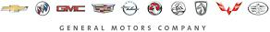

Back to Contents
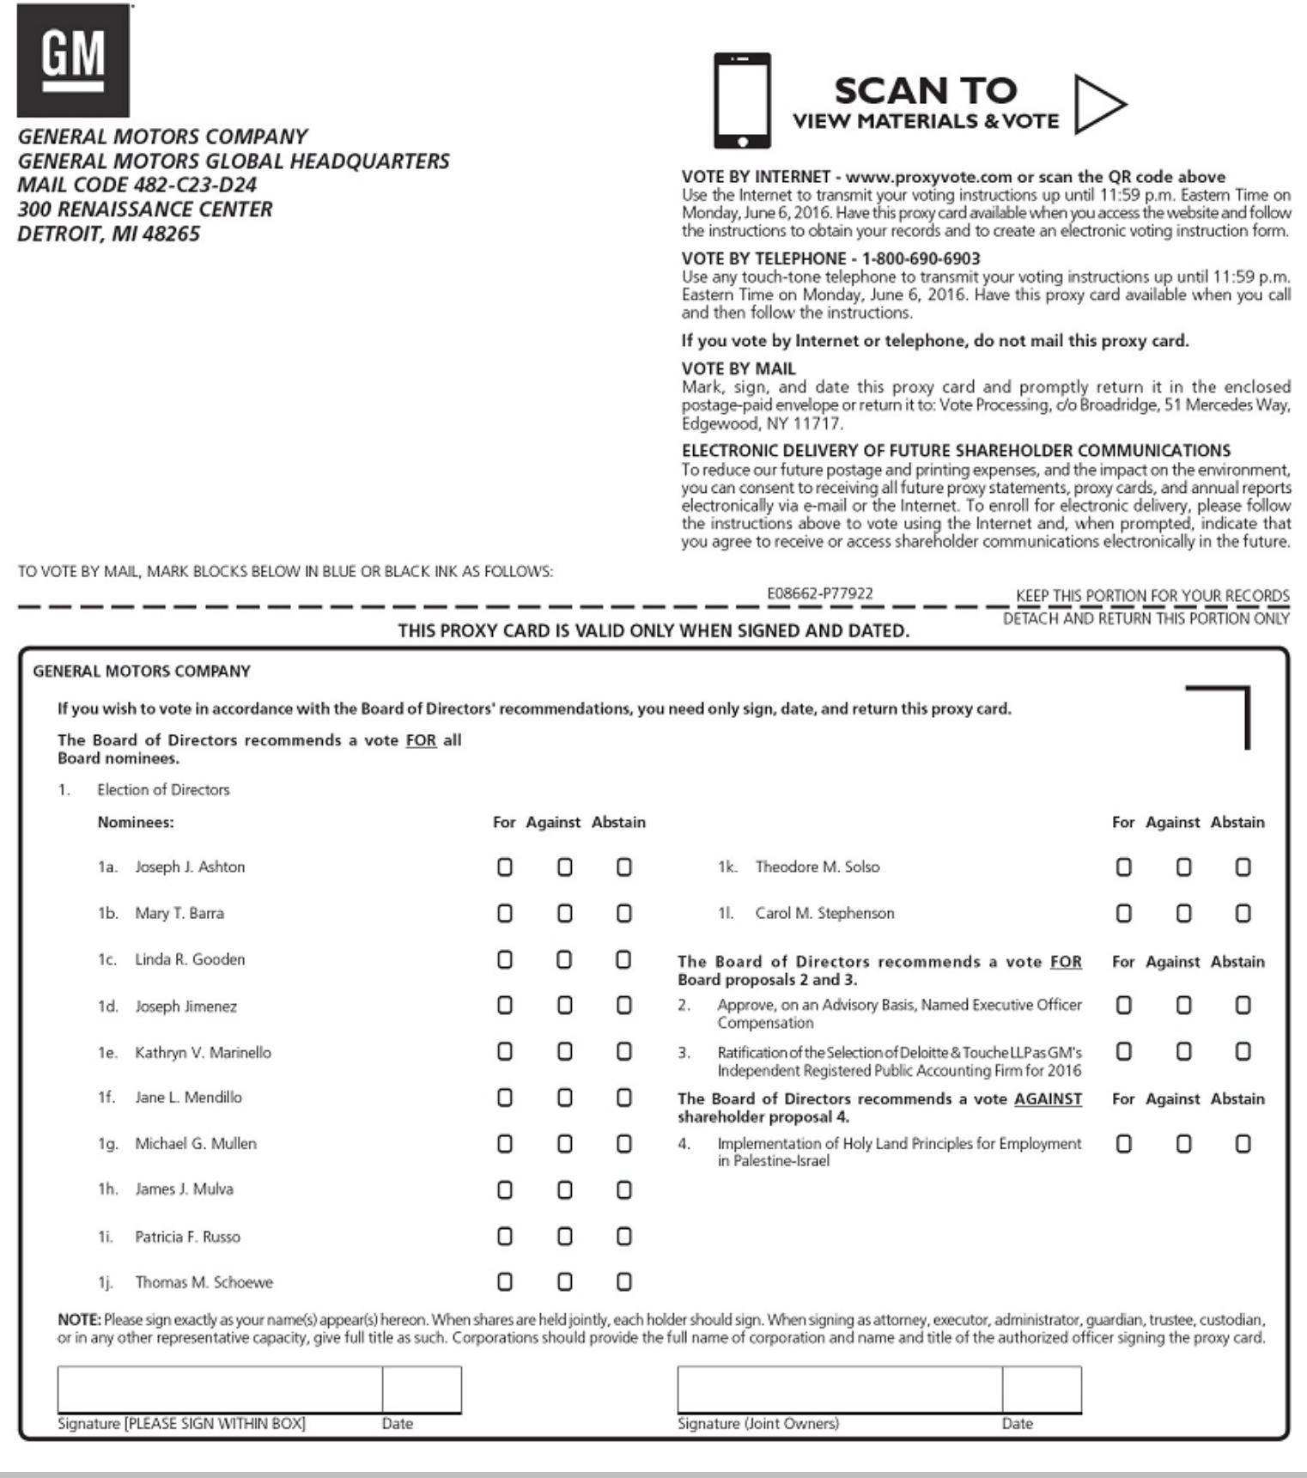

Back to Contents


